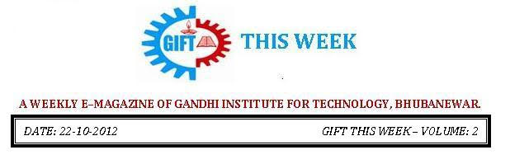

From the editor’s desk:

Dussehra festival is one of our great festivals, celebrated on the tenth day of ShuklaPaksha of Ashwin month as per the traditional Hindu calendar. This festival is also known as vijaydashmi or Dasara and it will be celebrated on October 24, 2012 this year. The purpose of this festival is to commemorate the victory of good over evil. This is an important day as it carries a very beautiful message for the people that truth always prevails in this world. | 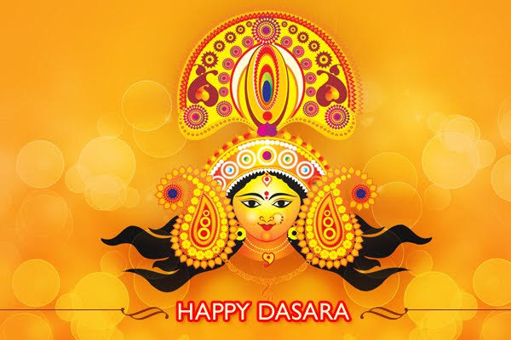
On this propitious occasion, Hindus perform special prayers with pure heart and complete faiths as well as they offer some special food to deities at temples or homes. One of the common practices during Dussehra Festival is that people on this very day burn the effigies of Ravana (who was a mythical king of Sri Lanka) or burn bonfire (symbolic of Ravana) which spreads the message that an individual can only progress if he/she chooses the right path in his/her life.

Make the best of your Puja Vacation! & just enjoy!
Wishing you and your family a Very Happy Vijayadashmi!

Pranati Mishra.
Sr. Lect. (English Dept.)

Robotics workshop

A workshop on Robotics and Embedded systems was organised on 14th October 2012 by the CSE & IT department in GIFT in association with Campus Component Pvt. Ltd., Bhubaneswar and Powered by Institute of Embedded system and Robotics Research, Pune. It was carried out in the Seminar Hall from 10am to 6pm. 8 hours of priceless wisdom was shared by the highly qualified experts from the Campus Component, Bhubaneswar. This workshop was made free for the students of GIFT. The students learned to use Sinaprog software in developing autonomous robots. Here the students were provided with the required equipments for their practice. | 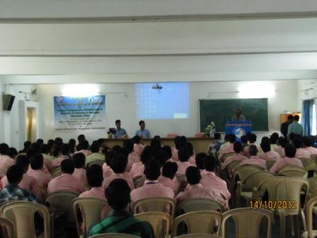
They were divided into groups each of whom made separate autonomous robots which were ready to run by the evening. This workshop not only aroused the students’ interest in the field of robotics but also imparted knowledge which they can successfully implement in their future.
Parents’ Meet
A workshop on Robotics and Embedded systems was organised on 14th October 2012 by the CSE & IT department in GIFT in association with Campus Component Pvt. Ltd., 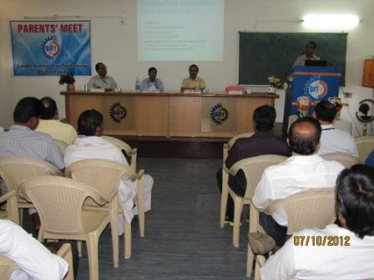Bhubaneswar and Powered by Institute of Embedded system and Robotics Research, Pune. It was carried out in the Seminar Hall from 10am to 6pm. 8 hours of priceless wisdom was shared by the highly qualified experts from the Campus Component, Bhubaneswar. This workshop was made free for the students of GIFT.

The students learned to use Sinaprog software in developing autonomous robots. Here the students were provided with the required equipments for their practice. They were divided into groups each of whom made separate autonomous robots which were ready to run by the evening. This workshop not only aroused the students’ interest in the field of robotics but also imparted knowledge which they can successfully implement in their future.

Behera House Musical Night
BEHERA House night was celebrated on 6th October 2012 with complete zeal and enthusiasm of the BEHERA house students. This cultural house night was marked by number of innovations it portrayed. The performances given by the students were dance, vocal music, musical dance dramas, recitation and a lot more which effectively brought about sheer exhilaration and entertainment. The prevalent part of the show was the ramp walk by the BEHERA house students who presented a theme based gothic style of walk for the first time arousing the audience and earning a standing ovation from one and all which gave it a remarkable valediction.
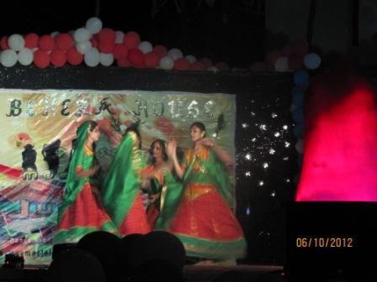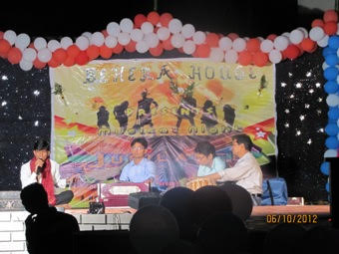

Foot-ball Euphoria
A foot-ball match was held on 10th October 2012 between the winning team from the foot-ball match which was conducted earlier among the students and the college staff which were “KALAM House students and the non-teaching staff teamed as Dean Administration XI” respectively. The game proved to be tremendously exciting and the whole college was found to be watching it as it implicated the involvement of both students and college staff. The competition was neck to neck, but the KALAM house team met with a glorious victory for the students exhibiting their extraordinary competence. This match organised was to encourage both students and college staff and to build a rapport between them.
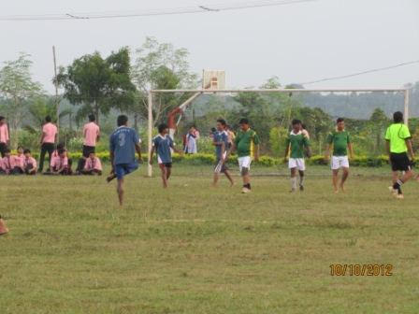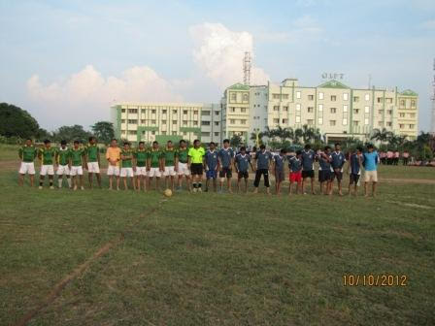

PLACEMENT (OCT 2012):
In this month we have organized one ON Campus Drive for HYMA Plates & Vessels, a CORE Company where 12 students got selected from MECHANICAL & EEE Branches.

THOUGHTS OF THE WEEK
Thought for the Day is a daily scripted slot which appears on one of our college’s stand board and it reflects lessons to be learned from different spheres of life including education, knowledge, success, motivation, life, world, philosophy and so on. The thought of the day message is also sent as ‘SMS’ to all the members of GIFT on a daily basis. So the last week messages, form the THOUGHTS OF THE WEEK and is as follows :
15.10.12.
Courage is the first of human qualities because it is the quality which guarantees all other.
16.10.12. -
Don't waste time with someone, who won't support you in the time of need.
17.10.12 -
Never discuss your health, wealth, and personal matter with anyone outside your immediate family. Be much disciplined in this regard.
18.10.12-
You can get more with a kind word and a gun than you can with a kind word alone.
19.10.12-
If someone doesn't appreciate your presence make them appreciate your absence.
20.10.12-
The nice thing about egotists is that they do not talk about other people.
21.10.12-
Integrity is doing the right thing when no one is watching.
---------------------------------------------------------------------------------------------------------
These are the students who have contributed for the E-Magazine; their efforts helped us to publish this."
1) Ankita Sinha(CSE 2nd yr)
2) Jasmie Choudhury(CSE 2nd yr)
3) Amrendra Chandan (Mech. 1st Yr. Sarabhai)

