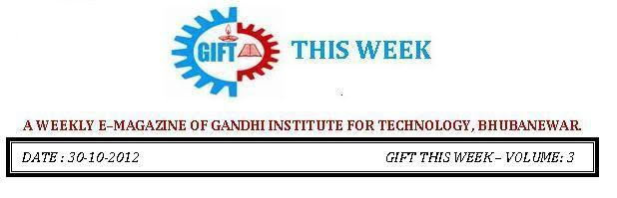

From the editor’s desk:

Deepawali or Diwali is certainly the biggest and the brightest of all Hindu festivals. It's the festival of lights (deep = light and avali = a row i.e., a row of lights) which literally illumines the country with its brilliance, and dazzles all with its joy. The festival of Diwali is separated by a different tradition, but what remains true and constant is the celebration of life, its enjoyment and goodness.

With gleam of Diyas and the Echo of the Chants May Happiness and Contentment Fill Your life Best Wishes for You & Your Family Happy Diwali!

Pranati Mishra. Sr. Lect. (English Dept.)

MBA WELCOME
The MBA freshers had their welcome ceremony on 9th November 2012. The objective was to stimulate them and also inform them of the regular college procedures. They were welcomed in an inclusive traditional manner. The dignitaries present were the Dean Academics, Dean Admin and the MBA faculties shared their precious thoughts regarding the academic proceedings of the college and motivated them to bring improvement in their performance. A seminar on CSR activities was held after that which was conducted by Mr. Krishna Chandra Biswal. After the formal events, the luncheon party arranged for the MBA 1st year students. An informal entertainment event was organised by the senior students of MBA where the 1st years were made to interact without restraint to raise their confidence. Finally the welcome ceremony was adjourned with the announcement of Miss Supriya Mohanty and Mr. Baikunth Nath Patro as Miss &Mr Fresher. The selection took place on the basis of personality, behaviour and academic performance.
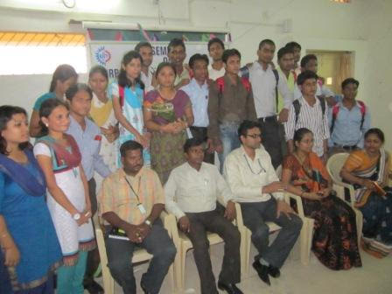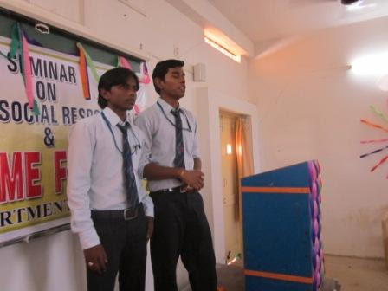

LAKSHYA

A Motivational workshop was arranged for the Mechanical students of Engg.on 9th November 2012. Lakshya is a term we use to define our goal in life. The Chief Guest MrNasim Khan, corporate trainer was invited for career counselling of the students who educated the budding technicians as how to choose their path in life to achieve their ambition. This workshop was arranged in order to motivate the students and prepare them to face all the challenges in the corporate world. The base line of the workshop was to help prospective generation to understand their hidden talent. He inspired the students to go in right direction in right time so that it will be a boost to their confidence as well as career. To remove the aspect of confusion in career selection in the final year and encourage the students to settle on to a decision at this early period, the workshop provided guidance to choose and apt career options for themselves. The workshop was conducted again for the ECE branch students on 10th November 2012.
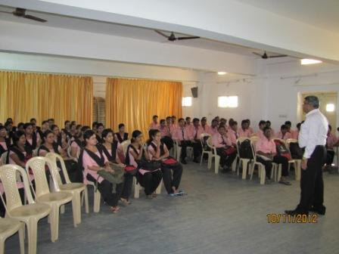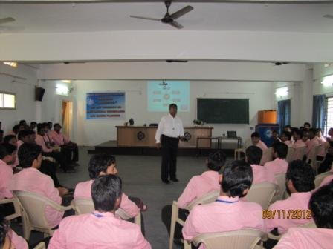

STUDY TOUR
GIFT arranges for study tour for students on a yearly basis. This gives an opportunity to the students to visit new places, interact with new people and learn novelties. Not only does this offer exposure to the students but also freshens their minds from their routine monotonous activities. A study tour was arranged for the EEE branch, 3rd year students who were taken to Vishakapatnam for three days. They left on 8th November 2012 and returned on 11th November 2012. Another study tour was arranged for the Anand house 1st year students who were taken to Pathani Samanta Planetarium, on 9th November 2012. They learnt interesting scientific facts from there and enjoyed their very 1st study tour of B. Tech Career.

THOUGHTS OF THE WEEK
Thought for the Day is a daily scripted slot which appears on one of our college’s stand board and it reflects lessons to be learned from different spheres of life including education, knowledge, success, motivation, life, world, philosophy and so on. The thought of the day message is also sent as ‘SMS’ to all the members of GIFT on a daily basis. So the last week messages, form the THOUGHTS OF THE WEEK and is as follows :

01.11.2012
That some achieve great success is proof to all that others can achieve it as well.
02.11.2012
Live in such a way,that if someone will speak badly of you,no one would believe it.
03.11.2012
Scientists dream about doing great things.Engineers do them.
04.11.2012
You have got to do your own growing,no matter how tall your grandfather was .
05.11.2012
If you tell the truth it becomes apart of your past.If you lie,it becomes a apart of your future.
06.11.2012
No matter how you behave with people arround you,they will love you according to their need and mood.
07.11.2012
Three qualites required for a truly great man: a man's brain, a woman's heart,a child's temperament.

---------------------------------------------------------------------------------------------------------
These are the students who have contributed for the E-Magazine; their efforts helped us to publish this."
1) Ankita Sinha(CSE 2nd yr)
2) Jasmie Choudhury(CSE 2nd yr)
3) Amrendra Chandan (Mech. 1st Yr. Sarabhai)

