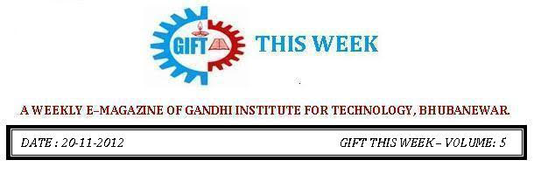

From the editor’s desk:

It’s a great pleasure to share “GIFT THIS WEEK (volume - 6)” with you. Hope you will enjoy.
Your suggestions for improvement of the week news letter are highly solicited.
Pranati Mishra. Sr. Lect. (English Dept.)
Electrical Society:
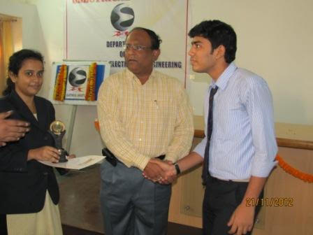 | 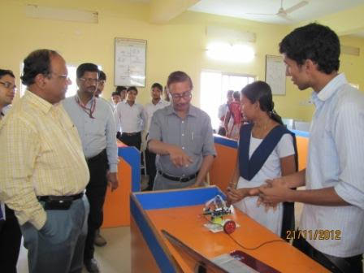
The electrical society which has formed under the sought guidance of Mr. Srikant Das, HOD EEE Dept, had its inauguration ceremony held on 21st of November 2012. The chief guest delivered imperative talk for the welfare of the students. Several events like Quiz Competition, White paper presentation and Project presentation of the 4th year students took place. Mr. Sudhir Rath and his group won the 1st prize exhibiting their extraordinary presentation skills in 4th year project presentation. This was followed by a career motivation program held exclusively for the 2nd year students to bring determination and courage in them from this very early period.  Not only was this the inauguration of the Electrical Society but also the launch of the e-magazine of EEE department which has been named "Vidyut" and would arrive before our eyes soon. | 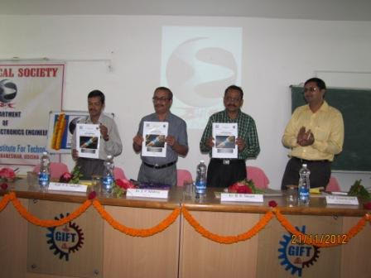

VISVESWARAYA HOUSE NIGHT
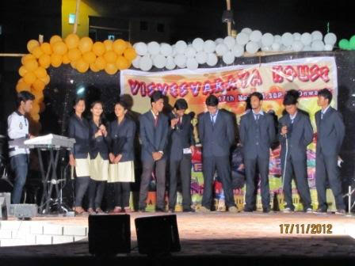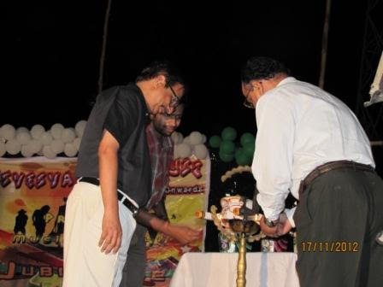
The Culture, the word itself defines so much. And when it comes to Indian culture words fall short. The culture of India refers to so much which includes the religions, the beliefs, customs, traditions, languages, ceremonies, arts, values and the way of life in India and its people. Talking of diversity, indubitably, India is one of the most religiously diverse nations in the world, with some of the most deeply religious societies and cultures. This was truly proved by the Visveswarayans on the visveswarya house night held on 17th November, 2012 which was rich in Indian culture. All the students of this house actively took part in their night and gave their best to bestow respect to our cultural integrity. The performances included dance, song, drama, poetry, band and many more events which attracted the audience. The special attraction of this night was the human pyramid and short musical acts.

PLACEMENT
This month saw a very good ON-Campus Drive by MAGNAJ INNOVATION, in which 15 students got selected.

By : Chandan Subasit Sahoo
T& P Cell

THOUGHTS OF THE WEEK
Thought for the Day is a daily scripted slot which appears on one of our college’s stand board and it reflects lessons to be learned from different spheres of life including education, knowledge, success, motivation, life, world, philosophy and so on. The thought of the day message is also sent as ‘SMS’ to all the members of GIFT on a daily basis. So the last week messages, form the THOUGHTS OF THE WEEK and is as follows :
Nov-19
“When you feel like quitting, think about why you started. “
Nov-20
“The Real test of power is not capacity to make war but capacity to prevent it. “
Nov-21
“Wealth consists not in having great possessions, but in having few wants. “
Nov-22
“How strange to use you only live once as an excuse to throw life away. “
Nov-23
“The only disable in life is a bad attitude. “
Nov-24
“He, who fears your presence, will hate your absence.”

By: Amrendra Chandan (Mech. 1st Yr. Sarabhai)
---------------------------------------------------------------------------------------------------------
These are the students who have contributed for the E-Magazine; their efforts helped us to publish this."
1) Mr Iquebal Ahemad(System Admin., CSE)
1) Ankita Sinha (CSE 2nd yr)
2) Jasmie Choudhury (CSE 2nd yr)
3) Amrendra Chandan (Mech. 1st Yr. Sarabhai)

