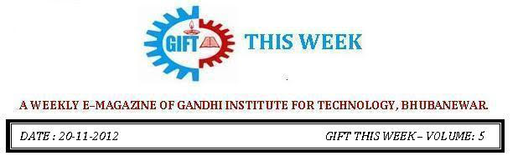

From the editor’s desk:

It’s a great pleasure to share “GIFT THIS WEEK (volume - 7)” with you. Hope you will enjoy.
Your suggestions for improvement of the week news letter are highly solicited.

Pranati Mishra. Sr. Lect. (English Dept.)
MEGA JOB FAIR - 2012:
A MEGA JOB FAIR was organized by GIFT and Times Job .com on 8th and 9th Dec 2012 in GIFT Campus where in around, 5000 job seekers from different part of Odisha & others states have participated. The students had a wide range of choices to choose from different companies from different sectors. The following companies were participated in the job fair:
Ericsson, Maruti Suzuki, Sky Automobiles, VRX Labs - GKB Opticals, SKM Group, Apollo Gleneagles, Concerntrix Infotech, Reliance Life Insurance, Pour Vous, Zodiac Express/ 3 Dots, Willing Star, Serco, Karvy, Institution of Competition & Success, Bhushan Power & Steel, DLF Pramerica, Paharpur Cooling Towers, Futuresoft, MSP Steel & Power.

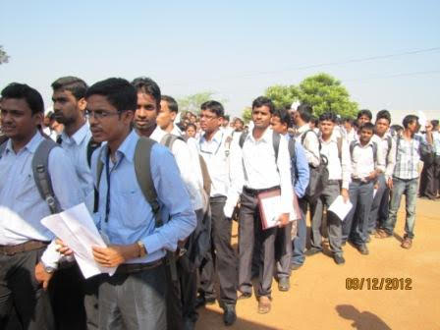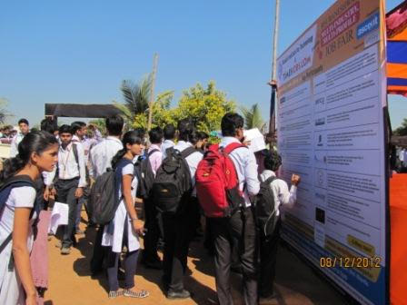

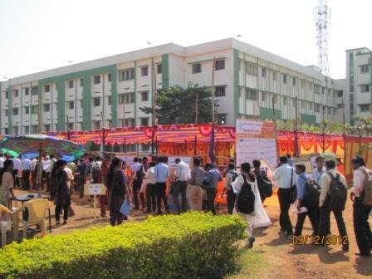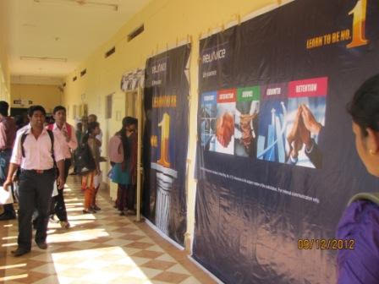

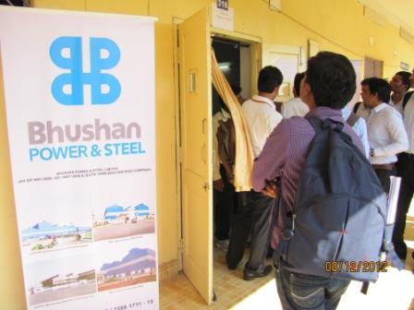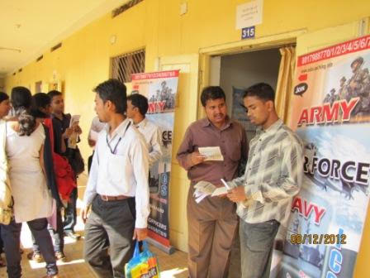
E-LEARNING COMPUTER LAB
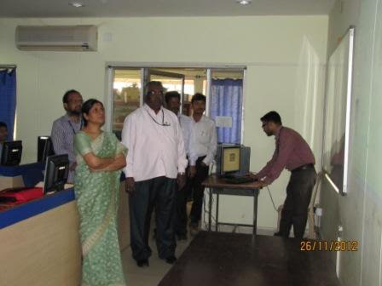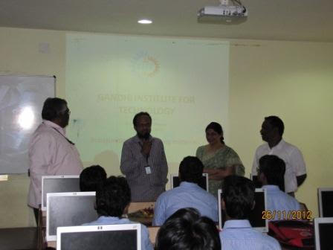
GIFT witnessed the inauguration of E-LEARNING COMPUTER LAB in Computer Lab-1 by Prof. (Dr.) D.V.R. Shankar, Principal GITA. A welcome speech was presented by Prof. Subrat Sekher Pattnaik. It was none other than Prof. Srinibash Rao, Dept. of CSE, GITA and Dr. Sujata Dash, Dean Development, GIFT who graced the occasion with their valuable inputs in the presence of 1st and 2nd year students. Other staffs like Priyabrata Nayak, Biswadarsi Biswal and Iquebal Ahemad contributed their part in making this event a great success.
E-learning computer lab has been introduced at GIFT especially keeping in view the interest of the Students who can access e-learning resources of NPTEL and WINJEST through college intranet. It is sincerely hoped that this endeavor will definitely reap rewarding results in the days ahead.

THOUGHTS OF THE WEEK

Thought for the Day is a daily scripted slot which appears on one of our college’s stand board and it reflects lessons to be learned from different spheres of life including education, knowledge, success, motivation, life, world, philosophy and so on. The thought of the day message is also sent as ‘SMS’ to all the members of GIFT on a daily basis. So the last week messages, form the THOUGHTS OF THE WEEK and is as follows :
03.12.2012
"The more we study the more we discover about our ignorance"
04.12.2012
"The only disable in life is a bad attitude"
05.12.2012
"Anyone who has never made a mistake has never tried anything."
06.12.2012
"He who fears your presence, will hate your absence."
07.12.2012
"Destiny is not a matter of chance, it’s a matter of choice, it’s not a thing to be waited for but a thing to be achieved."
08.12.2012
"If you can't fly, run. If you can't run, walk. If you can't walk, crawl. But never stop till you are alive. "

By: Amrendra Chandan (Mech. 1st Yr. Sarabhai)
---------------------------------------------------------------------------------------------------------
These are the staffs and students who have contributed for the E-Magazine; their efforts helped us to publish this."
1) Mr Iquebal Ahemad(System Admin., CSE)
2) Mr Priyabrat Nayak (Lect., CSE)
3) Ankita Sinha (CSE 2nd yr)
4) Jasmine Choudhury (CSE 2nd yr)
5) Amrendra Chandan (Mech. 1st Yr. Sarabhai)

