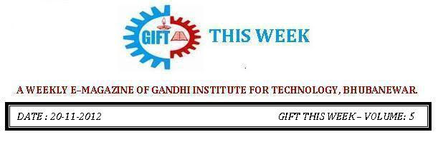

From the editor’s desk:

It’s a great pleasure to share “GIFT THIS WEEK (volume - 8)” with you. Hope you will enjoy.
Your suggestions for improvement of the week news letter are highly solicited.
Pranati Mishra. Sr. Lect. (English Dept.)

EIRC ROBOTICS WORKSHOP:
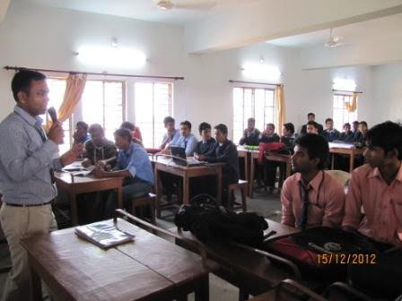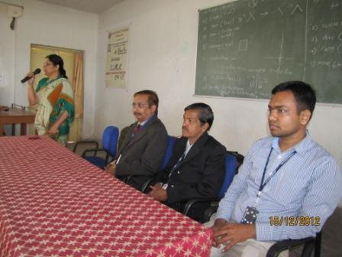
An autonomous robotics open workshop was arranged by the VSSUT, Burla in association with ThinkWare in Gandhi Institute For Technology on 15th and 16th of December 2012. It was a 2 days programme where students from several other institutes apart from GIFT took part. This was made possible with the efforts of Mrs. Rashmi Rani Panda, Mr. Chinmayananda Padhy and a few volunteering students. Here the students were provided with their own kits and were taught the basics of the electronic equipments which were required in the workshop for building their own autonomous robots in the 1st day. In the 2nd day the students were exposed to the all India Robo challenge prelims whose finale is going to be conducted in Burla. There were 3 winning teams who directly qualified for the all India Robochallenge finale. All the three winning teams were from GIFT. The students taking part in this workshop received exposure and were endowed with an opportunity to learn autonomous robotics which is so much in demand in the present day.

KALAM HOUSE MUSICAL NIGHT
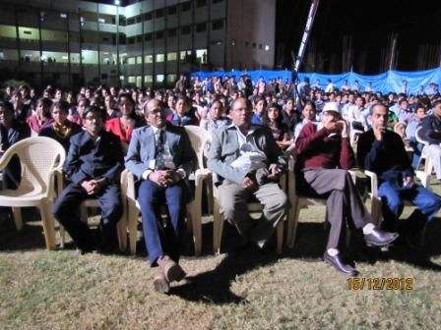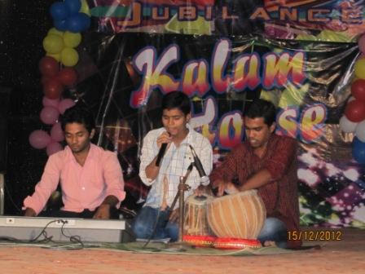
The Kalam house night was celebrated on 15th December 2012. After weeks of rigorous practice and effort from the students and faculties it was made possible. The Saturday night began with the lighting of the holy lamp by the dignitaries which was followed by a odhisi dance by to pay a tribute to our culture. The rest of the evening was vibrantly marked by melodious music, dance, drama, acts and special attractions like mono acts being performed by students which won the hearts of many. The audience cheered the performers and tapped their feet in elation throughout the cultural night. |  | 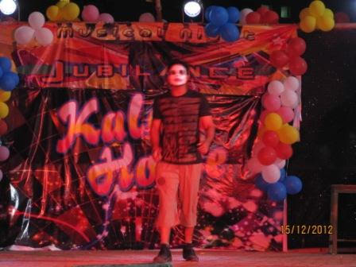
IBPS EXAM
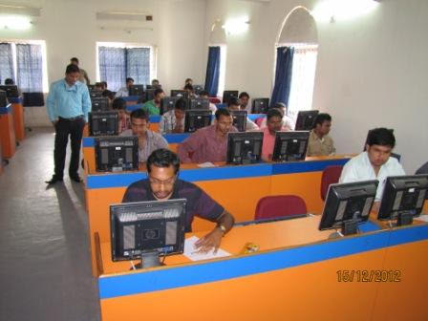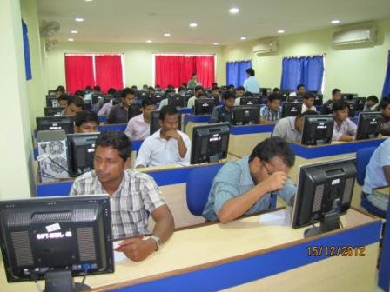
GIFT successfully organized the IBPS online Banking Exam conducted by TCS on Dt. 15th and 16th Dec.
INAGURATION OF NEW COMPUTER LAB :
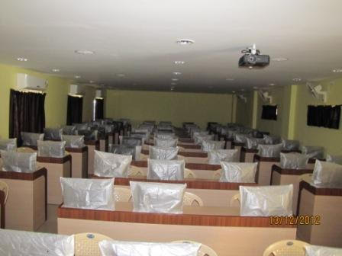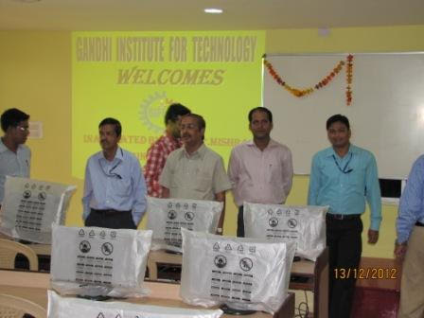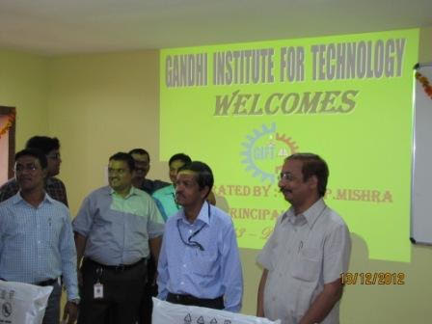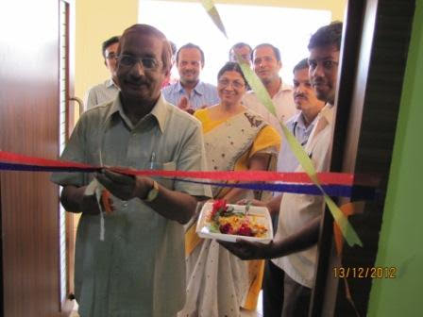

On Dt. 13/12/2012 the new computer Lab has been inaugurated by Prof. Dr. S. P. Mishra, Principal, GIFT. It is a well equipped lab with 65 stand alone desktops, all connected to the LAN, internet facility, two servers in the attached server room, wall mount OHP and eight 2 Ton ACs.

THOUGHTS OF THE WEEK
Thought for the Day is a daily scripted slot which appears on one of our college’s stand board and it reflects lessons to be learned from different spheres of life including education, knowledge, success, motivation, life, world, philosophy and so on. The thought of the day message is also sent as ‘SMS’ to all the members of GIFT on a daily basis. So the last week messages, form the THOUGHTS OF THE WEEK and is as follows :
17.12.2012
"Anxiety is the assassinatior of creativity."
18.12.2012
"When we don't learn lesson at the right time,life will teach us the same lession at the wrong time."
19.12.2012
"You alone are the judge of your worth and your goal is to discover infinty worth in yourself,no matters what anyone else thinks."
20.12.2012
"Your dream is your mind's creation of a life less ordinary.Your life is your opportunity to open your mind and create the dream."
21.12.2012
"Be gracious in your love of others.Difficult time may show the worst in some.They are the ones who need it most ."
22.12.2012
"Knowlege is knowing the solution to a problem while wisdom is knowing how best to apply knowledge to the solution."
23.12.2012
"Life is simply continual ever-changing events...... We control life changes or they control us.The choice is ours to make."

By: Amrendra Chandan (Mech. 1st Yr. Sarabhai)
---------------------------------------------------------------------------------------------------------
These are the staffs and students who have contributed for the E-Magazine; their efforts helped us to publish this."
1) Mr Iquebal Ahemad(System Admin., CSE)
2) Mr Sanjaya Kumar Barik (Lab Asst., CSE)
3) Ankita Sinha (CSE 2nd yr)
4) Jasmine Choudhury (CSE 2nd yr)
5) Amrendra Chandan (Mech. 1st Yr. Sarabhai)

