From the editor’s desk:
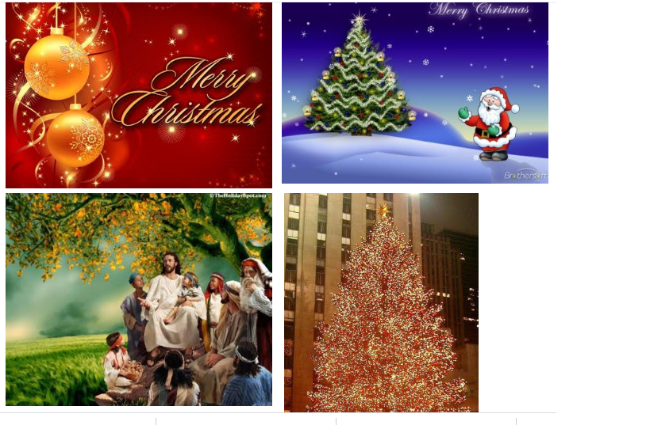

Christmas - celebrating the birth of Jesus Christ.

Christmas or Christmas Day is an auspicious religious festival for Christians. It is being celebrated every year on the specified date December 25 with great fervor to commemorate the birth and life of Lord Jesus Christ. Christians on this occasion gather at the churches in the morning for the 'church service', popularly known as mass, for Christ. Christmas, nominally a holiday is observed in various innovative ways apart from following traditional practices that includes: preparation of dishes, exchanging gifts, offering prayers and enjoying meal with family members.

For pilgrims and ardent followers of Jesus, Christmas is a season for pilgrimage. To make long and tiresome journeys to shrines or the sacred city Bethlehem, located in Palestine, Jerusalem that is believed to be the birthplace of Jesus according to the New Testament Gospels of Luke and Matthew.

Merriment of Christmas has a long history and believed to bring goodwill. For many people, this festival is truly a magical season as they can stay at their houses and spend some good moments with their friends and family members. Christmas is a very special occasion for children because they fantasize Santa Claus travelling a long journey carrying fancy gifts for them.

Christmas is celebrated across the world following customs that varies from one to another country. But certain customs prevails irrespective of geographical boundary that includes sending warm Christmas greetings, fancy Christmas gifts and Christmas cards; to hold nativity plays, beautify Christmas tree and visit church to sing Christmas songs praising or reliving baby Jesus and Holy Mother Mary.

Christmas tree, known as Yule tree, has a distinctive significance in this festival. The Christmas tree is adorned with beautifully wrapped gifts, ribbons and attractive items to make the occasion more pleasant. But with the growing awareness to protect trees and go eco-friendly, people now opting for artificial Yule tree at their houses to observe Christmas.
Christmas is the best time for a vacation. As New Year follows the festivity, people plan for long rejuvenating vacation making the occasion a memorable one.

Wishing you and your family a Merry Christmas!

Pranati Mishra. Sr. Lect. (English Dept.)

THOUGHTS OF THE WEEK
Thought for the Day is a daily scripted slot which appears on one of our college’s stand board and it reflects lessons to be learned from different spheres of life including education, knowledge, success, motivation, life, world, philosophy and so on. The thought of the day message is also sent as ‘SMS’ to all the members of GIFT on a daily basis. So the last week messages, form the THOUGHTS OF THE WEEK and is as follows :

"There is always a little more toothpaste in the tube. Think about it."
"Notes From A Big Country" by Bill Bryson

"You see things that are and say 'Why?' But I dream of things that never were and say 'Why not?'’ Writer George Bernard Shaw (1856-1950)

"Problems cannot be solved by thinking within the framework in which they were created." Scientist Albert Einstein (1879-1955)

"Everything should be made as simple as possible, but not simpler."
Scientist Albert Einstein (1879-1955)

"My country is the world and my religion is to do good."

"Most smiles are started by another smile."

"The mind is not a vessel to be filled, but a fire to be ignited."

"You're either part of the solution or part of the problem."
---------------------------------------------------------------------------------------------------------
These are the staffs and students who have contributed for the E-Magazine; their efforts helped us to publish this."
1) Mr Iquebal Ahemad(System Admin., CSE)
2) Mr Sanjaya Kumar Barik (Lab Asst., CSE)
3) Ankita Sinha (CSE 2nd yr)
4) Jasmine Choudhury (CSE 2nd yr)
5) Amrendra Chandan (Mech. 1st Yr. Sarabhai)

