From the editor’s desk:

The year 2012 has brought innumerable fortunes for Gandhi Institute For Technology. With a hope of keeping this augmentation mounting in the near future we all welcome the New Year 2013 heartily. We express our earnest and warm wishes on behalf of the team of GIFT THIS WEEK to all the students, faculties, staff and everyone associated with us. New Year comes with ray of hopes in our mind arousing new confidence and courage for a new beginning to all our ventures both pending and new with optimism and a new spirit of prosperity. So let us make a great start to the New Year in this festive mood with prayers and gratitude to the almighty to bless us with immeasurable affluences and mercies.
Wishing you and your family a Very HAPPY NEW YEAR 2013.
Pranati Mishra. Sr. Lect. (English Dept.)

STUDENT EXCHANGE PROGRAMME
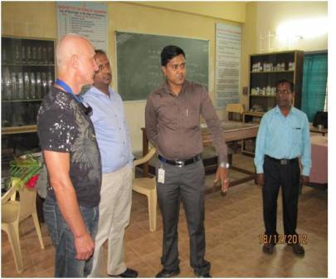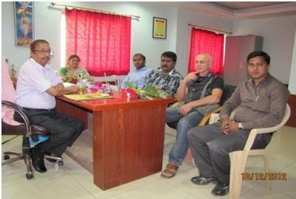

GIFT has arranged for the foreign student exchange programme which provides the students of GIFT with the opportunity to pursue their higher education in any foreign university. Dr. Andrey Anatoly Bich Kalibreda from Rostov on Don State University, Rostov on Don, Russia visited Gandhi Institute for Technology for prospective tie up with GIFT for high end research and Student Exchange Program. This was made possible with the diligent efforts of Mr. Sitanath Biswas (Dept. of CSE) who made the associations of GIFT with the foreign universities and today GIFT has become a world class brand for students across the globe.

Publication and Achivement:

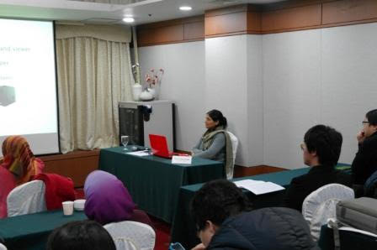
Publications of Dr. Sujata Dash, Professor Computer Science, (Dean research), GIFT, BBSR as First Author:
1. “Rough Set Aided Gene Selection for Cancer Classification”, 7th International Conference on Computer Sciences and Convergence Information Technology, 3nd Dec to 5th Dec, 2012 in Seoul, Republic of Korea. Presented and published in IEEE Xplore.
Acievments:
1. Awarded with Travel Grant to attend International Conference abroad from Department Of Science and Technology, India, sanction order no. SR/ITS/1724/2012-2013 dated 19-11-2012.
2. Reviewer and Organizing member of International Conference InSITE organized by Informing Science Institute(ISI), California, USA.
3. Chaired two Technical sessions in an International Conference ICCIT2012, at Seoul, South Korea in December 2012.
4. Chaired two Technical sessions in an International Conference BIOCOMP’12 at Las Vegas, USA in July 2012.
5. Participated and presented a paper in an International Conference ICCIT 2012 at Seoul, Republic of Korea from 3nd December to 5th December 2012. Paper selected as best paper and given an offer by the Organizing committee to send another paper to IEEE journal within 6 months of time.

Placement :

This week saw a very good off-Campus Drive by Aanvi web solution result awaited and another off campus by Meltek Infosystem where 14 no students got selected.
AN INDUSTRIAL VISIT BY MBA STUDENTS:

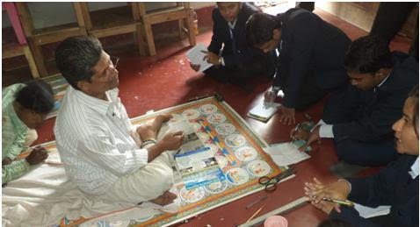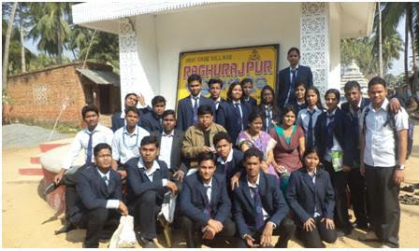
All students of MBA visited Raghurajpur, a craft village of Puri district on 28 December 2012. Raghurajpur is popular for the birth place of Odishi Guru Late Kelu Charan Mohapatra and Goti Pua Dance all over the world. Raghurajpur has been declared as a craft village. All family members of the village depend on craft work like Pattachitra, Paper Michie, Palm Leaf Engraving and Wooden Painted Toys.
Students interacted with different artisans regarding their profession and livelihood and any support extended by the Govt. Students were encouraged by the artworks of the villagers who convert some waste products into attractive decorative items. Students appreciated the people for their contribution on palm leaf and Pattachitra. Students also learned as to how one can start a small scale business at low initial investment. Ultimately, the visit was entirely educative and interactive.

SPORTS THIS WEEK:
This week was marked as a sports week for the students of GIFT. In order to induce agility and competitive nature among the students Throw-ball matches for the girls and Volley-ball matches for the boys were conducted among different houses. The final matches were conducted on 29th December 2012. The teams qualifying from the girls for the finals were from Visveswaraya and Khosla where the Khola girls’ team won victoriously. The qualifying teams for the volley-ball match were from Visveswaraya and Bhaba. The Bhaba boys’ team was triumphant in exhibiting their extraordinary sports skills. This week refreshed the students through these extra-curricular activities and also introduced competency among the students.

THOUGHTS OF THE WEEK:
Thought for the Day is a daily scripted slot which appears on one of our college’s stand board and it reflects lessons to be learned from different spheres of life including education, knowledge, success, motivation, life, world, philosophy and so on. The thought of the day message is also sent as ‘SMS’ to all the members of GIFT on a daily basis. So the last week messages, form the THOUGHTS OF THE WEEK and is as follows :
1. Dec-24: To see yourself, do not look to the mirror; look to the eyes of the people.
2. Dec-25: Life laughs at you when you are unhappy. Life smiles at you when you are happy. But, Life salutes you when you make others happy.
3. Dec-26: Life is hard, life is tough; life is for the living, so buckle up.
4. Dec-27: One who sees the weakness of his strength can also leverage the strength of his weakness, readily, to his advantage.
5. Dec-28: Expectations are premeditated resentments.
6. Dec-29: Pure logic is the ruin of the spirit.
7. Dec-30: Whatever you do may seem insignificant, but it is most important that you do it.
---------------------------------------------------------------------------------------------------------
These are the staffs and students who have contributed for the E-Magazine; their efforts helped us to publish this."
1) Mr Iquebal Ahemad(System Admin., CSE)
2) Mr Sanjaya Kumar Barik (Lab Asst., CSE)
3) Ankita Sinha (CSE 2nd yr)
4) Jasmine Choudhury (CSE 2nd yr)
5) Amrendra Chandan (Mech. 1st Yr. Sarabhai)

