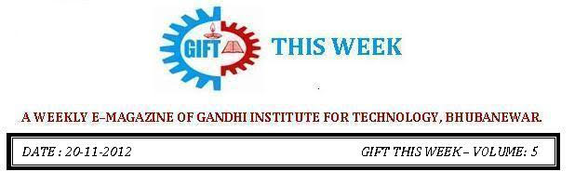

From the editor’s desk:

It’s a great pleasure to share “GIFT THIS WEEK (volume - 11)” with you. Hope you will enjoy.
Your suggestions for improvement of the week news letter are highly solicited.
Pranati Mishra. Sr. Lect. (English Dept.)

THOUGHT FOR THE NEW YEAR
Mr Prakash C. Panda, Asst. Prof.(English)
Hermans Hermits (British Pop Singer of the 60s)

Years may come
years may go
some go fast
some go slow
some are good
some are bad
for each one just be glad
whatever may come true
ahead for me and you
Someday it will be all memories.
Publication and Achivement:

Publications of Dr. Sujata Dash, Professor Computer Science, (Dean research), GIFT, BBSR as First Author:
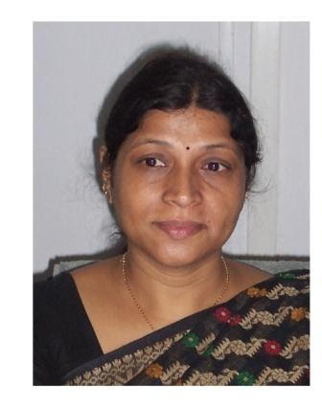
1. “Rough Set Aided Gene Selection for Cancer Classification”, 7th International Conference on Computer Sciences and Convergence Information Technology, 3nd Dec to 5th Dec, 2012 in Seoul, Republic of Korea. Presented and published in IEEE Xplore.
2. “Study of Classification Accuracy of Microarray Data for Cancer Classification using Multivariate and Hybrid Feature Selection Method”, IOSR Journal of Engineering , ISSN:2250-3021 Volume 2, Issue 8,(August 2012), pp 112-119.(www.iosrjen.org)
3. “A Hybrid Data Mining Technique for Improving the Classification Accuracy of Microarray Data Set”, Published Online in I.J. Information Engineering and Electronic Business, (IJIEEB), 2012,2,43-50,April 2012 in MECS(http://www.mecs-press.org/) DOI:10.5815/ijieeb.2012.02.07.
4. “Optimized Multi Agent Coordination using Evolutionary Algorithm: Special Impact in Online Education”, Published in IJCSN Volume 1,Issue 4, August 2012
5. “Agent Based Meta Learning in Distributed Data Mining System”, published to International Journal of Engineering Research and Applications(IJERA), ISSN: 2248-9622(Online), vol 2,Issue 3,May-Jun 2012, pp. 342-348.
6. “Study of Classification accuracy of microarray data for cancer classification using hybrid, wrapper and filter feature selection method”, Proceedings of The 2012 International Conference on Bioinformatics & Computational Biology,WORLDCOMP’12, July 18-21,2012, Las Vegas Nevada, USA indexed in Inspec / IET / The Institute for Engineering and Technology;
DBLP / Computer Science Bibliography; CNRS, INIST, PASCAL, Elsevier .
7. “A Method for Feature Reduction in Gene Expression-Based Disease Classification”, Proceedings of PIMR SIXTH INTERNATIONAL CONFERENCE and a BOOK chapter on “Business Innovations and Entrepreneurship: Transforming world Economy”, from February 11-12, 2012.
Acievments:
1. Awarded with Travel Grant to attend International Conference abroad from Department Of Science and Technology, India, sanction order no. SR/ITS/1724/2012-2013 dated 19-11-2012.
2. Reviewer and Organizing member of International Conference InSITE organized by Informing Science Institute(ISI), California, USA.
3. Chaired two Technical sessions in an International Conference ICCIT2012, at Seoul, South Korea in December 2012.
4. Chaired two Technical sessions in an International Conference BIOCOMP’12 at Las Vegas, USA in July 2012.
5. Participated and presented a paper in an International Conference ICCIT 2012 at Seoul, Republic of Korea from 3nd December to 5th December 2012. Paper selected as best paper and given an offer by the Organizing committee to send another paper to IEEE journal within 6 months of time.

Publications of Ms. Aradhana Sahoo, Lect. Computer Science, GIFT, BBSR

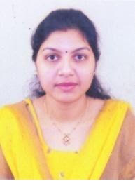
We are glad to share that, her paper "Optimized Software Test Management using Risk Based Approach" is accepted for publication in a reputed free International journal in the field of Software Engineering having impact factor of 0.7621 [the impact factor chart is attached. You can find the same at page no-13 and row number-17].
Science and Engineering Research Support Society(SERSS), Australia are also going to reward $100 for the cause of contribution of this paper.

AN INDUSTRIAL VISIT BY 2nd Year CSE & IT STUDENTS:

The students of B.Tech (2nd Year) of CSE & IT branch visited the Doordasrshan Kendra, located in Acharya Vihar, Bhubaneswar. The faculties under whose supervision the students were taken were Mr. Satyajit Nayak, Mr.Sitanath Biswas and Mr. Sujit Kumar Panda. In today’s world any information needs to be broadcasted as in order to communicate it to the audience and educate them. This expedition was made with an objective of familiarizing the CSE and IT students with the latest technologies and equipments which are used in the current day in broadcasting media to prepare them for the upcoming hardships and the increasing rivalry in this particular area. The students were introduced to high configuration setups which are operated in the broadcasting process and an in depth knowledge about the telecommunication system was imparted to them.

THOUGHTS OF THE WEEK:
Thought for the Day is a daily scripted slot which appears on one of our college’s stand board and it reflects lessons to be learned from different spheres of life including education, knowledge, success, motivation, life, world, philosophy and so on. The thought of the day message is also sent as ‘SMS’ to all the members of GIFT on a daily basis. So the last week messages, form the THOUGHTS OF THE WEEK and is as follows :
1. Jan-1: "If you don't develop a strategy of your own, you become a part of someone else's strategy." American futurist Alvin Toffler
2. Jan-2: "We either make ourselves miserable or we make ourselves strong. The amount of work is the same." Peruvian-American author Carlos Castaneda (1925-1998)
3. Jan-3: "A faithful friend is the medicine of life."
4. Jan-4: "You will never 'find' time for anything. If you want time, you must make it." English philanthropist Charles Buxton (1823-1871)
5. Jan-5: "The illiterate of the 21st century will not be those who cannot read or write, but those who cannot learn, unlearn and relearn."
6. Jan-6: "Happiness is not a destination; it is a way of life."
7. Jan-7: "Our doubts are traitors, and make us lose the good we oft might win by fearing to attempt." William Shakespeare (1564-1616) in “Measure For Measure”
---------------------------------------------------------------------------------------------------------
These are the staffs and students who have contributed for the E-Magazine; their efforts helped us to publish this."
1) Mr Iquebal Ahemad(System Admin., CSE)
2) Mr Sanjaya Kumar Barik (Lab Asst., CSE)
3) Ankita Sinha (CSE 2nd yr)
4) Jasmine Choudhury (CSE 2nd yr)
5) Amrendra Chandan (Mech. 1st Yr. Sarabhai)

