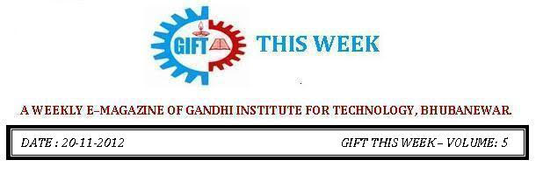

From the editor’s desk:

It’s a great pleasure to share “GIFT THIS WEEK (volume - 12)” with you. Hope you will enjoy.
Your suggestions for improvement of the week news letter are highly solicited.

Pranati Mishra. Sr. Lect. (Department of English)
INDUSTRIAL VISITS BY 2nd Year STUDENTS:

The students of B.Tech (2nd Year) of THREE branches visited the CTTC Bhubaneswar. This expedition was made with an objective of familiarizing the students with the latest technologies and equipments which are used in the current day to prepare them in following areas.

1. MECHANICAL ------- WORKSHOP ON CAD, CAM & CNC Technology.
2. ECE -------------------- WORKSHOP ON VLSI & EMEDDED SYSTEMS.
3. EEE ------------------- WORKSHOP ON INDUSTRIAL AUTOMATION.
BOOKS PUBLICATIONS :
It is our great pleasure to share that Mr. Saumendra Behera, Asst. Prof. belongs to the Department of ECE, has published the following three Books to his credit.
1.BASIC ELECTRONICS
(2nd Edition) Month & Year of publication: November,2012 , Publisher: Lakhmi Publisher, Bhubaneswar
2.Analog Communication Techniques
(2nd Eddition)Month & Year of Publication: December,2012, Publisher: Lakhmi Publisher, Bhubaneswar.
3.Analog Electronics Circuit
(1nd Eddition)Month & Year of Publication: August,2011, Publisher: Lakhmi Publisher, Bhubaneswar.
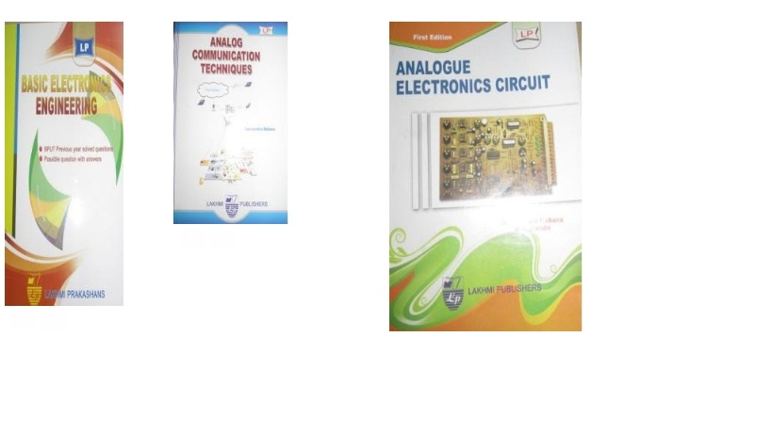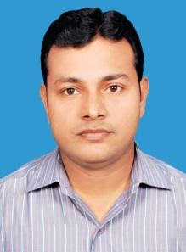

THOUGHTS OF THE WEEK
Thought for the Day is a daily scripted slot which appears on one of our college’s stand board and it reflects lessons to be learned from different spheres of life including education, knowledge, success, motivation, life, world, philosophy and so on. The thought of the day message is also sent as ‘SMS’ to all the members of GIFT on a daily basis. So the last week messages, form the THOUGHTS OF THE WEEK and is as follows :
1. Education makes a people easy to lead, but difficult to drive: easy to govern, but impossible to enslave. Peter Brougham

2. Education is not the filling of a pail, but the lighting of a fire. Wiliam Butler Yeats

3. Tell me and I'll forget. Show me, and I may not remember. Involve me, and I'll understand. Native American Saying

4. What we learn with pleasure we never forget. Alfred Mercier

5. Education is simply the soul of a society as it passes from one generation to another.
G. K. Chesterson.
6. Instruction ends in the school-room, but education ends only with life.
Frederick W.Robertson
7. Whatever is good to know is difficult to learn.
Greek Proverb

---------------------------------------------------------------------------------------------------------
These are the students who have contributed for the E-Magazine; their efforts helped us to publish this."
1) Shishir Barik, Sr. Lect. (Department of English)
2)Ankita Sinha(CSE 2nd yr)
3) Jasmie Choudhury(CSE 2nd yr)
4) Amrendra Chandan (Mech. 1st Yr. Sarabhai)

