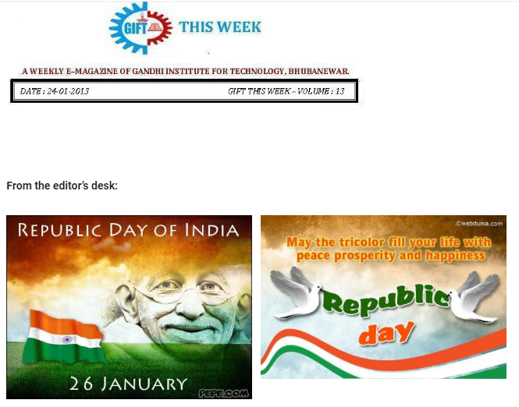

Free to fly
free to be
an Indian by birth
that’s all I want to be.

Celebrating with you the great Indian Pride.
Pranati Mishra. Sr. Lect. (English Dept.)

PLACEMENT CELL:

The new year brought smile on to the faces of B.Tech Mechanical student. They participated in the Off-Campus drive for “Bhusan Power & Steel Limited”. Seven students of GIFT got selected in the company with a handsome package of 3 Lacs / annum.
We had proposed for PIAGGIO Campus drive for B. Tech students, it will be held very soon.
For the 1st time in Orissa EC Council (an US based organization giving certification on Ethical hacking), is going to organize a workshop for our students in the month of Feb 2013.

A PANEL DISCUSSION BY MBA 1ST YEAR STUDENTS:
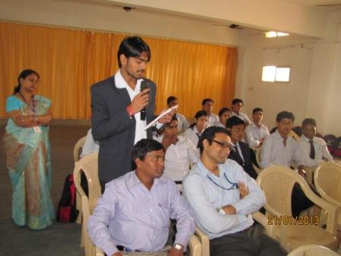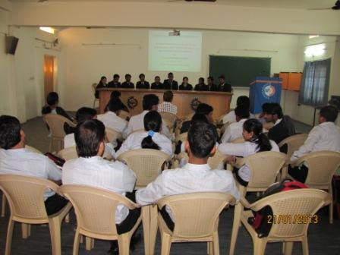
A panel discussion was conducted on “Direct cash Transfer” by Govt. of India by department of MBA in the presence of principal DR. S.P. Mishra and dean research Dr. Sujata Dash. The 1st year students of MBA enthusiastically participated in the discussion and presented their views on subsidy.

THOUGHTS OF THE WEEK
Thought for the Day is a daily scripted slot which appears on one of our college’s stand board and it reflects lessons to be learned from different spheres of life including education, knowledge, success, motivation, life, world, philosophy and so on. The thought of the day message is also sent as ‘SMS’ to all the members of GIFT on a daily basis. So the last week messages, form the THOUGHTS OF THE WEEK and is as follows :
18/01/2012 | The great growling engine of change - technology.
19/01/2012 | Parenthood remains the greatest single preserve of the amateur.
20/01/2012 | Nothing is ever built to last but that doesn’t mean it’s not worth building.
21/01/2012 | The Law of Raspberry Jam: the wider any culture is spread, the thinner it gets. (Alvin Toffler)
22/01/2012 | Knowledge is the most democratic source of power.
23/01/2012 | The Law of Raspberry Jam: the wider any culture is spread, the thinner it gets. (Alvin Toffler)
24/01/2012 | There is nothing wrong with the way you look, you need to change the way you see.

---------------------------------------------------------------------------------------------------------
These are the students who have contributed for the E-Magazine; their efforts helped us to publish this."

1) Shishir Barik, Sr. Lect. (Department of English)
2)Ankita Sinha(CSE 2nd yr)
3) Jasmie Choudhury(CSE 2nd yr)
4) Amrendra Chandan (Mech. 1st Yr. Sarabhai)

