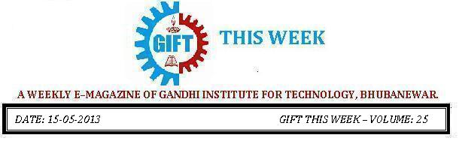

From the editor’s desk:

It gives me great pleasure today to share with you the 25th volume of “GIFT THIS WEEK”, the weekly e-magazine that aspires to attain new heights in the days ahead with your valuable suggestions.
Pranati Mishra.
Sr. Lect. (English Dept.)

ANNUAL SPORTS
GIFT celebrated its Annual Sports of the session 2012-13 on 29th and 30th April,2013.The break of mid-noon on 29th and 30th April promised to bathe everyone in our GIFT world in the bright sunshine of glory and success. All the Staff and Students in large numbers gathered in the Kalinga Stadium with sparks in eyes and fire in the bellies even after the strenuous morning classes. The event formally commenced with lighting of the Torch Light by our respected Principal Sir. All the Students stood in a queue in-front of their respective House Flags and witnessed the oath taking ceremony. Naini Sangha, a student of 2nd Year administered the oath to all the participants, thus instilling a feeling of camaraderie among all. The college flag was hoisted by our Principal Dr.Trilochana Sahu who then raised the spirit of one and all by his motivating speech which added much change to the occasion.
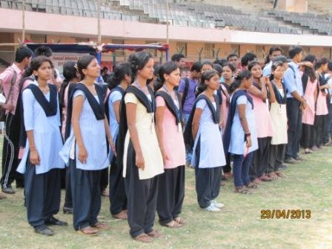 | 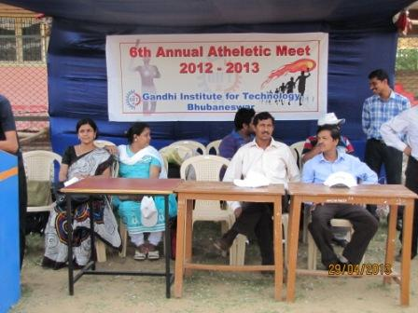
.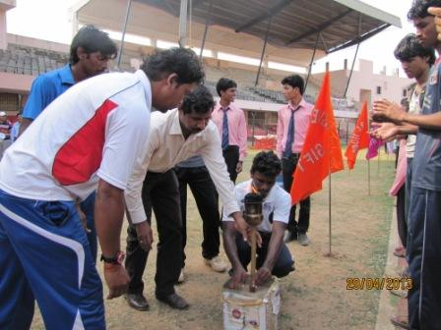 | 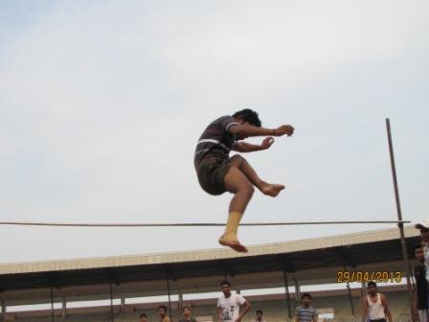
The Sporting events began with 100 meters race for the boys and girls followed by Discuss throw, Shot-Put, Javelin throw for the girls and High Jump for the boys. These were events on 29th April and the rest continued on the 30th starting with 200 meters race (boys and girls) followed by Long Jump (boys and girls), 400 meters for boys, Discuss throw, Shot-put and Javelin throw for boys and winded up with 4x100 meter relay .Everyone possessed the same spirit as soldiers in a battle field and played with a lot of anxiety.
After completion of the athletic events, Winners were honored by our Principal, Dean Academics Sir and many other Respected Authorities with Medals. The Winners gained a lot of appreciation and thunderous applause from one and all. The Event formally ended with the declaration of the meet closed and thanking everyone for their co-operation. | 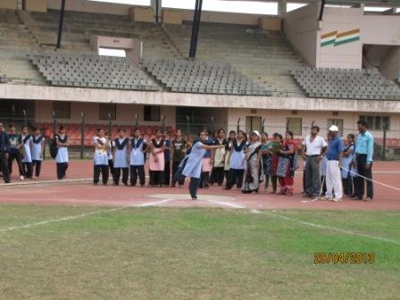
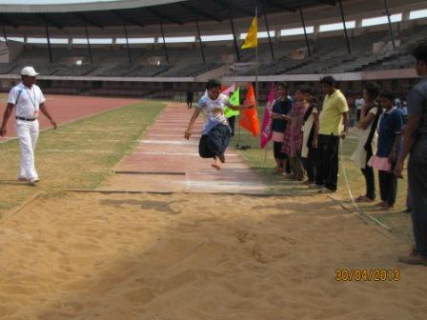 | 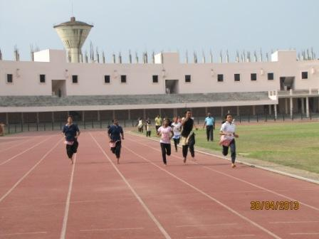
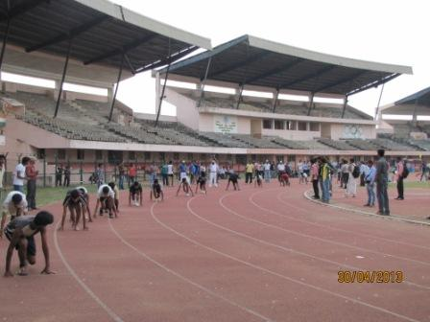 | 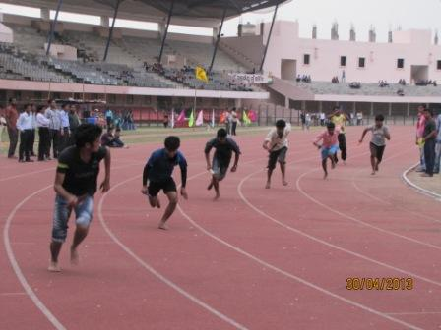
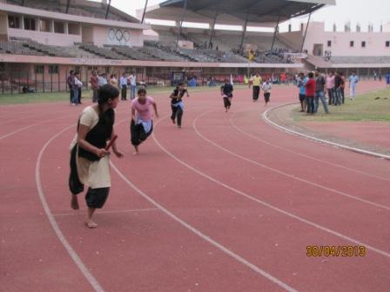 | 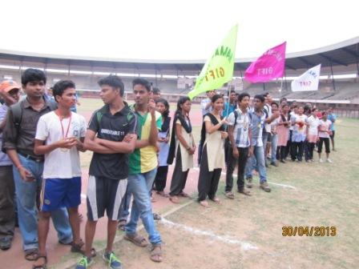
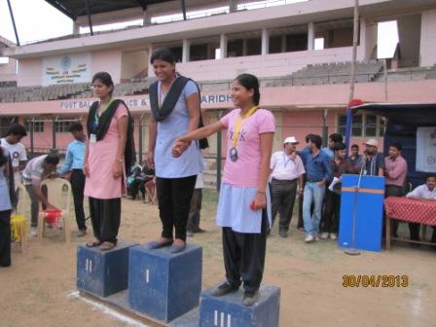 | 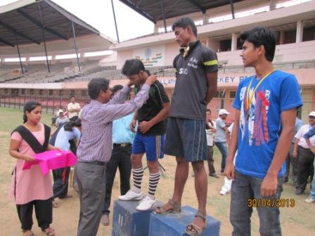
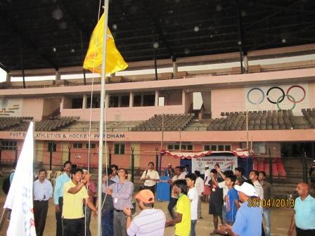 | 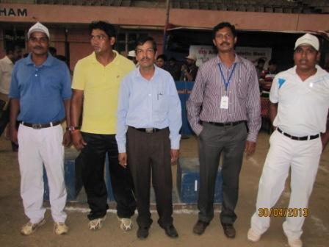

Alumni Meet of C.S.E & IT Department:
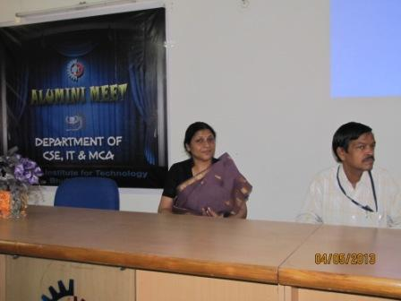 | 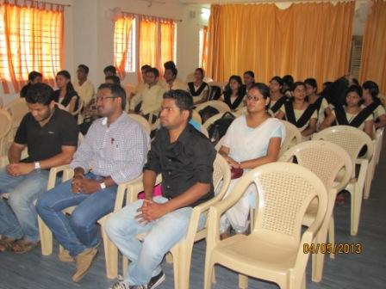
Gandhi Institute For Technology organized its first Alumni Meet of C.S.E,IT & MCA branch on 4th may 2013.Many of the alumni played active role in contacting their batch mates and others. The Meet was attended by few alumni of batches that graduated in year 2011-12.It was a great pleasure to know about their professional lives.
The general Body meeting of the Alumni Association was held at 12:00 p.m. in the conference hall. In this meeting, Dean Administrative Lt.col (Ret) M.k Raut, Dean Academic Prof.Dr P.k subudhi, Dean Research Prof.Dr sujata dash,Asst Dean Academic Prof Tapan Panda & H.O.Ds also participated. A feedback was collected from alumni regarding the organizational aspects of the meet and their suggestions for the improvement in college. A powerpoint presentation was presented by smruti ranjan patri (3rd year) to bring their past memories afresh. Then a game was organized by komal joshi & kritika kumari for entertainment purpose. Lastly memento was provided by the H.O.D Prof. Satya Ranjan Mohapatra to the Alumni. Lunch was arranged for Alumni. Everyone departed with the resolve to visit again and spread the message amongst all who could not visit this time.The whole event was handled by respected faculty members with the assistance of volunteers(komal and shruti)..hope this gatherings will take place again in future and keep on inspiring the students more and more......
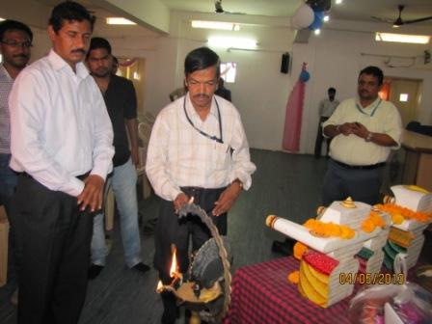 | 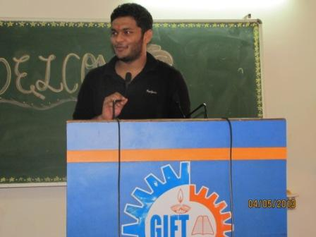

Farewell of C.S.E & IT Department:

Goodbye or parting is sweet sorrow,  But we all have to face it tomorrow.  A Farewell for the 4th year Computer Science & IT batch-2013 was organized on 24th April 2013 at Gandhi Institute For Technology Conference Hall. The presence of Dean Administrative Lt. Col(Ret) M.K Rout, Dean Academic Prof.Dr P.K Subudhi, Dean Research Prof.Dr Sujata Dash along with the principal Prof.Dr Trilochan Sahu made the last days of the seniors a touching and memorable one. | 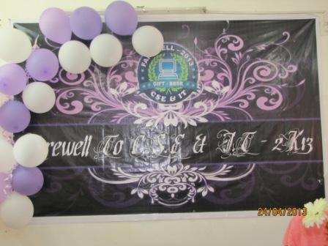
The program started with the welcoming of seniors with Tilak & Farewell Badge at 10:00 a.m. After the recitation of holy bhajan just at 10:30 a.m.Thereafter two students of 3rd year, shruti nayak & akshay keshav on behalf of the students of the college addressed the farewell.The event begun with the cutting of cake by the Head of the Department. Prof Satyaranjan Mohapatra & 4th year students as well as snacks were provided to all by the volunteers. Then the H.O.D delivered his mesmerising speech.
There were various events related to games as Bowl game, Rapid-fire & Paper dance were organized by komal joshi,anjali kumari & aastha to choose Mr.&Ms. C.S.E & IT. The award was won by neha kumari & vinay kumar.At the end of the function memento was distributed to the senior by the H.O.D. Lastly lunch was provided to everyone.The juniors tried their best to make the last day ,the best day which would always remain fresh in their mind.......

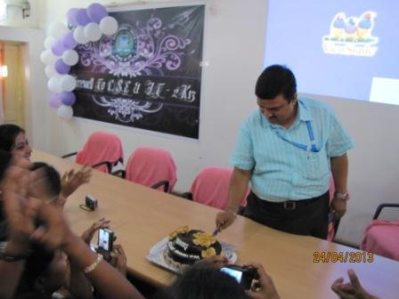 | 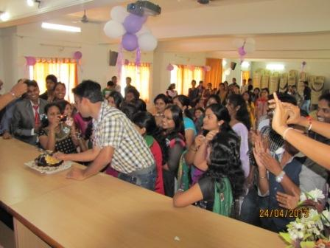

Mechanical Farewell Party....
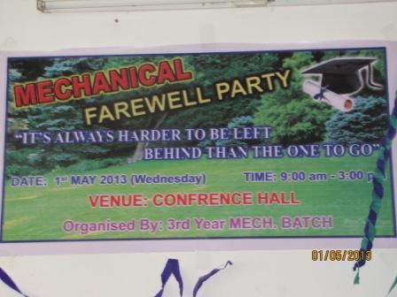 | 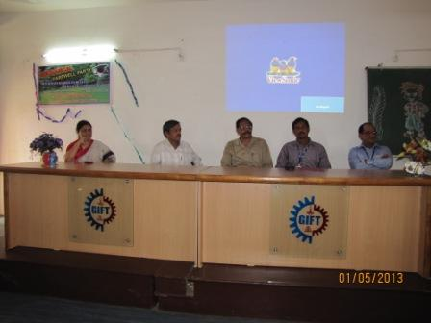
“It’s harder to be left behind than the one to go...”  With this beautiful quote, the students of 3rd yr Mechanical bade a memorable farewell to their seniors. The presence and speech of principal inspired all the students and boosted them as winners. The students present a memento to their seniors as a token of love and organized a sequence of events. Along with it Miss. and Mr. Mechanical was chosen by various stages of selection. The winners were Mr. Amit Kumar Saraf and Miss Tapaswani Chataria. | 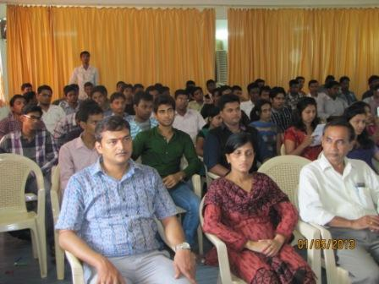
The students left no stone unturned in making the program a grand success. Of all the events, the best part was the convocation cap which made the seniors feel as successful engineers...it was a wonderful moment for both seniors and 3rd yr students. Lastly all the 3rd yr students and seniors danced together on music and made the farewell party a memory to cherish forever. | 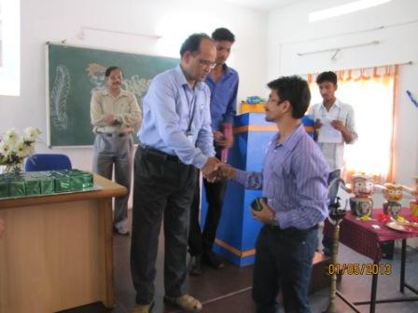
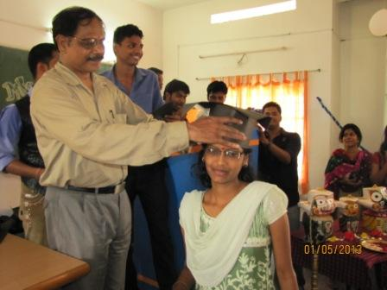 | 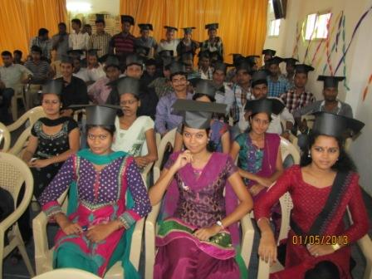
BEC Initiation Program:
In order to make the 2nd phase students of BEC acclimatized with the the curriculum, structure and pattern of BEC Prelim Exam, BEC Initiation Program was conducted in Conference Hall by Dept. of English under the supervision of . Prof B. K. Rout, Head Dept of English.
The program started at 8.00a.m. and continued up to 9.30 a.m. The program started with an inspiring speech by Dean Academics, who explained the importance of undertaking such a program.
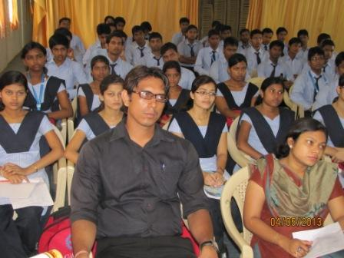 | 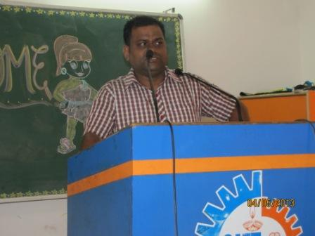
The importance of Effective Business communication especially in the context of a globalized market was reiterated. A Power Point presentation on the BEC Curriculum, structure, its exam pattern and the proposed training was shown to the students for their better grasping. A total of 112 students attended the training program.  The program concluded by showing the students a motivational video to encourage them and to bring out the best in them. | 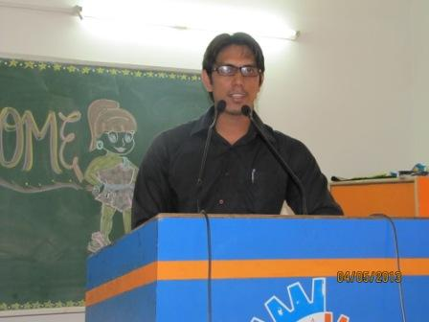
Follow “GIFT THIS WEEK” at:
➢www.facebook.com/giftthisweek
➢http://www.gift.edu.in/eMagazine.shtml
➢In your Email_ID (for students it is mailed to your GIFT domain mail_ID ie. xxxxxxxxx@gift.edu.in)
If you want to receive the weekly E-magazine then mail to giftthisweek@gift.edu.in.

These are the Professors and students who have contributed for the E-Magazine; their efforts helped us to publish this.
1) Prof B. K. Rout, Head Dept of English.
2) Mr Sanjaya Kumar Barik (Lab Asst., CSE)
3) Amit Saraf ( Mech. 4th Year)
4) Komal Johsi (CSE 3rd year)
5) Ankita Sinha(CSE 2nd yr)
6) Belal Ali khan (ECE 1st Yr.)

