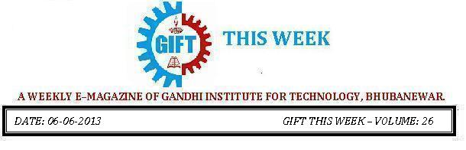

From the editor’s desk:

It gives me great pleasure today to share with you the 26th volume of “GIFT THIS WEEK”, the weekly e-magazine that aspires to attain new heights in the days ahead with your valuable suggestions.
Pranati Mishra.
Sr. Lect. (English Dept.)

Inauguration of Analog Electronics Workshop:
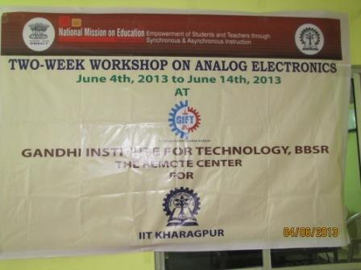 | 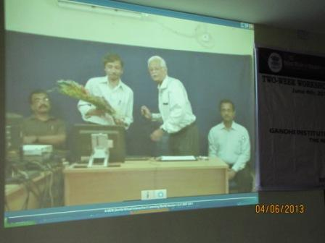
IIT Kharagpur has learned up with IIT Bombay in organizing a series of workshops, as a part of "Talk to 10,000 teachers" program. Under such Program A TWO-WEEK WORKSHOP ON ANALOG ELECTRONICS Sponsored by National Mission on Education through ICT (NMEICT) (MHRD, Govt. of India) has been Started at GIFT, The Remote center for IIT Kharagpur, from 4th June to 14th June 2013. The program was inaugurated at IIT Kharagpur and live telecasted through A-VIEW software. The participating teachers attend the live lectures delivered by IIT faculty at GIFT, using the AVIEW technology through internet.
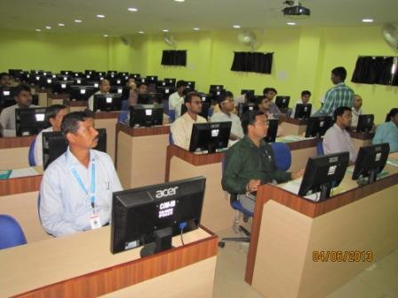 | 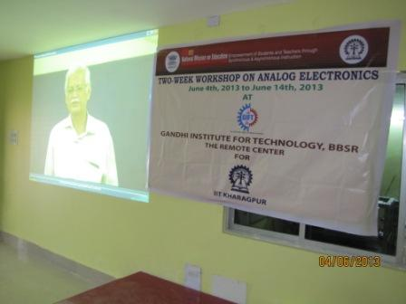
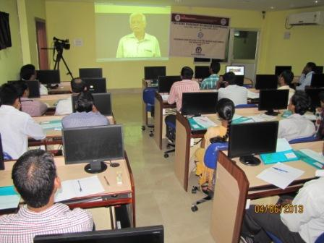 | 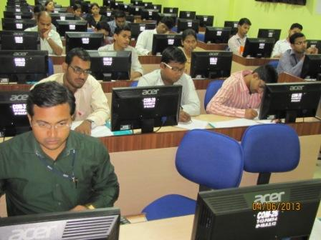
Follow “GIFT THIS WEEK” at:
➢www.facebook.com/giftthisweek
➢http://www.gift.edu.in/eMagazine.shtml
➢In your Email_ID (for students it is mailed to your GIFT domain mail_ID ie. xxxxxxxxx@gift.edu.in)
If you want to receive the weekly E-magazine then mail to giftthisweek@gift.edu.in.

These are the Professors and students who have contributed for the E-Magazine; their efforts helped us to publish this.
- Anup Sankar Sadangi, Asst.Prof. (ECE)
- Mr Sanjaya Kumar Barik (Lab Asst., CSE)
- Ankita Sinha(CSE 2nd yr)
- Belal Ali khan (ECE 1st Yr.)

