29th volume
Celebrating Independence, Going Green, NPTEL Works, Computer Literacy, Football Match, Field Training on Coir products.
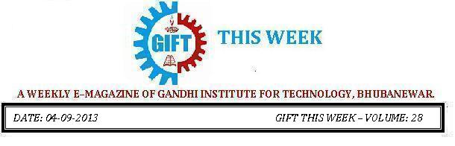

From the editor’s desk:

Here comes yet another Gift This Week and it gives me immense pleasure to present this 29th volume to you. We have begun our new session in a spirit of hope and new beginnings; pushing aside all grievances, we are striding off towards the emerging bright future of GIFT and our students.
We have been successfully publishing Gift This Week delivering the current goings-on of the college every week. This was made feasible only by your support and cooperation. We seek your suggestions and feedback for improvement. We encourage all of you to join us in effectively achieving betterment.
Thank You.
Pranati Mishra.
Sr. Lect. (English Dept.)

Celebrating Independence:
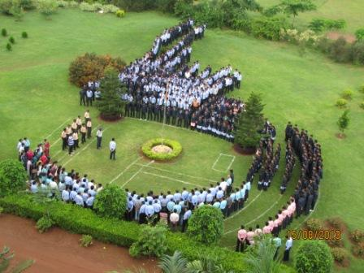 | 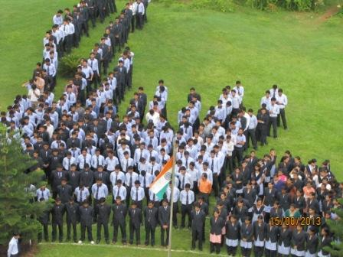
The 67th Independence Day was celebrated with the enthusiastic participation from the students, staff and Faculty Members on the very special day August 15.
While paying rich tributes to our Freedom Fighters who sacrificed their today for better tomorrow of all of us, it was indeed a proud moment for all the GIFTians present there to feel the spirit of independence.
Long Live Independence
On this occasion, our revered principal Dr. Trilochan Sahu in his welcome address linked the true spirit of freedom with development and prosperity of people of this country.
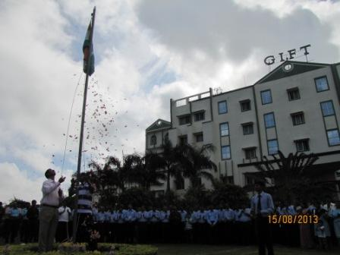 | 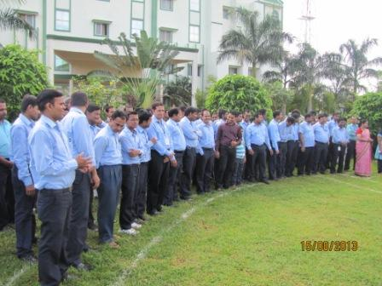

Going Green on Building front:
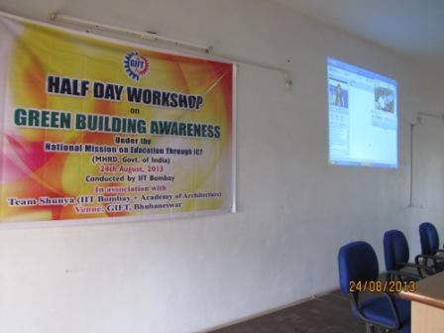 | 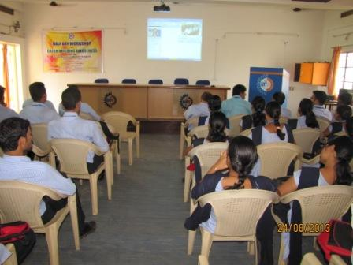
Green is the catchphrase today. Going eco-friendly is the ultimate answer for safety and longevity of our mother earth. Our buildings need to go Green Way.
A workshop on ‘Green Building Awareness’ for the students of Civil Engineering was held on 24th Aug’13. Under the National Mission of Education through ICT, IIT Mumbai conducted the workshop in association with Academics of Architecture. 60 students and Faculty Members attended it from different Departments.
Green Building Awareness workshop
Mr. Sourav Kumar Das from Department of Civil Engineering and Mr. Priyabrata Nayak from Computer Science Engineering coordinated the arrangements under the guidance of our Principal Dr. Trilochan Sahu.

Technology can enhance learning:
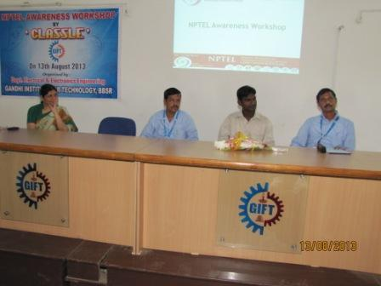 | 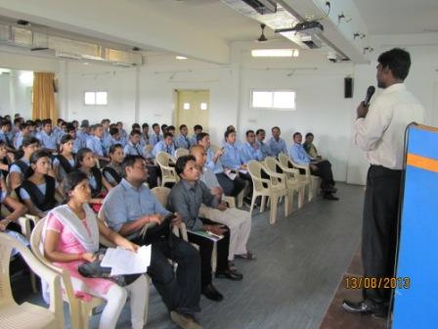
National Programme on Technology Enhanced Learning (NPTEL) in coordination with Classle Knowledge Pvt. Ltd conducted a one-day workshop for the students and Faculty Members of GIFT on 13th Aug 2013.

NPTEL Workshop

The objective of the workshop was to familiarize the audience to the ways of assessing NPTEL, in creating or supporting courses, ways of integrating NPTEL courses with existing teaching and obtain feedback on course quality and ways of improving NPTEL courses.
Helping in Computer Literacy:
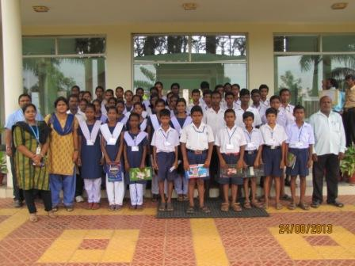 | 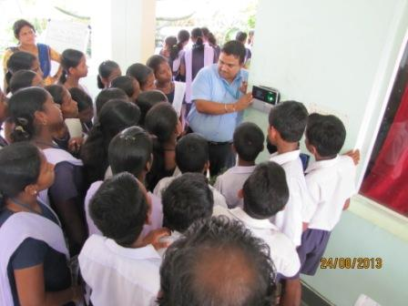
A Computer Literacy Programme for Students of Gramadiha High School students, located in the vicinity of our campus has been started since ------- with an objective to make the students convergent with digital education.
Extending a hand of support

The students in urban Odisha are better placed compared to their rural counterparts with access to modern technology. Its time to make the technology also reach the rural students.
GIFT students and Faculty Members joined hands to help these students of Gramadiha High School by empowering them with the much-needed technological intervention. It was encouraging to find 44 students showing interest and showing deep interest to learn.

Playing Football with Fun
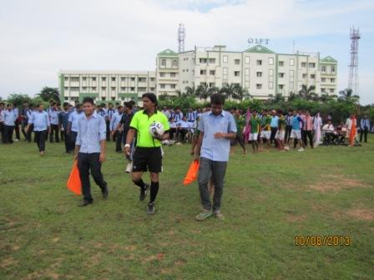 | 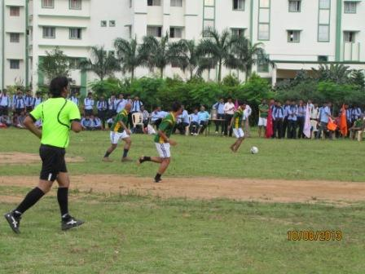
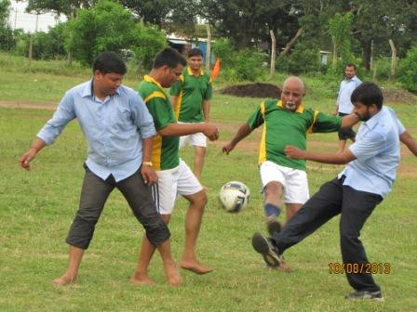 | 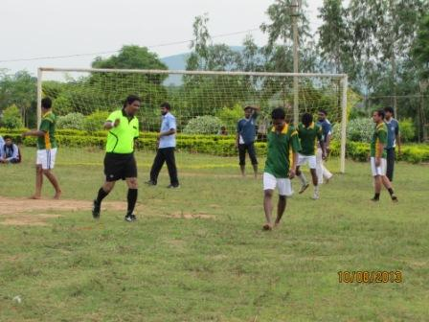
It was time for the GIFT family to witness the Football match between ‘Principal XI’ led by Prof. Satyajit Nayak and the ‘Dean XI’ led by Sri Tapan Ku. Panda on 10th August’13.
Dean XI beats Principal XI

All the staff members, teachers and students gathered to encourage the players of the two teams. ‘Dean XI’ won the enthralling match.

Field Training on Coir products:
Its economic empowerment of the women, which could really make them powerful may it be family or the community.
The programme “Field Training Centre on Coir Scheme" has a very clear objective- empower the women with capacity to earn.
Training programme on coir products trained women in nitty gritty of developing user-friendly coir products that people need for their day to day use.
Making resource and skill to reach the women through which they can positively contribute to their family income was the sole priority.
The programme also aims at to make these women the change agents of economic growth, social progress and sustainable development.
Let’s empower our women
District Industry Centre (DIC) in coordination with GIFT conducted this programme The eminent personalities whose presence was highly appreciated were
Mr. Anand Chandra Rath (General Manager, DIC), Mr. Biranchi Narayan Satpathy (Asst GM, DIC), Mr. Pratap Sethy (I.P.O, Jatni) and Mr. Umakanta Mishra (Coir Expert and Director of Industries).
Follow “GIFT THIS WEEK” at:
➢www.facebook.com/giftthisweek
➢http://www.gift.edu.in/eMagazine.shtml
➢In your Email_ID (for students it is mailed to your GIFT domain mail_ID ie. xxxxxxxxx@gift.edu.in)
If you want to receive the weekly E-magazine then mail to giftthisweek@gift.edu.in.

These are the Professors and students who have contributed for the E-Magazine; their efforts helped us to publish this.
- Mr. Iquebal Ahemad(System Admin., CSE)
- Mr Sanjaya Kumar Barik (Lab Asst., CSE)
- Ankita Sinha(CSE 2nd yr)

