E-Wave

(July 2018-19)

DEPARTMENTOF
ELECTRONICS & COMMUNICATION ENGINEERING
GIFT, BHUBANESWAR

DEPARTMENT OF

ELECTRONICS AND COMMUNICATION ENGINEERING

Electronics and Communication Engineering is one of the most upcoming areas of Research &Engineering among all other branches of engineering. As of today, Electronics and Communication Engineers are working in all spheres of modern industry. The goal of this course is to impart all-round technical education to the students to fulfil the requirements of new challenges of industries to solve the practical problems of our daily life, as well as to find new ways.

The Department of Electronics and Communication Engineering was established in the year 2007. The department has well equipped Labs and dedicated and ebullient faculties having vast experience in their respective fields. Industrial visits and practical projects are also encouraged by the department in various sectors.

Vision

To establish a conducive ambience for advancing and enriching the knowledge of electronics and communication engineering, through qualitative and holistic collaboration among students, faculties, PG Scholars, Domain experts from premier institutions and Research laboratories

Mission

To advance knowledge and educate in major paradigms of electronics and communication engineering, circuit design and signal processing and to create a distinctive culture of research and innovation among faculties and students, with an inherent focus on behavioural and communication aspects, so as to generate a pool of admirable quality of professionals and entrepreneurs with the ability to address
the industry and social problems.

Message from the Principal …

I am pleased to know that the Department of Electronics & Communication Engineering of Gandhi Institute For technology(GIFT),Bhubaneswar is bringing out its July 2018-19 issue of "E-wave" . I extend my best wishes on the occasion of the publication of the technical magazine. I hope this magazine will be a treasure for those associated with Electronics & Communication Engineering and will help in providing a platform for sharing experiences & learning in this area.

Dr, S. Krishna Mohan Rao

Message from the HoD…

I am proud to see that the students of our department have put in appreciable effort into creating the e-magazine, E-Wave. It is good to see that today’s generation has not lost its literary roots, despite the perpetual efforts of e-Technology to extinguish the flames of the written word. This e-magazine is an exceptional proof that the literary flame is burning bright. I look forward to seeing the juniors taking up the reigns of this e- magazine in future, so that this tradition remains eternal.

Prof. Saumendra Behera

From the Editor…

It gives me immense pleasure to announce the release of the July 2018-19 issue of E-Wave. The primary focus of this technical e- magazine is to empower our students with overall development. I am grateful to everyone involved in making this journey successful.

Prof.Monalisa Samal

“Successful and unsuccessful people do not vary greatly in their abilities. They vary in their desires to reach their potential.”

CONTENTS:

- Polymer memory
- Interferometry Modulator
- Zig-Bee Technology
- Adaptive Cruise Control
- Wireless USB
- Steganography
- Department Activities
- Gallery

POLYMER MEMORY

Imagine a time when your mobile will be your virtual assistant and will need far more than the 8k and 16k memory that it has today, or a world where laptops require gigabytes of memory because of the impact of convergence on the very nature of computing. How much space would your laptop need to carry all that memory capacity? Not much, if Intel's project with Thin Film Electronics ASA (TFE) of Sweden works according to plan. TFE's idea is to use polymer memory modules rather than silicon-based memory modules, and what's more it's going to use architecture that is quite different from silicon-based modules.
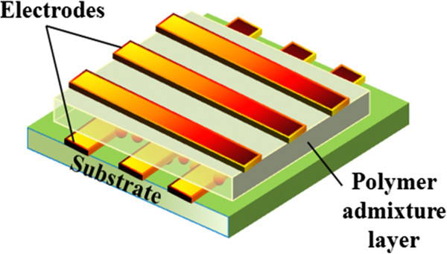
Polymer-based memory modules, as against silicon-based ones, promise to revolutionize the storage space and memory capabilities of chips. Coatue’s polymer memory cells are about one-quarter the size of conventional silicon cells. And unlike silicon devices, the polymer cells can be stacked that architecture could translate into memory chips with several times the storage capacity of flash memory.
The fundamental idea of all these technologies is the bistable nature possible for of the selected material which is due to their difference in behavior of internal dipoles when electric field is applied. And they retain those states until an electric field of opposite nature is applied. FeRAM works on the basis of the bistable nature of the centre atom of selected crystalline material. A voltage is applied upon the crystal which in turn polarizes the internal dipoles up or down. I.e. actually the difference between these states is the difference in conductivity. Non –Linear FeRAM read capacitor,
i.e., the crystal unit placed in between two electrodes will remain in the direction polarized(state) by the applied electric field until another field capable of polarizing the crystal’s central atom to another state is applied.
Saumendra Behera
H.O.D,ECE

INTERFEROMETRIC MODULATOR

Wireless communications are an essential and continuously expanding part of modern life. Smart phones presents a number of challenging requirements on the display module, such as low power consumption, video quality speed, and viewability in a broad range of lighting conditions.
The Interferometric Modulator (IMOD) is an electrically switched light modulator comprising a micro-machined cavity that is switched on and off using driver ICs similar to those used to address LCDs. An IMOD based reflective flat panel display can comprise hundreds of thousands of individually addressable IMOD elements. IMOD displays represent one of the largest examples of a micro electro mechanical systems (MEMS) based device. In one state an IMOD reflects light at a specific wavelength and gives pure, bright colors while in a second state it absorbs incident light and appears black to the viewer. As clear as an image on paper, IMOD displays can be viewed in any lighting condition including direct sunlight. Two to three times as bright as other technology
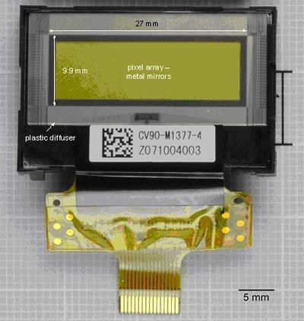
The IMOD displays minimize eye strain, and their wide viewing cones are free of the inversion effects that plague polarization-based displays. Qualcomm’s new media FLO technology will enable user to watch high performance video on portable device and applications such as this need a display offering superior viewability and less power consumption. The Qualcomm’s IMOD display technology will overcome all above mentioned requirements.

Jyostnammayee Behera
Assistant Professor,ECE

ZIGBEE TECHNOLOGY

ZigBee is the name of a specification for a suite of high level communication protocols using small, low-power digital radios. The technology is intended to be simpler and cheaper than other WPANs such as Bluetooth. The most capable ZigBee node type is said to require only about 10% of the software of a typical Bluetooth or Wireless Internet node. The estimated cost of the radio for a ZigBee node is about $1.10 to the manufacturer in very high volumes. Most ZigBee solutions require an additional microcontroller driving the price further up at this time. ZigBee is the newest and provides specifications for devices that have low data rates, consume very low power and are thus characterized by long battery life. Other standards like Bluetooth and IrDA address high data rate applications such as voice, video and LAN communications.
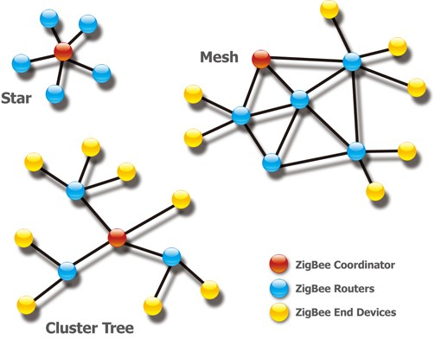
The target networks encompass a wide range of devices with low data rates in the Industrial, Scientific and Medical (ISM) radio bands, with building-automation controls like intruder/fire alarms, thermostats and remote (wireless) switches, video/audio remote controls likely to be the most popular applications. So far sensor and control devices have been marketed as proprietary items for want of a standard. With acceptance and implementation of ZigBee, interoperability will be enabled in multi-purpose, self- organizing mesh networks.Now picture a home with entertainment units, security systems including fire alarm, smoke detector and burglar alarm, air-conditioners and kitchen appliances all within whispering distance from each other and imagine a single unit that talks with all the devices, no longer depending on line-of-sight, and traffic no longer being one-way. This means that the devices and the control unit would all need a common standard to enable intelligible communication. ZigBee is such a standard for embedded application software.

Abanikanta Das
7th Semester,ECE

ADAPTIVE CRUISE CONTROL

An ‘Adaptive Cruise Control’ (ACC) system developed as the next generation assisted the driver to keep a safe distance from the vehicle in front. This system is now available only in some luxury cars like Mercedes S-class, Jaguar and Volvo trucks the U.S. Department of transportation and Japan’s ACAHSR have started developing ‘Intelligent Vehicles’ that can communicate with each other with the help of a system called ‘Co operative Adaptive Cruise Control’
PRINCIPLE OF ACC :ACC works by detecting the distance and speed of the vehicles ahead by using either a Lidar system or a Radar system. The time taken by the transmission and reception is the key of the distance measurement while the shift in frequency of the reflected beam by Doppler Effect is measured to know the speed. According to this, the brake and throttle controls are done to keep the vehicle the vehicle in a safe position with respect to the other. These systems are characterized by a moderately low level of brake and throttle authority. These are predominantly designed for highway applications with rather homogenous traffic behaviour.
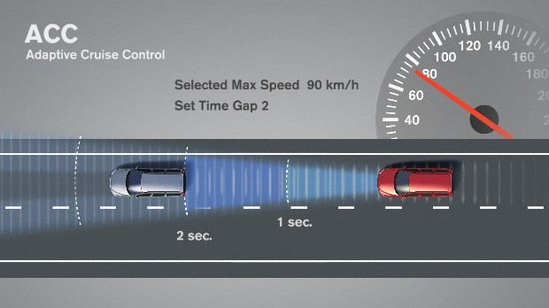
The second generation of ACC is the Stop and Go Cruise Control (SACC) whose objective is to offer the customer longitudinal support on cruise control at lower speeds down to zero velocity. The SACC can help a driver in situations where all lanes are occupied by vehicles or where it is not possible to set a constant speed or in a frequently stopped and congested traffic. There is a clear distinction between ACC and SACC with respect to stationary targets. The ACC philosophy is that it will be operated in well structured roads with an orderly traffic flow with speed of vehicles around 40km/hour. While SACC system should be able to deal with stationary targets because within its area of operation the system will encounter such objects very frequently.
Abhishek Majhi
5th Semester,ECE

WIRELESS USB

The Universal Serial Bus (USB), with one billion units in the installed base, is the most successful interface in PC history. Projections are for 3.5 billion interfaces shipped by 2006. Benefiting from exceptionally strong industry support from all market segments, USB continues to evolve as new technologies and products come to market. It is already the de facto interconnect for PCs, and has proliferated into consumer electronics (CE) and mobile devices as well.
The Wireless USB is the first the high speed Personal Wireless Interconnect. Wireless USB will build on the success of wired USB, bringing USB technology into the wireless future. Usage will be targeted at PCs and PC peripherals, consumer electronics and mobile devices. To maintain the same usage and architecture as wired USB, the Wireless USB specification is being defined as a high-speed host-to-device connection. This will enable an easy migration path for today€™s wired USB solutions.
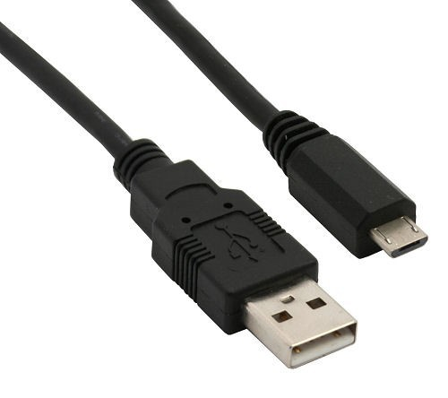
There are many new features included in the new Universal Serial Bus Specification. The most important one is the super speed data transfer itself. Then the USB 3.0 can support more devices than the currently using specification which is USB 2.0. The bus power spec has been increased so that a unit load is 150mA (+50% over minimum using USB 2.0). An un configured device can still draw only 1 unit load, but a configured device can draw up to 6 unit loads (900mA, an 80% increase over USB 2.0 at a registered maximum of 500mA). Minimum device operating voltage is dropped from 4.4V to 4V. When operating in Super Speed mode, full-duplex signaling occurs over 2 differential pairs separate from the non-Super Speed differential pair.

Sumouly Nandi
3rd Semester,ECE

STEGANOGRAPHY

Steganography is the art and science of communicating in a way which hides the the existence of the secret message communication. It aims to hide information /covered writing. Information to be protected is hidden in another data known as cover or carrier. Data containing hidden message are called as Steganos or Stegos. Steganos look like cover data and it is difficult to differentiate between them.
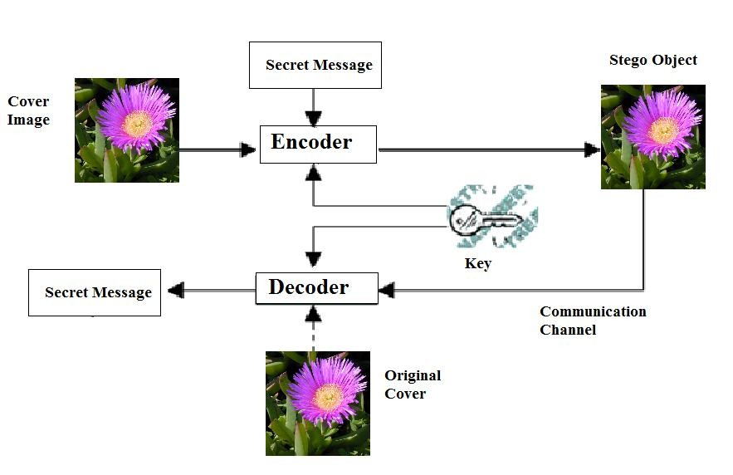
Steganography based communication over easily accessible platforms to prevent leakage of information.. Although related to cryptography, they are not the same. Steganography's intent is to hide the existence of the message, while cryptography scrambles a message so that it cannot be understood.
EVOLUTION OF STEGANOGRAPHY
CODE BREAKERS: David Kahn's The Code breakers and Bruce Norman’s Secret
WARFARE: The Battle of Codes and Ciphers recounts numerous tales of steganography.
INVISIBLE INK: An innocent letter may contain a very different message written between the lines with invisible ink. Common sources for invisible inks are milk, vinegar, fruit juices and urine. All of these darken when heated.
MICRODOTS: The Germans developed microdot technology. Microdots are photographs the size of a printed period having the clarity of standard-sized typewritten pages.

Pritisudha Dash
5th Semester,ECE

DEPARTMENT ACTIVITIES

Department of Electronics and Communication Engineering and All India Institute Of Medical Sciences
(AIIMS), Bhubaneswar jointly organized sensitization seminar on “MENTAL HEALTH OF YOUTH IN THE CHANGING WORLD” on 5/10/2018 from 2.00 P.M to 4PM at our Mini Conference Hall (Room No 309) .
This seminar was organized in connection with the World Mental Health Day.
The topics discussed in this seminar were the common mental health issues among youth, Substance use disorder and Gadget addiction .It was an informative seminar and the invited speakers for this seminar were

1. Dr. Biswa Ranjan Mishra, Associate Professor, Dept. of Psychiatry (AIIMS, BBSR)

2. Dr. Shri Mishra, Assistant Professor, Dept. of Psychiatry (AIIMS, BBSR)

3. Dr. Renju Sussan Baby, Associate Professor, College of Nursing (AIIMS, BBSR)

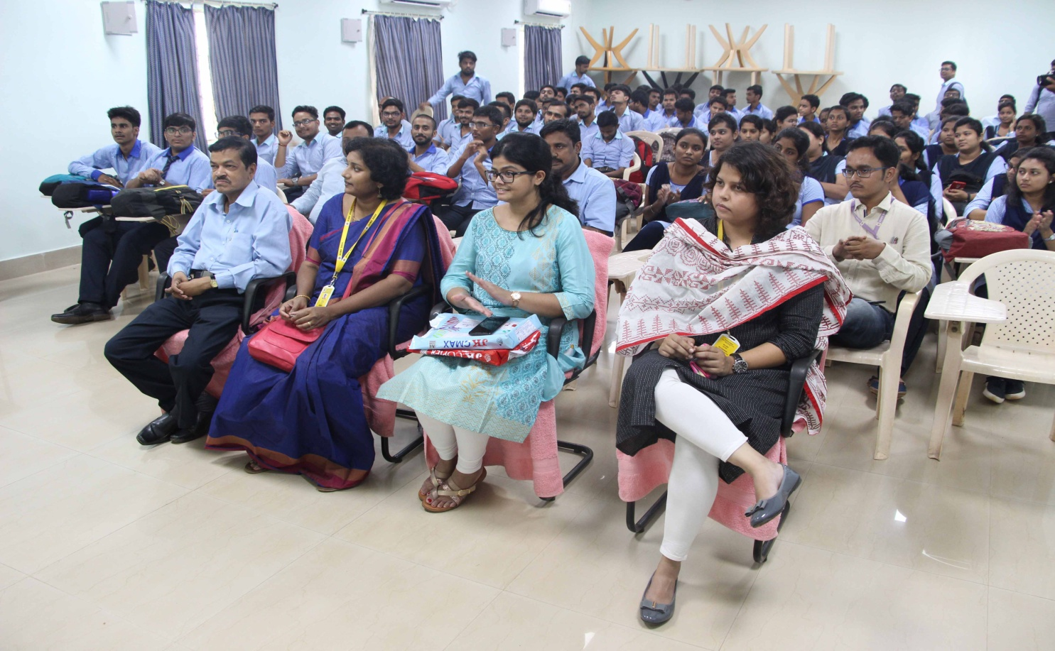

GALLERY

GALLERY

