E-Wave

(December 2018-19)

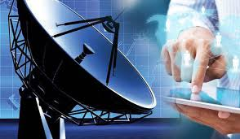

DEPARTMENTOF
ELECTRONICS & COMMUNICATION ENGINEERING
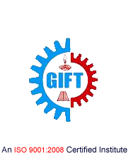
GIFT, BHUBANESWAR

DEPARTMENT OF

ELECTRONICS AND COMMUNICATION ENGINEERING

Electronics and Communication Engineering is one of the most upcoming areas of Research &Engineering among all other branches of engineering. As of today, Electronics and CommunicationEngineers are working in all spheres of modern industry. The goal of this course is to impart all-roundtechnical education to the students to fulfil the requirements of new challenges of industries to solve the practical problems of our daily life, as well as to find new ways.

The Department of Electronics and Communication Engineering was established in the year 2007 inGANDHI INSTITUTE FOR TECHNOLOGY (GIFT), Bhubaneswar. The department has well equipped Labs and dedicated and ebullient faculties having vast experience in their respective fields. Industrialvisits and practical projects are also encouraged by the department in various sectors.

Vision

To establish a conducive ambience for advancing and enriching the knowledge of electronicsand communication engineering, through qualitative and holistic collaboration amongstudents, faculties, PG Scholars, Domain experts from premier institutions andResearch laboratories

Mission

To advance knowledge and educate in major paradigms of electronics and communicationengineering, circuit design and signal processing and to create a distinctive culture ofresearch and innovation among faculties and students, with an inherent focus onbehavioural and communication aspects, so as to generate a pool of admirable quality ofprofessionals and entrepreneurs with the ability to address
the industry and social problems.

Message from the Principal …

It truly is a matter of deep pride and elation for me to learn that the students of the Electronics and Communication Engineering Department have produced the Dec 2018-19edition of this technically magnificence known as “E-Wave”. This magazine has succeeded in its endeavors to keep the students well informedabout the innovation of the ever transient field of technology. Our students have proved that the literary prowess can go hand in hand with technical mastery, thus enabling accomplishment of the GIFT goal of all round development of a student.I hope that students would continue to keep the brilliant torch of E-Waveburning bright in the future as well.

Dr, S. Krishna Mohan Rao

Message from the HoD…

It is a matter of great pleasure for me to go through the wonderful contributions made by the students. This magazine is intended to bring out the hidden talents in the students and the teachers and to inculcate leadership skills among them.I wish all the students and faculties involved all the success.

Prof. SaumendraBehera

From the Editor…

This magazine provides a platform for students and staff to share information, spread the latest technical knowledge and cultivate right ways that will equip all of us to stay competent in our respective fields of study and research. I congratulate and thank all the students and staff coordinators who have made untiring efforts to bring out this magazine.

Prof.Monalisa Samal

“ Failure Will Never Overtake Me If My Determination To Succeed Is Strong Enough”

CONTENTS:

- Satrack
- IP Telephony
- Graphics Processing Unit
- Digital Signature
- Digital Light Processing
- Direct Memory Access
- Department Activities
- Gallery

SATRACK
SATRACK deals with the measurement concept that tests the missile accuracy. SATRACK receives, rebroadcast, records and tracks the satellite signals sent by the GPS signals. The reception and rebroadcast of the signals is done by a missile hardware called the GPS translator. The ground telemetry stations consist of the RF antenna and recorders for the data. Post-flight processing and modelling are done later at the SATRACK Facility. Also the major error contributors to the missile flight are determined by the modelling done. There is extensive use of simulated signals in this method. This seminar also throws light on the major breakthrough technologies that were developed during the research leading up to the final form of this technology.
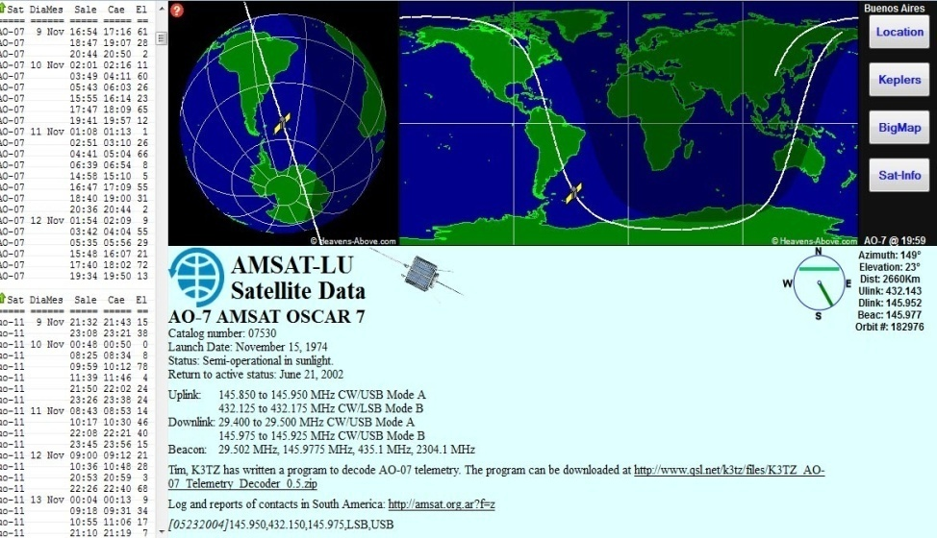
According to the dictionary guidance is the ‘process of guiding the path of an object towards a given point, which in general may be moving’. The process of guidance is based on the position and velocity if the target relative to the guided object. The present day ballistic missiles are all guided using the global positioning system or GPS.GPS uses satellites as instruments for sending signals to the missile during flight and to guide it to the target. SATRACK is a system that was developed to provide an evaluation methodology for the guidance system of the ballistic missiles.
This was developed as a comprehensive test and evaluation program to validate the integrated weapons system design for nuclear powered submarines launched ballistic missiles .This is based on the tracking signals received at the missile from the GPS satellites. SATRACK has the ability to receive record, rebroadcast and track the satellite signals.
Monalisa Samal
Assistant Professor,ECE

IP TELEPHONY

If you've never heard of Internet Telephony, get ready to change the way you think about long-distance phone calls. Internet Telephony, or Voice over Internet Protocol, is a method for taking analog audio signals, like the kind you hear when you talk on the phone, and turning them into digital data that can be transmitted over the Internet. How is this useful? Internet Telephony can turn a standard Internet connection into a way to place free phone calls.
The practical upshot of this is that by using some of the free Internet Telephony software that is available to make Internet phone calls, you are bypassing the phone company (and its charges) entirely. Internet Telephony is a revolutionary technology that has the potential to completely rework the world's phone systems. Internet Telephony providers like Vonage have already been around for a little while and are growing steadily. Major carriers like AT&T are already setting up Internet Telephony calling plans in several markets around the United States, and the FCC is looking seriously at the potential ramifications of Internet Telephony service.
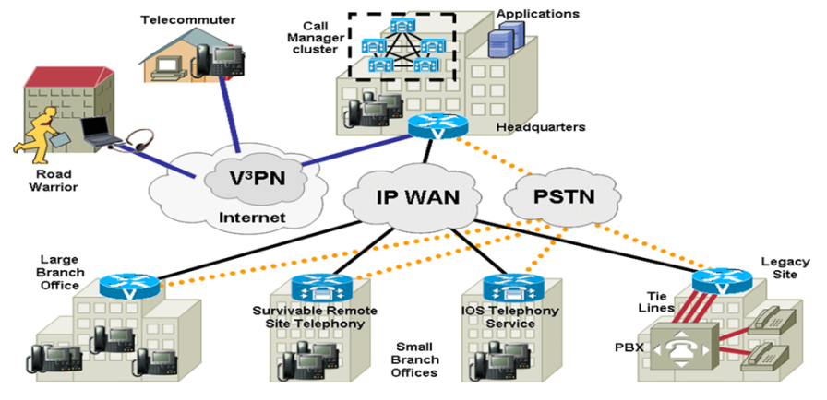
The main motivation of development of IP Telephony is the cost saving & integrat ing new services. Internet telephony integrates a variety of services Vocaltec introduced the first Internet telephony software product in early 1995, running a multimedia PC, the Vocaltec Internet Phone. In 1996, Vocaltec announced it was working with an Intel Company (Dialogic Corporation, an Intel acquisition made in 1999) to produce the first IP telephony gateway. The technology has improved to that point where conversations are easily possible. Gateways are the key to bringing IP telephony into the mainstream. By bridging the traditional circuit-switched telephony world with the Internet. Internet telephony technology has caught the world's attention.
Manas Ranjan Sethi
Assistant Professor,ECE

GRAPHICS PROCESSING UNIT

There are various applications that require a 3D world to be simulated as realistically as possible on a computer screen. These include 3D animations in games, movies and other real world simulations. It takes a lot of computing power to represent a 3D world due to the great amount of information that must be used to generate a realistic 3D world and the complex mathematical operations that must be used to project this 3D world onto a computer screen. In this situation, the processing time and bandwidth are at a premium due to large amounts of both computation and data.The functional purpose of a GPU then, is to provide a separate dedicated graphics resources, including a graphics processor and memory, to relieve some of the burden off of the main system resources, namely the Central Processing Unit, Main Memory, and the System Bus, which would otherwise get saturated with graphical operations and I/O requests. The abstract goal of a GPU, however, is to enable a representation of a 3D world as realistically as possible. So these GPUs are designed to provide additional computational power that is customized specifically to perform these 3D tasks.
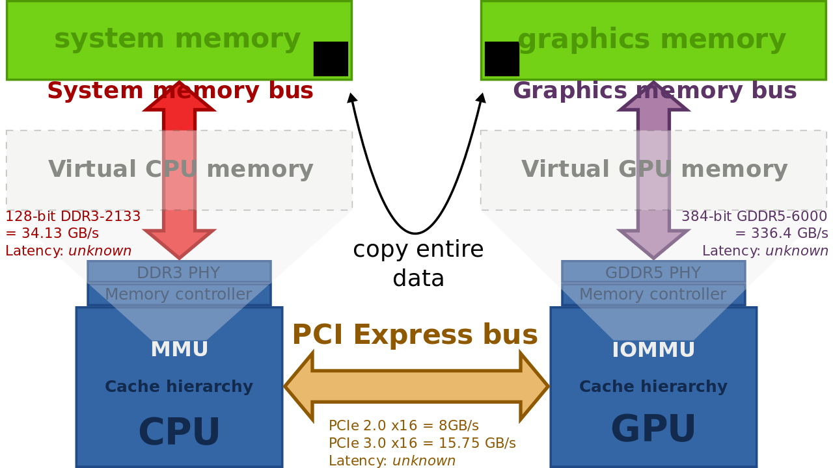

A Graphics Processing Unit (GPU) is a microprocessor that has been designed specifically for the processing of 3D graphics. The processor is built with integrated transform, lighting, triangle setup/clipping, and rendering engines, capable of handling millions of math-intensive processes per second. GPUs form the heart of modern graphics cards, relieving the CPU (central processing units) of much of the graphics processing load.

Annanya Tripathy
7th Semester,ECE

DIGITAL SIGNATURE
The authenticity of many legal, financial, and other documents is determined by the presence or absence of an authorized handwritten signature. The recipient of the signed document can verify the claimed identity of the sender using the signature. Also, if the sender later repudiates the contents of the document, then recipient can use the signature to prove the validity of the document.
With the computerized message systems replacing the physical transport of paper and ink documents, an effective solution for authentication of the electronic data is necessary. Various methods have been devised to solve this problem, but the use of ‘digital signature’ is definitely the best solution amongst them.
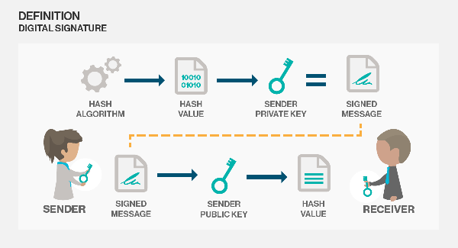
A digital signature is nothing but an attachment to any piece of electronic information, which represents the content of the document and the identity of the originator of that document uniquely. The digital signature is intended for use in electronic mail, electronic funds transfer, electronic data interchange, software distribution, data storage, and other applications which require data integrity assurance and data origin authentication.
When a message is received, the recipient may desire to verify that the message has not been altered in transit. Furthermore, the recipient may wish to be certain of the originator's identity. Both of these services can be provided by the digital signature. Digital signatures may also be generated for stored data and programs so that the integrity of the data and programs may be verified at any later time.
Basically, the idea behind digital signatures is the same as your handwritten signature. You use it to authenticate the fact that you promised something that you can't take back laterA digital signature is an electronic signature to be used in all imaginable type of electronic transfer. Digital signature significantly differs from other electronic signatures in term of process and results. These differences make digital signature more serviceable for legal purposes.
Md.Aftab Alam
5th Semester,ECE

DIGITAL LIGHT PROCESSING
Digital Light Processing is the one of primary display technologies driving this rapid growth and maturation .it is a revolutionary way to project and display information based on the Digital Micro Mirror Device (DMD) Digital Light processing was invented in 1987 by Texas Instruments it creates the final link to display digital visual information.
Digital Light Processing creates deeper blacks, conveys fast moving images very well and uses a single, replaceable, white -light bulb . it is available in both front-and rear-projection models DLP is an excellent choice for people who watch a lot of sports or fast-action movies because of the speed at which it creates an image.
A Digital Micro Mirror Divice chip is the heart of Digital Light Processing projector, DMD can be described simply as a semiconductor light switch. The micro mirrors are mounted on the DMD chip and it tilts in response to an electrical signal. The tilt directs light toward the screen, or into a "light trap" that eliminates unwanted light when reproducing blacks and shadows. Other elements of a DLP projector include a light source, a colour filter system, a cooling system, illumination and projection optics.
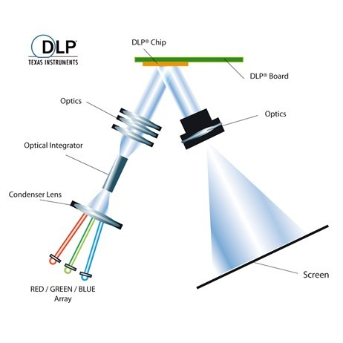
A DLP based projector system includes memory and signal processing to support a fully digital approach. Depending on the application, a DLP system will accept either a digital or analog signal. Analog signals are converted into digital in the DLPs front –end processing. Any interlaced video signal is converted into an entire picture frame video signal through interpolative processing. The signal goes through DLP video processing and becomes progressive Red (R), Green (G) and Blue (B) data. The progressive RGB data is then formatted into entire binary bit planes of data.

Megha Shukla
5th Semester,ECE

DIRECT MEMORY ACCESS
Direct memory access (DMA) facilitates the maximum data transfer rate and microprocessor concurrence. Unlike programmed or interrupt controlled I/O, where data is transferred via the microprocessor and its internal registers, DMA (as its name implies) transfers data directly between an I/O device and memory (memory to memory DMA transfers are also possible). Whichever CPU is being used, it must have a DMA feature to determine when DMA is required, so that it can relinquish control of the address and data buses, as well as the control lines required to read and write to memory. In addition, the CPU must inform the I/O device that requires the DMA data transfer when it again requires control of the address and data buses and I/O control lines. Further to this, a separate DMA controller is required to actually perform the DMA I/O operations.
The transfer of data between a fast storage device such as magnetic disk and memory is often limited by the speed of the CPU. Removing the CPU from the path and letting the peripheral device manage the memory buses directly would improve the speed of transfer .this transfer technique is called Direct memory access(DMA).During DMA transfer the CPU is idle and has no control of the memory buses. A DMA controller takes over the buses to manage the transfer directly between the IO device and memory.
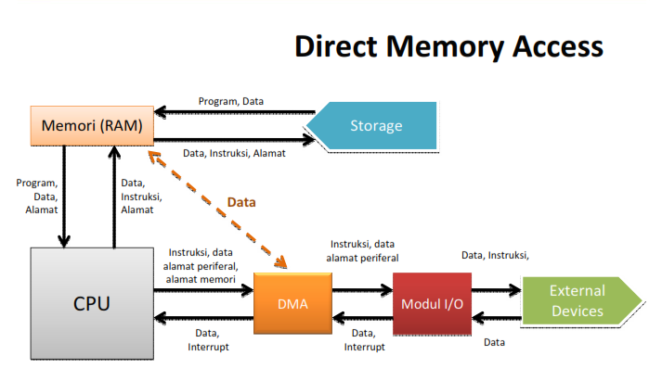
The process of DMA is handled by a DMA chip and it can be considered as a primitive secondary processor whose job is to relieve the main processor of much of the burden of memory transfers between memory and I/O Devices. The DMA chip was originally an Intel 8237 device. There are three possible ways that the 8237 can transfer data - I/O to Memory, Memory to I/O and Memory to Memory.

Bharti Kumari
3rd Semester,ECE

DEPARTMENT ACTIVITIES

Department of Electronics and Communnicatio Engineering organised a Two day Faculty Development Programme on “ Antenna Basics and HFSS software” for ECE Faculties on 29th and 30th December 2018 in mini conference hall(309) from 10:30-1:00pm and Labs in room no.505 from 2:00-4:15pm.
Dr.Sanjeev Kumar Mishra(IIIT,Bhubaneswar) was the key-note speaker He took a theory session on Antenna basics,followed by hand on session .
The programme was very interesting and helped the faculties to become familiar with a new software HFSS.

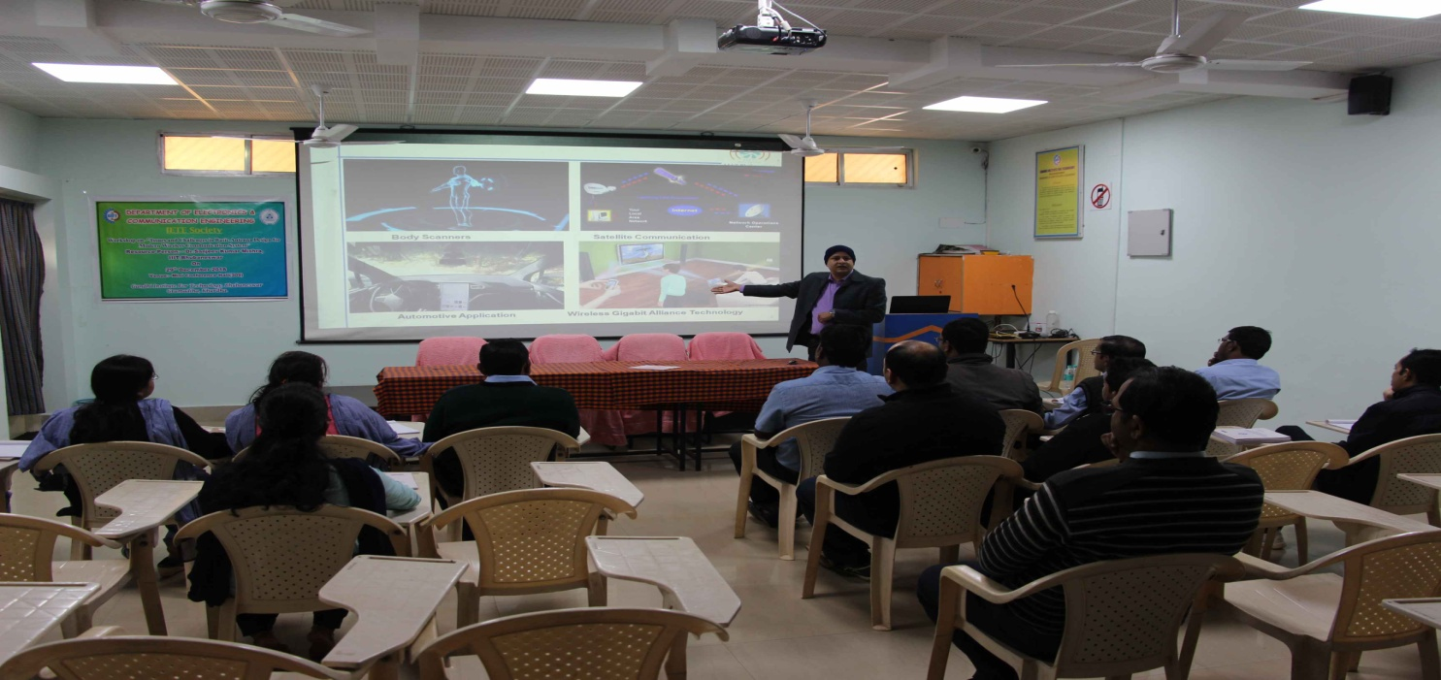
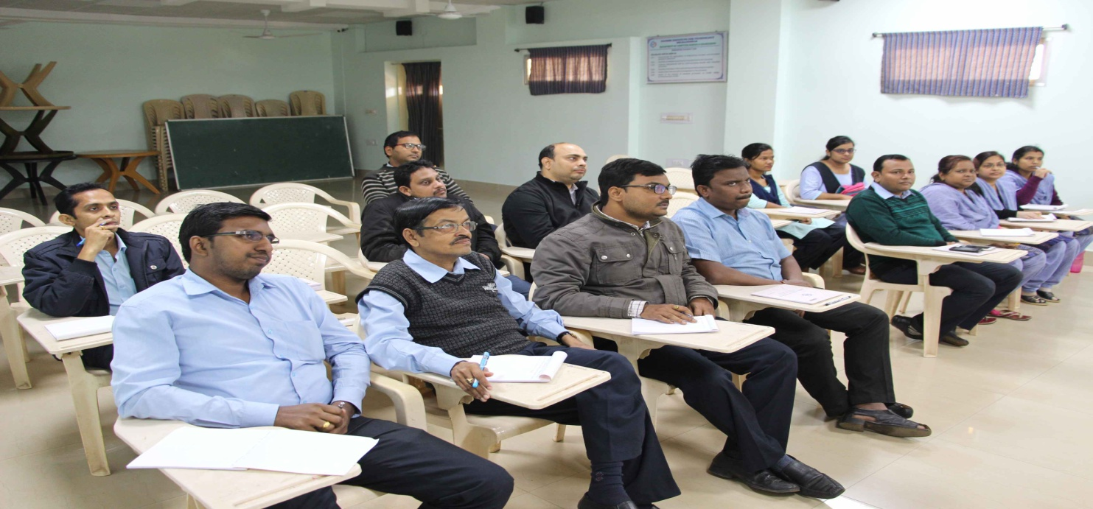

GALLERY

