E-Wave

(July 2019-20)

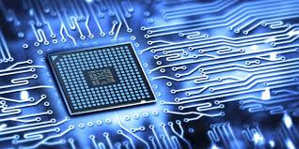

DEPARTMENTOF
ELECTRONICS & COMMUNICATION ENGINEERING
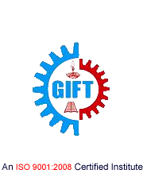
GIFT, BHUBANESWAR

DEPARTMENT OF

ELECTRONICS AND COMMUNICATION ENGINEERING

Electronics and Communication Engineering is one of the most upcoming areas of Research &Engineering among all other branches of engineering. As of today, Electronics and CommunicationEngineers are working in all spheres of modern industry. The goal of this course is to impart all-roundtechnical education to the students to fulfil the requirements of new challenges of industries to solve the practical problems of our daily life, as well as to find new ways.

The Department of Electronics and Communication Engineering was established in the year 2007 inGANDHI INSTITUTE FOR TECHNOLOGY (GIFT), Bhubaneswar. The department has well equipped Labs and dedicated and ebullient faculties having vast experience in their respective fields. Industrialvisits and practical projects are also encouraged by the department in various sectors.

Vision

To establish a conducive ambience for advancing and enriching the knowledge of electronicsand communication engineering, through qualitative and holistic collaboration amongstudents, faculties, PG Scholars, Domain experts from premier institutions andResearch laboratories

Mission

To advance knowledge and educate in major paradigms of electronics and communicationengineering, circuit design and signal processing and to create a distinctive culture ofresearch and innovation among faculties and students, with an inherent focus onbehavioural and communication aspects, so as to generate a pool of admirable quality ofprofessionals and entrepreneurs with the ability to address
the industry and social problems.

Message from the Principal …

I am quite pleased to learn about the forthcoming issue of the Department magazine of ECE, ‘E-Wave’. No doubt this creative endeavor will bring out an array of artistic and scientific expressions with distinct individual signatures.

Dr, S. Krishna Mohan Rao

Message from the HoD…

Nurturing creativity and inspiring innovation are two of the key elements of a successful education, and E-Wave is the perfect amalgamation of both. It harnesses the creative energies of the academic community, and distils the essence of their inspired imagination in the most brilliant way possible.I take this opportunity to congratulate the editorial board for bringing out the July209-20 edition of the magazine.

Prof. SaumendraBehera

From the Editor…

This magazine is a platform that exhibits the literary skills and innovative ideas of teachers and students. “E-Wave” presents the hard work and dedication of students and contributions of teachers. I would like to thank all my editorial team members for helping me pull this through. I express my considerable appreciation to all the authors of the articles in this magazine. These contributions have required a generous amount of time and effort. It is this willingness to share knowledge, concerns and special insights with fellow beings that has made this magazine possible.

Prof.Monalisa Samal

“The Pessimist Sees Difficulty In Every Opportunity. The Optimist Sees Opportunity In Every Difficulty.”

CONTENTS:

- Microelectronic Pill
- Biochip
- X-Max Technology
- Optical Coherence Tomography
- Global Systems for Mobile Communication
- Mobile Phone Cloning
- Department Activities
- Gallery

MICROELECTRONIC PILL

The invention of transistor enabled the first use of radiometry capsules, which used simple circuits for the internal study of the gastro-intestinal (GI) tract. They couldn’t be used as they could transmit only from a single channel and also due to the size of the components. They also suffered from poor reliability, low sensitivity and short lifetimes of the devices. This led to the application of single-channel telemetry capsules for the detection of disease and abnormalities in the GI tract where
restricted area prevented the use of traditional endoscopy.
They were later modified as they had the disadvantage of using laboratory type sensors such as the glass pH electrodes, resistance thermometers, etc. They were also of very large size. The later modification is similar to the above instrument but is smaller in size due to the application of existing semiconductor fabrication technologies. These technologies led to the formation of Microelectronic Pill”.Microelectronic pill is basically a multichannel sensor used for remote biomedical measurements using micro technology. This is used for the real-time measurement parameters such as temperature, pH, conductivity and dissolved oxygen. The sensors are fabricated using electron beam and photolithographic pattern integration and were controlled by an application specific integrated circuit (ASIC).
An array consisting of both temperature sensor & pH sensor platforms were cut from the wafer & attached onto 100-µm- thick glass cover slip cured on a hot plate. The plate acts as a temporary carrier to assist handling of the device during level 1 of lithography when the electric connections tracks, electrodes bonding pads are defined. Bonding pads provide electrical contact to the external electronic circuit.
Lithography was the first fundamentally new printing technology since the invention of relief printing in the fifteenth century. It is a mechanical Plano graphic process in which the printing and non-printing areas of the plate are all at the same level, as opposed to intaglio and relief processes in which the design is cut into the printing block. Lithography is based on the chemical repellence of oil and water. Designs are drawn or painted with greasy ink or crayons on specially prepared limestone. The stone is moistened with water, which the stone accepts in areas not covered by the crayon. Oily ink, applied with a roller, adheres only to the drawing and is repelled by the wet parts of the stone. Pressing paper
against the inked drawing then makes the print.
Robin Abraham
Assistant Professor,ECE

BIOCHIP

A biochip is a collection of miniaturized test sites (micro arrays) arranged on a solid substrate that permits many tests to be performed at the same time in order to get higher throughput and speed. Typically, a biochip’s surface area is not longer than a fingernail. Like a computer chip that can perform millions of mathematical operation in one second, a biochip can perform thousands of biological operations, such as decoding genes, in a few seconds.
A genetic biochip is designed to “freeze” into place the structures of many short strands of DNA (deoxyribonucleic acid), the basic chemical instruction that determines the characteristics of an organism. Effectively, it is used as a kind of “test tube” for real chemical samples.
A specifically designed microscope can determine where the sample hybridized with DNA strands in the biochip. Biochips helped to dramatically increase the speed of the identification of the estimated 80,000 genes in human DNA, in the world wide research collaboration known as the Human Genome Project. The microchip is described as a sort of “word search” function that can quickly sequence DNA.
STRUCTURE AND WORKING OF AN ALREADY IMPLANTED SYSTEM
The biochip implants system consists of two components: a transponder and a reader or scanner. The transponder is the actual biochip implant. The biochip system is radio frequency identification (RFID) system, using low-frequency radio signals to communicate between the biochip and reader. The reading range or activation range, between reader and biochip is small, normally between 2 and 12 inches.
The transponder is the actual biochip implant. It is a passive transponder, meaning it contains no battery or energy of its own. In comparison, an active transponder would provide its own energy source, normally a small battery. Because the passive contains no battery, or nothing to wear out, it has a very long life up to 99 years, and no maintenance. Being passive, it is inactive until the reader activates it by sending it a low-power electrical charge. The reader reads or scans the implanted biochip and receives back data (in this case an identification number) from the biochips. The communication between biochip and reader is via low-frequency radio waves. Since the communication is via very low frequency radio waves it is not
at all harmful to the human body.

Manas Ranjan Sethi
Assistant Professor,ECE

X-MAX TECHNOLOGY

XMax is a fixed and mobile wireless broadband system that includes a complete product line of high-performance access points, fixed and mobile personal WiFi hotspots, mobile switching centers (MSC) as well as network management and deployment tools. xG’s unique and patented protocol outperforms WiFi, WiMax and traditional cellular technologies like LTE in shared and interference prone radio bands. The xMax over the air waveform has been specifically designed for use in a deterministic (i.e. fixed low latency) cognitive radio network. This waveform, in conjunction with its purpose built Media Access Control (MAC) layer, offers capabilities and performance not found in other wireless solutions.
xMax is an end-to-end Internet Protocol (IP) network solution that incorporates xG’s patented cognitive radio technologies to deliver the first fully mobile VoIP and broadband network that also supports any smartphone, laptop, tablet and other commercial WiFi or IP-enabled devices via its xMod personal hotspot – while offering an excellent quality of service (QoS) and fixed, low latency.
xMax is designed to prioritize voice by delivering dedicated timeslots and bandwidth to every user. This approach guarantees a minimal and fixed latency for every call, which is an essential factor for any high Quality of Service (QoS) mobile VoIP system. This is in contrast to technologies like Wi-Fi and WiMAX, both of which are contention-based "best effort" delivery systems that are limited by scalability constraints.
Flexible Architecture Enhances and Extends Today’s Services.The primary consideration in the network architecture design of the xMax system is to achieve the goal of providing robust, scalable, and full-featured voice and data services to fixed and mobile subscribers at a fraction of the cost of traditional approaches. The system uses a proprietary over the air waveform that has been optimized for our sensing-based cognitive radio. While based on Orthogonal Frequency-Division Multiplexing (OFDM), xG’s unique and patented protocol outperforms WiFi, WiMax and traditional cellular technologies like LTE in shared and interference prone radio bands.
In addition to its proprietary and highly optimized over the air protocol, xMax offers several unique and valuable capabilities not found in other cognitive (and traditional) radio networks. These include its all-IP (Internet Protocol) architecture, as well as its support of commercial smartphones, laptops, tablets and other WiFi and Ethernet capable Internet appliances via the xMod personal hotspot.

Alisha Mahapatra
7th Semester,ECE

OPTICAL COHERENCE TOMOGRAPHY

Optical coherence tomography (OCT) is an emerging technology for performing high-resolution cross-sectional imaging.OCT can provide cross-sectional images of tissue structure on the micron scale in situ and in real time. Using OCT in combination with catheters and endoscopes enables high- resolution intraluminal imaging of organ systems.
OCT can function as a type of optical biopsy and is a powerful imaging technology for medical diagnostics because unlike conventional histopathology which requires removal of a tissue specimen and processing for microscopic examination, OCT can provide images of tissue in situ and in real time. OCT can be used where standard excisional biopsy is hazardous or impossible, to reduce sampling errors associated with excisional biopsy, and to guide interventional procedures..
Optical coherence tomography (OCT) is a fundamentally new type of optical imaging modality. OCT performs high-resolution, cross-sectional tomographic imaging of the internal microstructure in materials and biologic systems by measuring backscattered or backreflected light. OCT images are two-dimensional data sets which represent the optical backscattering in a cross-sectional plane through the tissue. Image resolutions of 1 to 15 µm can be achieved one to two orders of magnitude higher than conventional ultrasound. Imaging can be performed in situ and in real time. The unique features of this technology enable a broad range of research and clinical applications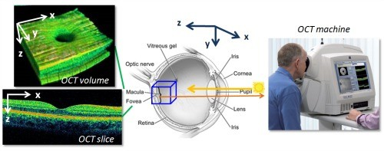
OCT enables the noncontact, noninvasive imaging of the anterior eye as well as imaging of morphologic features of the human retina including the fovea and optic disc. Working in collaboration with the New England Eye Center, our group has examined over 10,000 patients to date. The technology was transferred to industry and introduced commercially for ophthalmic diagnostics in 1996 (Humphrey Systems, Dublin, CA). Numerous clinical studies have been performed by many groups in the last several years.
Prangya Paramita Swain
5th Semester,ECE

GLOBAL SYSTEM FOR MOBILE COMMUNICATIONS

GSM (Global System for Mobile Communications, originally Groupe Spécial Mobile), is a standard developed by the European Telecommunications Standards Institute (ETSI) to describe protocols for second-generation (2G) digital cellular networks used by mobile phones. GSM - User Services
GSM has much more to offer than voice telephony. Additional services allow you greater flexibility in where and when you use your phone. You should contact your local GSM network operator for information on the specific services available to you.
But there are three basic types of services offered through GSM which you can ask for:
- Telephony (also referred to as teleservices) Services
Voice Calls
Videotext and Facsmile:
Short Text Messages:
- Bearer Services or Data Services
Using your GSM phone to receive and send data is the essential building block leading to widespread mobile Internet access and mobile data transfer. GSM currently has a data transfer rate of 9.6k. New developments that will push up data transfer rates for GSM users are HSCSD (high speed circuit switched data) and GPRS (general packet radio service) are now available.
- Supplementary Services
Supplementary services are provided on top of teleservices or bearer services, and include features such as caller identification, call forwarding, call waiting, multi-party conversations, and barring of outgoing (international) calls, among others.

Aishwarya Sahoo
3rd Semester,ECE

MOBILE PHONE CLONING

Mobile communication has been readily available for several years, and is major business today. It provides a valuable service to its users who are willing to pay a considerable premium over a fixed line phone, to be able to walk and talk freely. Because of its usefulness and the money involved in the business, it is subject to fraud. Unfortunately, the advance of security standards has not kept pace with the dissemination of mobile communication.
Some of the features of mobile communication make it an alluring target for criminals. It is a relatively new invention, so not all people are quite familiar with its possibilities, in good or in bad. Its newness also means intense competition among mobile phone service providers as they are attracting customers. The major threat to mobile phone is from cloning.Cell phone cloning refers to the act of copying the identity of one mobile telephone to another.This is usually done to make fraudulent telephone calls. The bill for the calls go to the legitimate subscriber. This made cloning very popular in areas with large immigrant populations, where the cost to “call home” was very steep. The cloner is also able to make effectively anonymous calls, which attracts another group of interested law breakers.
Cell phone cloning started with Motorola “bag” phones and reached its peak in the mid 90’s with a commonly available modification for Motorola “brick” phones such as the Classic, the Ultra Classic, and the Model 8000.Cloning involved modifying or replacing the EPROM in the phone with a new chip, which would allow one to configure an ESN (Electronic Serial Number) via software. The MIN (Mobile Identification Number) would also have to be changed.
Cloning still works under the AMPS/NAMPS system, but has fallen in popularity as older phones that can be cloned are more difficult to find and newer phones have not been successfully reverse engineered.Cloning has been successfully demonstrated under GSM, but the process is not easy and currently remains in the realm of serious hobbyists and researchers. Furthermore, cloning as a means of escaping the law is difficult because of the additional feature of a radio fingerprint that is present in every mobile phone’s transmission signal.

Ashim Bisayee
7th Semester,ECE

DEPARTMENT ACTIVITIES

Department of Electronics and Communication Engineering organised a one week AICTE sponsored STTP : Faculty Development Programme (FDP), from 1st July to 6th July, 2019, on “Orientation of Newly Admitted Students”. 1st to 6th July 2019 at Gandhi Institute For Technology (GIFT),Mini Conference Hall,Room No 309
Sl.No. | Name of Resource Person | Institution/Industry/University | Topics Covered
1 | Dr.TrilochanSahu | Principal,Govt.EngineeringCollege,Keonjhar | Initial Phase:Induction Program
2 | Dr.Amiya Kumar Rath | NAAC Advisor,Bangalore | Lecture by Eminent People
3 | Dr.Sanjib Kumar Pattnaik | Ex-Director AICTE | Lecture by Eminent People
4 | Sri ChinmayanandaPadhy | Entrepreneur | Innovation:How to motivate studentsfor Innovation and Entrepreneurship during studies.
5 | Prof.BikramKeshari Rout | GIFT,Bhubaneswar | Literary,Physical Activity & Creative Arts
6 | Mr.Naseem Khan | 3P Training | Universal Human Values
7. | Ms.ReebaKapoor | Trainer,New Delhi
8. | Dr.Suvendu Dash | Hiteisee Consulting
This FDP provided a platform for discussing a wide range of issues like Education, Reality, Happiness, Success, Aspirations and gaining an understanding on Our Nature, Relationships, Environment, Social Issues, and Self-Confidence. This FDP covers discussion of all the levels of living of human being i.e. Harmony at the level of individual, at the level of Family, at the level of Society and at the level of Nature/ Existence.The Resource Persons put light on various areas as mentioned :-

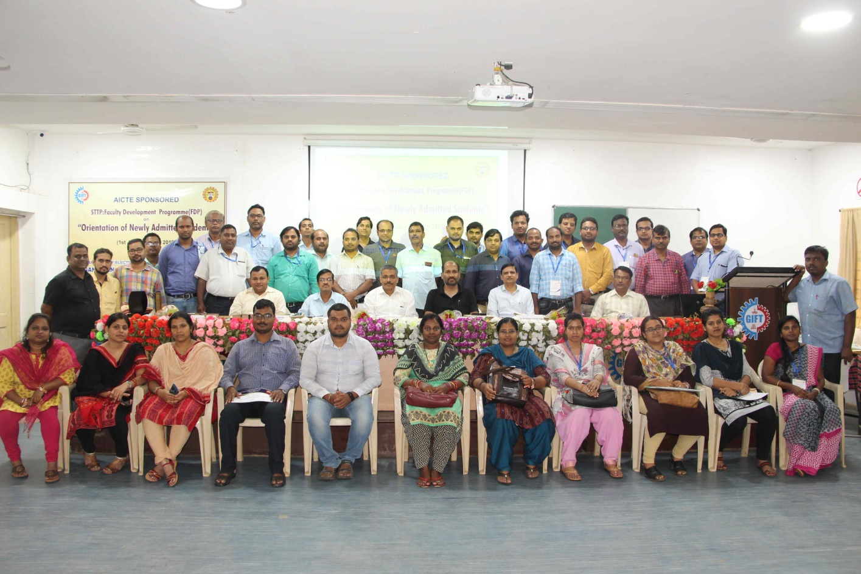

GALLERY





