E-NIRMAN

(JAN-MAR)

DEPARTMENTOF
CIVILENGINEERING
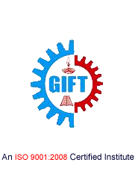
GIFT, BHUBANESWAR

DEPARTMENT OF

CIVIL ENGINEERING

CIVIL Engineering is one of the most upcoming areas of Research &Engineering among all other branches of engineering. As of today, CIVIL Engineers are working in all spheres of modern industry. The goal of this course is to impart all-round technical education to the students to fulfil the requirements of new challenges of industries to solve the practical problems of our daily life, as well as to find new ways.

The Department of CIVIL Engineering was established in the year 2012. The department has well equipped Labs and dedicated and ebullient faculties having vast experience in their respective fields. Industrial visits and practical projects are also encouraged by the department in various sectors.

Vision

To impart knowledge and excellence in civil engineering and technology with global perspectives to our students and to make them ethically strong engineers to build our nation.

Mission

- To produce civil engineers of high caliber and technical skill.
- To make the department a center of excellence in the field of civil engineering and allied research.
- To provide knowledge base and consultancy services to the community in all areas of civil engineering.
- To promote innovative and original thinking in the mind of budding engineers to face the challenges of future.
Message from the Principal …

I am pleased to know that the Department of Civil Engineering of Gandhi Institute For technology (GIFT), Bhubaneswar is bringing out its jan-mar issue of "E-Nirman" . I extend my best wishes on the occasion of the publication of the technical magazine.I hope this magazine will be a treasure for those associated with Civil Engineering and will help in providing a platform for sharing experiences & learning in this area.
Dr. Surya Narayan Patnaik
Message from the HoD…

I am proud to see that the professors of our department have put in appreciable effort into creating thee-magazine, E-Nirman. It is good to see that today’s generation has not lost its literary roots, despite the perpetual efforts of e-Technology to extinguish the flames of the written word. This e-magazine is an exceptional proof that the literary flame is burning bright. I look forward to seeing the juniors taking up the reigns of this e- magazine in future, so that this tradition remains eternal.

Prof. Surajit pattnaik

From the Editor…

It gives me immense pleasure to announce the release of the jan-mar2020 issue of Nirman. The primary focus of this technical e- magazine is to empower our students with overall development. I am grateful to everyone involved in making this journey successful.

Prof. Chitrabhanu sahoo

“No book or magazine article is for "everyone" so know your audience and then target them with your writing.”

CONTENTS:

- Waste disposal practice and Perceptions of Urban Area
- Mycelium brick
- APPLICATIONS OF NANOTECHNOLOGY IN CONSTRUCTION
- Department Activities
- Achievements
- Gallery

Waste disposal practice and Perceptions of Urban Area
There are many types of waste: municipal (household, commercial and demolition waste), hazardous (industrial), biomedical, electronic (e-waste), radioactive, etc. Waste management includes the collection, transport, valorization and disposal of these wastes. More broadly, it includes any activity involved in the organization of waste

The main principles of waste management are:
- Waste hierarchy, referring to the “3Rs rule” Reduce, Reuse and Recycle, waste prevention and minimization being the most desirable goal.
- Extended producer responsibility, adding all the environmental costs to the market price of a product, including end-of-life disposal.
- The polluter pays principle, requiring that a waste generator pays for the appropriate disposal of the waste.

Waste management techniques include:

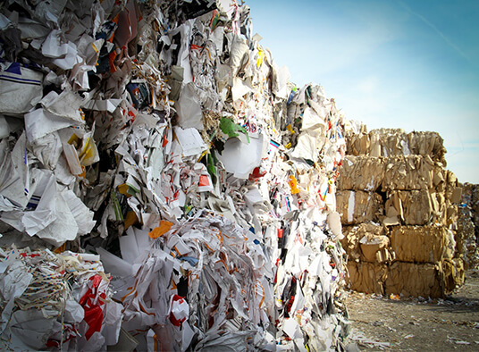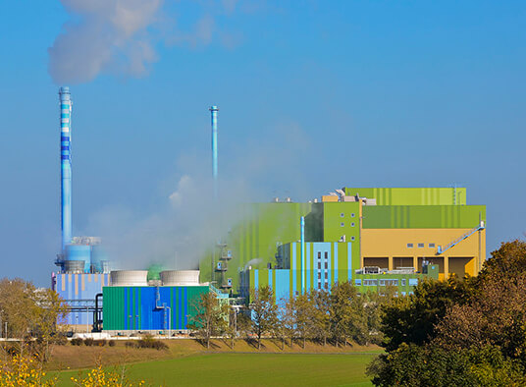

Landfill Incineration

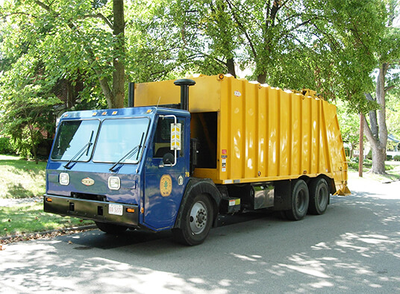
Waste collection Re cycling
Prof. Surajit Pattnaik
HOD , CIVIL
Mycelium brick

Building construction and materials have a substantial role in contributing to building waste and energy consumption. The race to find the next sustainable technology or material that will greatly reduce our ecological footprint as well as improve our environment is causing countless new materials to be developed which hold the possibility of helping to achieve this generation’s sustainability goals. One of the newest and most promising materials is mycelium-based bio-composites. Mycelium is the vegetative part of a fungus which can be obtained when the spores from the mushrooms germinate. Spawn (mushroom spores) are collected and placed in a PDA (potato dextrose agar) material for initiating the growth of mycelium fibers from the spores. These fibers are transferred into the substrate and allowed them to grow for few days. Substrate and the mycelium fibers are further condensed into a mould to form a composite (i.e. mycelium brick in this case). This composite is burnt to get a strong & “green” building material: Mycelium brick.

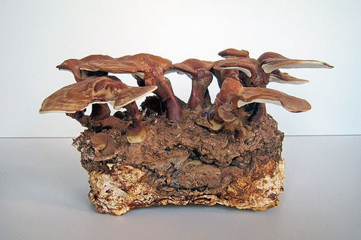
Mycelium brick

Ankit jena
Assistant Professor, Civil

APPLICATIONS OF NANOTECHNOLOGY IN CONSTRUCTION

The topics are related to the particularity, utility, complexity and importance of Nano- particles in various emerging fields now days and in the future. The importance of Nano technology in creating the innovations towards infrastructure has the probability of transforming the civil engineering practices and enlarged the civil engineering vision. In this paper, current developments and background information's in nanotechnology are represented. Finally leading toward the future course, probabilities and suggestion for development of Nano technology in civil engineering in the direction of economy, lower maintenance cost with more longevity and ponder.
“Small is beautiful” is a very well-known statement of past but now it has been transformed by ‘small is not only beautiful but powerful too’. In this technology, only the properties of material like colour , abrasion, conductivity, etc. are changed by reducing its size without changing its chemical composition.
Nanotechnology is not a new technology and it is not a new science either. An expansion of the sciences and technology already under development from many years.

Nano technology.
The word "Nano” comes from the Greek word "dwarf", which means a billionth. One nanometer is a billionth of a meter. Definition of ‘nanotechnology’ varies generally but refers to understanding and manipulation of matter on the Nano scale, say, from 0.1nmto 100 nm.

Nanotechnology in construction
Automation in nanotechnology construction can allow for the creation of structures from advanced homes to massive skyscrapers much more quickly and at much lower cost. In the near future, Nanotechnology can be used to sense cracks in foundations of architecture and can send nabobs to repair them. Construction industry involves nano particles such as silica and alumina. Producers are also investigating the methods for preparing nano- cement. If it is possible to prepare cement with nano sized particles it will open up a wide opportunity in the areas of manufacture of ceramics, electronic applications and high strength composites.

Abhijit mangaraj
Assistant Professor, civil

DEPARTMENT ACTIVITIES

Department of civil engineering had been involved in various types of activities in this period.

For industry institute interaction our HOD Mr. Surajit pattnaik and assistant professor Mr. Ankit jena had visited SM consultant for two days (4/1/2020-5/1/2020).

Our department conducted 3 days study tour programme for the 6th semester students from 2/2/2020 to 5/2/2020 to BHEL , Vizag.

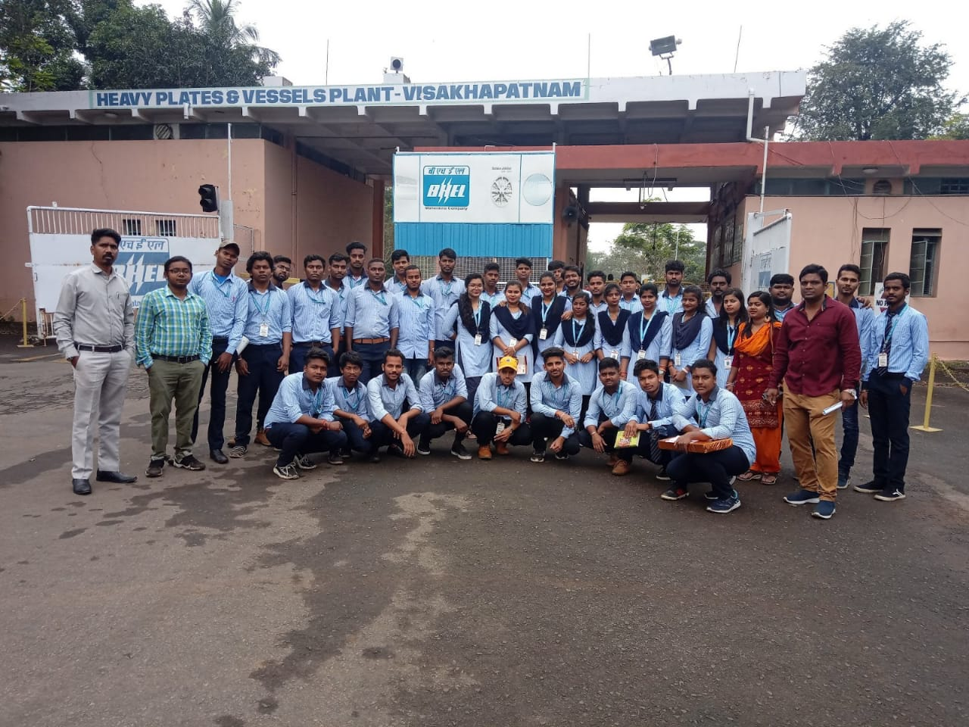

From our department assistant professor Mr. Ankit jena and Miss Honey Mishra represented their paper on “Vermin Composting” in IIT Guhati on 13th of feb during the conference “Recycle 2020”.

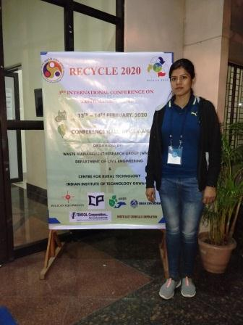

Department along with the 6th semester students given the farewell to the final year students

.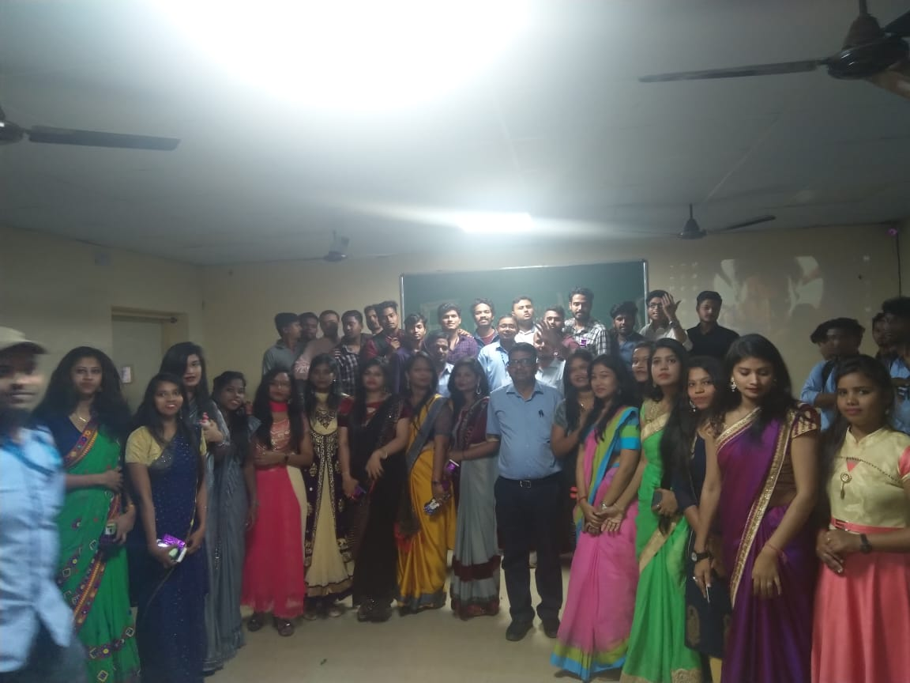

A seminar programme was held on 13th of March on “Sustainable construction on current trends and future prospective” by Sanket Nayak ,Assistant professor IIT(ISM) Dhanbad

.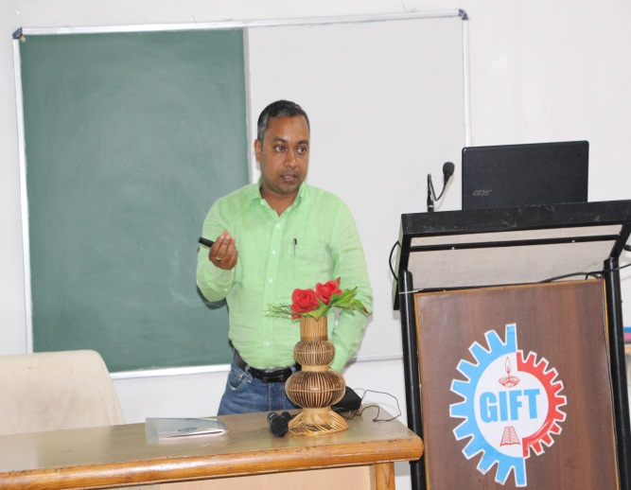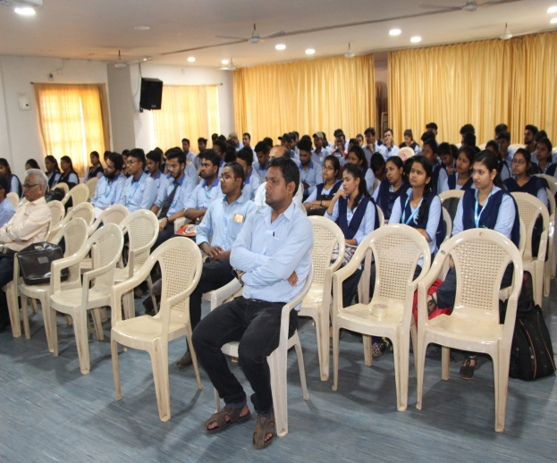

Acheivements

    - One of our Mtech. Student Farhad Jahan received gold medal in CTM from bput for the year 2020 in this time period.

GALLERY

