E-Wave

(December 2022-23)

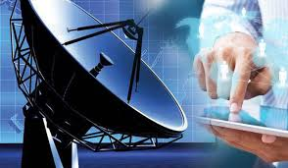

DEPARTMENTOF
ELECTRONICS & COMMUNICATION ENGINEERING
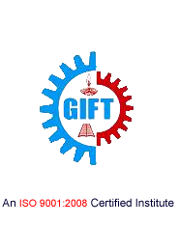
GIFT, BHUBANESWAR

DEPARTMENT OF

ELECTRONICS AND COMMUNICATION ENGINEERING

Electronics and Communication Engineering is one of the most upcoming areas of Research &Engineering among all other branches of engineering. As of today, Electronics and CommunicationEngineers are working in all spheres of modern industry. The goal of this course is to impart all-roundtechnical education to the students to fulfil the requirements of new challenges of industries to solve the practical problems of our daily life, as well as to find new ways.

The Department of Electronics and Communication Engineering was established in the year 2007 inGANDHI INSTITUTE FOR TECHNOLOGY (GIFT), Bhubaneswar. The department has well equipped Labs and dedicated and ebullient faculties having vast experience in their respective fields. Industrialvisits and practical projects are also encouraged by the department in various sectors.

Vision

To establish a conducive ambience for advancing and enriching the knowledge of electronicsand communication engineering, through qualitative and holistic collaboration amongstudents, faculties, PG Scholars, Domain experts from premier institutions andResearch laboratories

Mission

To advance knowledge and educate in major paradigms of electronics and communicationengineering, circuit design and signal processing and to create a distinctive culture ofresearch and innovation among faculties and students, with an inherent focus onbehavioural and communication aspects, so as to generate a pool of admirable quality ofprofessionals and entrepreneurs with the ability to address
the industry and social problems.

Message from the Principal …

It truly is a matter of deep pride and elation for me to learn that the students of the Electronics and Communication Engineering Department have produced the Dec 2018-19edition of this technically magnificence known as “E-Wave”. This magazine has succeeded in its endeavors to keep the students well informedabout the innovation of the ever transient field of technology. Our students have proved that the literary prowess can go hand in hand with technical mastery, thus enabling accomplishment of the GIFT goal of all round development of a student.I hope that students would continue to keep the brilliant torch of E-Waveburning bright in the future as well.

Dr Ch V S Parameswara Rao

Message from the HoD…

It is a matter of great pleasure for me to go through the wonderful contributions made by the students. This magazine is intended to bring out the hidden talents in the students and the teachers and to inculcate leadership skills among them.I wish all the students and faculties involved all the success.

Prof. SaumendraBehera

From the Editor…

This magazine provides a platform for students and staff to share information, spread the latest technical knowledge and cultivate right ways that will equip all of us to stay competent in our respective fields of study and research. I congratulate and thank all the students and staff coordinators who have made untiring efforts to bring out this magazine.

Prof.Monalisa Samal

“ Failure Will Never Overtake Me If My Determination To Succeed Is Strong Enough”

CONTENTS:

- Satrack
- IP Telephony
- Radar Systems And Its Applications
- Memory: A Challenge To Road On Industry 4.0
- Prodigious Technology
- Flexible Phototransistor
- Department Activities
- Gallery

SATRACK
SATRACK deals with the measurement concept that tests the missile accuracy. SATRACK receives, rebroadcast, records and tracks the satellite signals sent by the GPS signals. The reception and rebroadcast of the signals is done by a missile hardware called the GPS translator. The ground telemetry stations consist of the RF antenna and recorders for the data. Post-flight processing and modelling are done later at the SATRACK Facility. Also the major error contributors to the missile flight are determined by the modelling done. There is extensive use of simulated signals in this method. This seminar also throws light on the major breakthrough technologies that were developed during the research leading up to the final form of this technology.
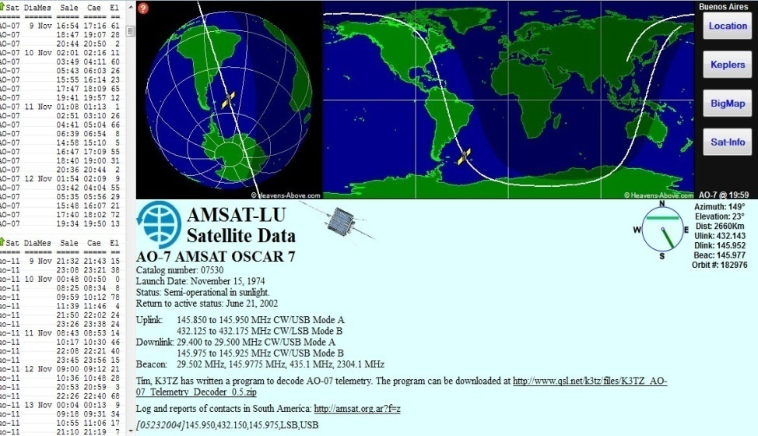
According to the dictionary guidance is the ‘process of guiding the path of an object towards a given point, which in general may be moving’. The process of guidance is based on the position and velocity if the target relative to the guided object. The present day ballistic missiles are all guided using the global positioning system or GPS.GPS uses satellites as instruments for sending signals to the missile during flight and to guide it to the target. SATRACK is a system that was developed to provide an evaluation methodology for the guidance system of the ballistic missiles.
This was developed as a comprehensive test and evaluation program to validate the integrated weapons system design for nuclear powered submarines launched ballistic missiles .This is based on the tracking signals received at the missile from the GPS satellites. SATRACK has the ability to receive record, rebroadcast and track the satellite signals.
Monalisa Samal
Assistant Professor,ECE

IP TELEPHONY

If you've never heard of Internet Telephony, get ready to change the way you think about long-distance phone calls. Internet Telephony, or Voice over Internet Protocol, is a method for taking analog audio signals, like the kind you hear when you talk on the phone, and turning them into digital data that can be transmitted over the Internet. How is this useful? Internet Telephony can turn a standard Internet connection into a way to place free phone calls.
The practical upshot of this is that by using some of the free Internet Telephony software that is available to make Internet phone calls, you are bypassing the phone company (and its charges) entirely. Internet Telephony is a revolutionary technology that has the potential to completely rework the world's phone systems. Internet Telephony providers like Vonage have already been around for a little while and are growing steadily. Major carriers like AT&T are already setting up Internet Telephony calling plans in several markets around the United States, and the FCC is looking seriously at the potential ramifications of Internet Telephony service.
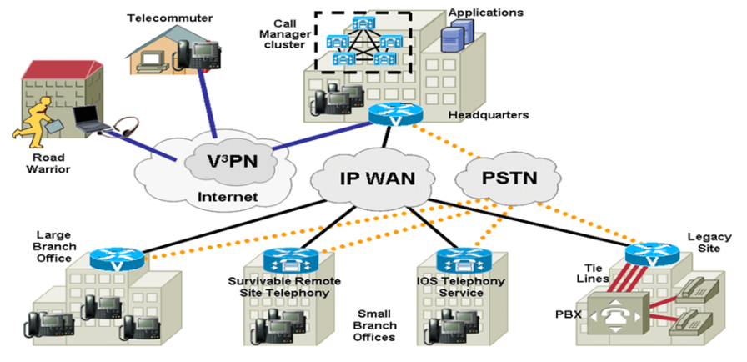
The main motivation of development of IP Telephony is the cost saving & integrat ing new services. Internet telephony integrates a variety of services Vocaltec introduced the first Internet telephony software product in early 1995, running a multimedia PC, the Vocaltec Internet Phone. In 1996, Vocaltec announced it was working with an Intel Company (Dialogic Corporation, an Intel acquisition made in 1999) to produce the first IP telephony gateway. The technology has improved to that point where conversations are easily possible. Gateways are the key to bringing IP telephony into the mainstream. By bridging the traditional circuit-switched telephony world with the Internet. Internet telephony technology has caught the world's attention.
Subhranshu Panda
Assistant Professor,ECE

RADAR SYSTEMS AND ITS APPLICATIONS

Radar systems are used to detect and track objects at a distance by emitting radio waves and measuring the reflected signals. The technology has a wide range of applications, including navigation, weather forecasting, and military defense.
One of the most common uses of radar is in air traffic control, where it is used to track the position, velocity, and altitude of aircraft. This information is used to ensure safe and efficient navigation of aircraft and prevent collisions. Another application of radar in the aviation industry is in weather forecasting, where it is used to measure precipitation and wind patterns in the atmosphere.
Another important application of radar is in the field of military defense. Military radar systems are used to detect and track aircraft, missiles, and other military vehicles, as well as to guide weapons systems. This information is used to defend against enemy attacks and to plan military operations.
In addition to these traditional applications, radar technology is also being used in new and emerging fields. For example, radar is being used to measure the distance between cars on the road, which helps to improve traffic flow and reduce congestion. It is also used in the field of autonomous vehicles, where it is used to detect and track other vehicles, pedestrians, and obstacles on the road.
Overall, radar systems are a critical technology with a wide range of applications. From air traffic control to military defense, radar is essential for ensuring safety and improving efficiency. With ongoing advancements in the field, radar technology is likely to continue to be an important tool in many areas of our lives.

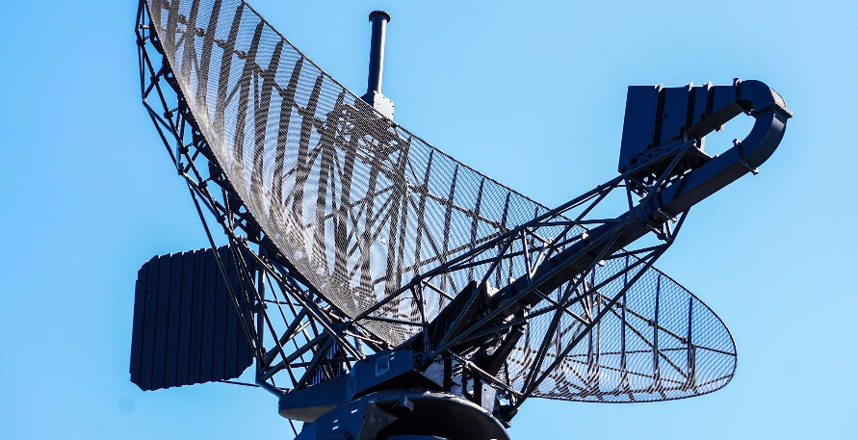

Barsapriyadarsani Sahoo
2nd year,ECE

MEMORY:A CHALLENGE TO ROAD ON INDUSTRY 4.0
Memory for data is among the most pressing challenges to Industry 4.0. Given the evolving nature of Industry 4.0 and associated memory solutions, however, some memory-based trends are becoming apparent.The integration of modern digital technology into industrial facilities is rapidly growing across the world—but it is not without its challenges. One of the main problems related to Industry 4.0 lies in the ability to process the data at a significantly higher magnitude and throughput in a reliable, error-free manner.Data is the most critical aspect of Industry 4.0 because the retrieval, processing, communication, storage, and availability of data are crucial to what makes Industry 4.0 possible. For example, consider how sensors generate massive amounts of data to be logged and processed in real time. Sensor data passes through modern industrial controllers and field devices, interacting with three kinds of memories in the system: flash, expansion RAM, and data-logging RAM. Memory is among the most pressing challenges to be overcome on the road to Industry 4.0. NOR Flash technology is responsible for storing boot code and data. It must be highly reliable, provide excellent safety and security, and meet strict industry requirements when used as part of Industry 4.0 technology. Another challenge for NOR flash memory involves the ability to remain functional in the extreme temperature environments that are common to many industrial systems.

Amitosh panda
3rd year, ECE

PRODIGIOUS TECHNOLOGY

Prodigious provides webdevelopment in the full sentence. Specialised in professional webdesign, webdevelopment, webhosting, domainhosting (100+ extensions available), Print-media and everything else what you need to present your company.The company is located in the area of Rotterdam, but serves to everyone who need something on the internet.

We bring specialist production expertise across all African channels and markets, together with consumer and performance data, to produce, adapt and deliver efficient and effective marketing content, helping brands win in the platform world.
Our team prides itself on the exceptionally high level of quality delivered, as well as the diverse variety of work produced across our African markets.
We use our comprehensive technology stack and streamlined, data-driven workflows to seamlessly connect our regional production campuses, on-site client studios and time zone-aligned offshore hubs deliver the perfect balance of efficiency and quality.

Shibani Dalabehera
3rd year,ECE

FlEXIBLE PHOTOTRANSISTOR
Ultraviolet (UV) photodetectors (PDs), which can convert ultraviolet light into electrical signals for dynamic monitoring, have attracted tremendous attention to protect humans from diseases induced by harmful light radiations. However, there are numerous challenges, such as unsatisfied transparency, poor mechanical flexibility and low photoelectric efficiency, in the development of superior PDs, which has hindered the further development of PDs. In this study, a full transparent vertical phototransistor by sandwiching indium tin oxide (ITO) between a single-walled carbon nanotube (SWCNT) source and drain electrode is invented for high-performance transparent UV photodetectors. Moreover, benefited from the nano-scale transmission channels in the vertical direction and rational selection of materials, the photodetector exhibits superior photoelectric performance, particularly in extremely high photoresponsivity of up to 1.02 × 10⁴ A W⁻¹ and photosensitivity above 4.2 × 10⁵%. Our transparent photodetector is competitive and superior to other reported planar TFTs or two-terminals devices. Moreover, the photodetectors maintain transparency of over 85% and high detectivity of up to 1.73 × 10¹⁶ Jones under a 15 mm bending, which ensures outstanding mechanical robustness against mechanical bending. This study establishes a new approach for high-performance transparent flexible UV photodetectors and shows great potential to next.

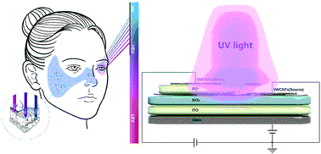

Sushrita Bedbak
4th year,ECE

DEPARTMENT ACTIVITIES

Department of Electronics and Communnicatio Engineering organised a Two day Faculty Development Programme on “ Antenna Basics and HFSS software” for ECE Faculties on 29th and 30th December 2018 in mini conference hall(309) from 10:30-1:00pm and Labs in room no.505 from 2:00-4:15pm.
Dr.Sanjeev Kumar Mishra(IIIT,Bhubaneswar) was the key-note speaker He took a theory session on Antenna basics,followed by hand on session .
The programme was very interesting and helped the faculties to become familiar with a new software HFSS.

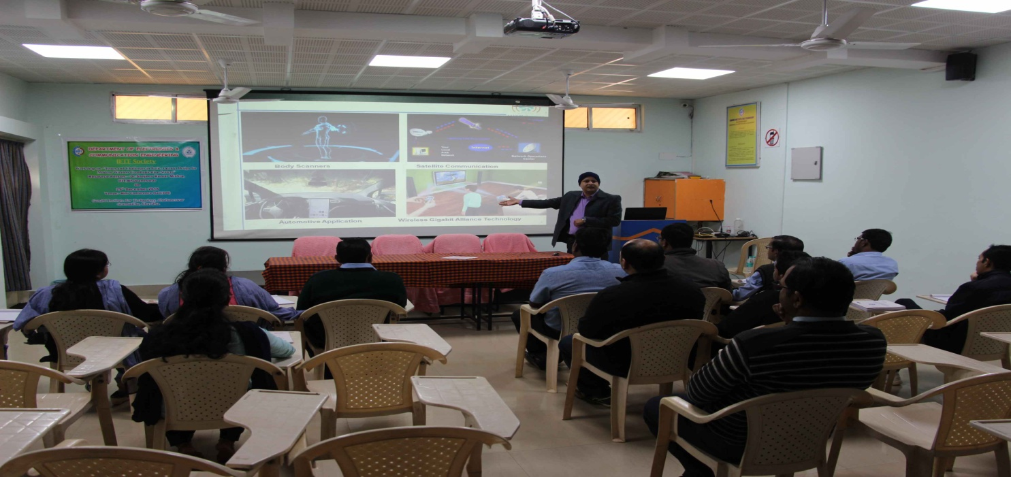

GALLERY

