E-Wave

(July 2022-23)

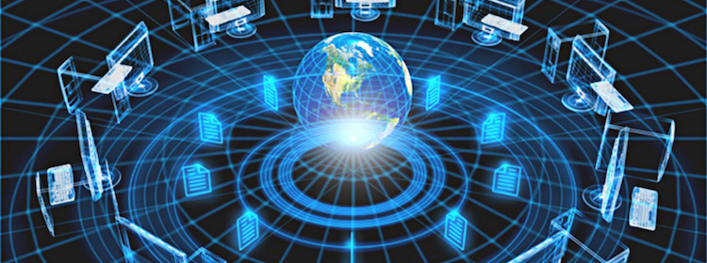

DEPT. OF ELECTRONICS & COMMUNICATION ENGINEERING
GIFT, BHUBANESWAR

DEPARTMENT OF ELECTRONICS AND COMMUNICATION ENGINEERING

Electronics and Communication Engineering is one of the most upcoming areas of Research & Engineering among all other branches of engineering. As of today, Electronics and Communication Engineers are working in all spheres of modern industry. The goal of this course is to impart all around technical education to the students to fulfill requirements of new challenges of industries to solve the practical problems of our daily life, as well as to find new ways.
The Department of Electronics and Communication Engineering was established in the year 2007 in GANDHI INSTITUTE FOR TECHNOLOGY, Bhubaneswar. The department has well equipped Labs and prominent Faculty members having a vast experience in their field. Industrial visits and practical projects are also encouraged by the department in various sectors.

Vision

To establish a conducive ambience for advancing and enriching the knowledge of electronics and communication engineering, through qualitative and holistic collaboration among students, faculty members, PG Scholars, Domain experts from premier institutions and Research laboratories

Mission

To advance knowledge and educate in major paradigms of electronics and communication engineering, circuit design and signal processing and to create a distinctive culture of research and innovation among faculty members and students, with an inherent focus on behavioral and communication aspects, so as to generate a pool of admirable quality of professionals and entrepreneurs with the ability to
addres the industry and social problems.

Message from Principal’s Desk …

I congratulate the department of ECE for bringing out the December issue 2019-20 of the department technical Magazine E-Wave. I am sure that the magazine will provide a platform to the students and faculty members to expand their technical knowledge and sharpen their hidden literary talent and will also strengthen the all round development of the students.

Message from HOD’s Desk …

Competition is an opportunity to prove one’s mettle. If students are on their toes to prove themselves to be true competitors, their success graph is always impressive. The ECE department are putting their best possible efforts to make their students global competitor.

From the Editor’s Desk …

I feel privileged in presenting the second issue of our Department Magazine E-WAVE. I would like to place on record my gratitude and heartfelt thanks to all those who have contributed to make this effort a success.
I congratulate all my team members for their constant effort in launching this Magazine. We are also thankful to our Management and Principal for their support and encouragement. Finally we are gratified to our reviewers for their frank opinions and constructive suggestions, namely our colleagues and students.

“Our greatest weakness lies in giving up. The most certain way to succeed is always to try just one more time.”

CONTENTS :

- Semiconductors can behave like metals
and even like superconductors
- Arduino
- 3D Printing
- OLED
- VOLTE Technology
- RF Design Basics
- Department Activities
- Gallery

SEMICONDUCTORS CAN BEHAVE LIKE METALS AND EVEN LIKE SUPER CONDUCTORS

The crystal structure at the surface of semiconductor materials can make them behave like metals and even like superconductors, a joint Swansea/Rostock research team has shown. The discovery potentially opens the door to advances like more energy-efficient electronic devices. Semiconductors are the active parts of transistors, integrated circuits, sensors, and LEDs. These materials, mostly based on silicon, are at the heart of today's electronics industry.We use their products almost continuously, in modern TV sets, in computers, as illumination elements, and of course as mobile phones. Metals, on the other hand, wire the active electronic components and are the framework for the devices.
The research team, led by Professor Christian Klinke of Swansea University's chemistry department and the University of Rostock in Germany, analysed the crystals at the surface of semiconductor materials.
Applying a method called colloidal synthesis to lead sulphide nanowires, the team showed that the lead and sulphur atoms making up the crystals could be arranged in different ways. Crucially, they saw that this affected the material's properties.
In most configurations the two types of atoms are mixed and the whole structure shows semiconducting behavior as expected. However, the team found that one particular "cut" through the crystal, with the so called {111} facets on the surface, which contains only lead atoms, shows metallic character. This means that the nanowires carry much higher currents, their transistor behaviour is suppressed, they do not respond to illumination, as semiconductors would, and they show inverse temperature dependency, typical for metals.
Dr. Mehdi Ramin, one of the researchers from the Swansea/Rostock team, said:
"After we discovered that we can synthesize lead sulphide nanowires with different facets, which makes them look like straight or zigzag wires, we thought that this must have interesting consequences for their electronic properties. But these two behaviours were quite a surprise to us. Thus, we started to investigate the consequences of the shape in more detail."
The team then made a second discovery: at low temperatures the skin of the nanostructures even behaves like a superconductor. This means that the electrons are transported through the structures with significantly lower resistance.
Professor Christian Klinke of Swansea University and Rostock University, who led the research, said:
"This behaviour is astonishing and certainly needs to be further studied in much more detail.
But it already gives new exciting insights into how the same material can possess different fundamental physical properties depending on its structure and what might be possible in the future.
One potential application is lossless energy transport, which means that no energy is wasted.
Through further optimization and transfer of the principle to other materials, significant advances can be made, which might lead to new efficient electronic devices.

Prof.Subrat KumarPanda
Asst.Professor,ECE

ARDUINO

Arduino is an open-source platform that uses simple hardware and software to make it easy for people to create interactive electronic projects. The platform consists of a microcontroller board (such as the Arduino Uno or Arduino Nano) and a development environment (the Arduino IDE) that allows users to write and upload code to the board.
One of the key features of Arduino is its ease of use. The boards are designed to be simple to use and require minimal programming knowledge. The Arduino IDE uses a simplified version of the C++ programming language, which makes it easy for beginners to learn and start creating projects. Additionally, there are a wide variety of tutorials and guides available online to help users get started with their projects.
Another advantage of Arduino is its flexibility. The platform can be used for a wide variety of projects, from simple LED blinkers to more complex projects such as robots and remote control vehicles. There are also a wide variety of sensors and actuators available that can be easily connected to the board, which allows users to add a wide range of functionality to their projects.
The Arduino community is also an important part of the platform. There are a large number of users worldwide who share their projects, tutorials, and code online. Additionally, there are a number of forums and websites where users can ask questions, share their experiences, and get help with their projects.
In summary, Arduino is an open-source platform that makes it easy for people to create interactive electronic projects. Its simple hardware and software, ease of use and flexibility, and large community make it a popular choice for people of all ages and skill levels who are interested in electronics and programming. With Arduino, you can make your own DIY projects, learn about electronics, and even develop your own products for commercial uses.
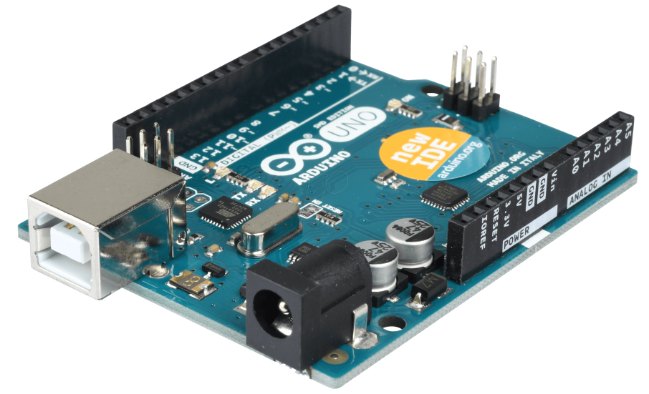

Aditya Gautam
2ND year,ECE

3D PRINTING
3D printing, also known as additive manufacturing, is a process of creating three-dimensional objects by building up layers of material. The process begins with a digital model, which is sliced into layers and then sent to the 3D printer. The printer then uses various methods, such as fused deposition modeling (FDM) or stereolithography (SLA), to create the object layer by layer.
One of the biggest advantages of 3D printing is its ability to create complex geometries that would be difficult or impossible to achieve with traditional manufacturing methods. This allows for the creation of customized and highly specialized products, such as prosthetic limbs, aerospace components, and medical devices. Additionally, 3D printing allows for the rapid prototyping of designs, which can save time and money in the development process.
3D printing also has the potential to revolutionize the way we think about manufacturing and supply chains. With the ability to print parts on demand, businesses and individuals can reduce their reliance on traditional manufacturing processes and inventory management. This can lead to a reduction in waste and increased efficiency.
Another advantage of 3D printing is its accessibility. With the development of affordable and easy-to-use 3D printers, individuals and small businesses can now create their own products, without the need for expensive factory equipment. This has led to the rise of a maker culture, where people can design, print, and share their own creations online.
However, 3D printing also has its limitations. The materials that can be used for 3D printing are still relatively limited, and the process is not yet capable of producing objects with the same level of detail or strength as those created through traditional manufacturing methods. Additionally, 3D printing can also be a slow process, especially for larger or more complex objects.
Overall, 3D printing is a rapidly evolving technology with a wide range of applications. From prototyping to manufacturing, 3D printing has the potential to change the way we create and consume products. However, it is still a relatively new technology, and there are limitations to its capabilities. As the technology continues to evolve and improve, it is likely that we will see even more applications and advancements in 3D printing in the future.

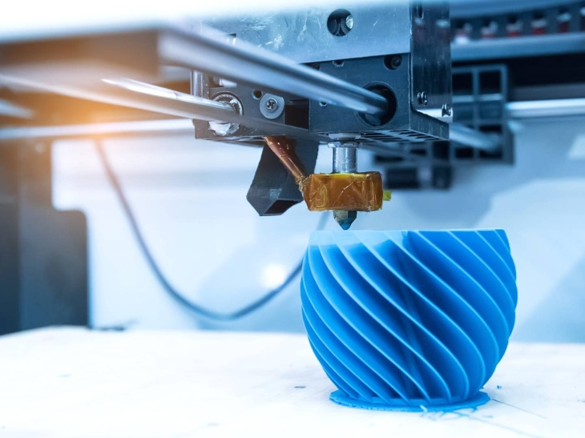
Pritinanda Routray
2ND year,ECE

OLED

Prototype OLED lighting pane An organic light-emitting diode (OLED or organic LED), also known as organic electroluminescent (organic EL) diode,^{[1][2]} is a light-emitting diode (LED) in which the emissive electroluminescent layer is a film of organic compound that emits light in response to an electric current. This organic layer is situated between two electrodes; typically, at least one of these electrodes is transparent. OLEDs are used to create digital displays in devices such as television screens, computer monitors, and portable systems such as smartphones and handheld game consoles. A major area of research is the development of white OLED devices for use in solid-state lighting applications.^{[3][4][5]}
There are two main families of OLED: those based on small molecules and those employing polymers. Adding mobile ions to an OLED creates a light-emitting electrochemical cell (LEC) which has a slightly different mode of operation. An OLED display can be driven with a passive-matrix (PMOLED) or active-matrix (AMOLED) control scheme. In the PMOLED scheme, each row and line in the display is controlled sequentially, one by one,^{[6]} whereas AMOLED control uses a thin-film transistor (TFT) backplane to directly access and switch each individual pixel on or off, allowing for higher resolution and larger display sizes.
OLED is fundamentally different from LED which is based on a p-n diode structure. In LEDs doping is used to create p- and n- regions by changing the conductivity of the host semiconductor. OLEDs do not employ a p-n structure. Doping of OLEDs is used to increase radiative efficiency by direct modification of the quantum-mechanical optical recombination rate. Doping is additionally used to determine the wavelength of photon emission.^{[7]}
An OLED display works without a backlight because it emits its own visible light. Thus, it can display deep black levels and can be thinner and lighter than a liquid crystal display (LCD). In low ambient light conditions (such as a dark room), an OLED screen can achieve a higher contrast ratio than an LCD, regardless of whether the LCD uses cold cathode fluorescent lamps or an LED backlight. OLED displays are made in the same way as LCDs, but after TFT (for active matrix displays), addressable grid (for passive matrix displays) or indium-tin oxide (ITO) segment (for segment displays) formation, the display is coated with hole injection, transport and blocking layers, as well with electroluminescent material after the first 2 layers, after which ITO or metal may be applied again as a cathode and later the entire stack of materials is encapsulated.

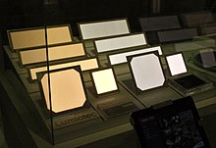
Abhishek Kumar
3rd year,ECE

RF DESIGN BASICS

RF (radio frequency) design is the process of designing and creating electronic devices and systems that operate at radio frequencies, typically in the range of 3 kHz to 300 GHz. RF design encompasses a wide range of applications, including wireless communication systems, satellite navigation, and medical imaging.
The basic building block of an RF system is the antenna, which is responsible for transmitting and receiving electromagnetic waves. The design of the antenna is critical to the performance of the system, as it determines the directionality, gain, and bandwidth of the signal. Common types of antennas include dipoles, Yagi, and patch antennas.
Another important component in RF design is the RF amplifier, which is used to boost the power of the signal. RF amplifiers can be classified into two main types: voltage-controlled and current-controlled. The choice of amplifier will depend on the specific requirements of the system, such as frequency range, power output, and linearity.
RF filters are also an essential component in RF design, as they are used to separate wanted signals from unwanted ones. The most common types of RF filters are low pass, high pass, and band pass filters. The filter design is crucial for the performance of the system, as it determines the selectivity and insertion loss of the signal.
The RF signal also needs to be modulated to carry the information. The modulation method used will depend on the specific requirements of the system, such as bandwidth, data rate, and error rate.
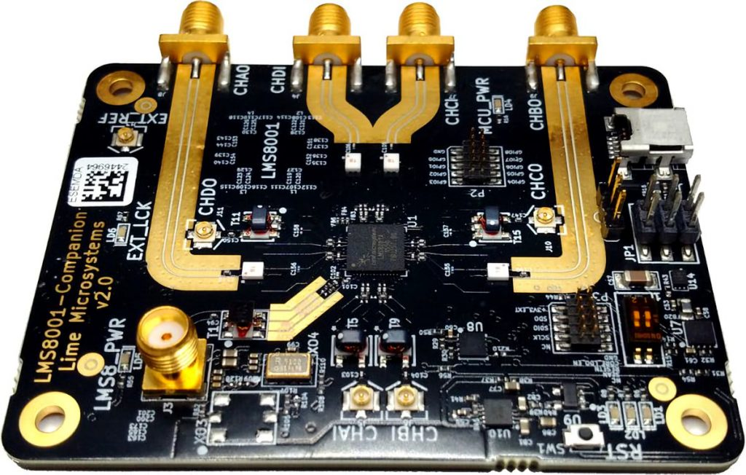

Netai Lohar
4th Year ,ECE

NEW STUDY ALLOWS BRAIN AND ARTIFICIAL NEURONS TO LINK OVER THE WEB

Brain functions are made possible by circuits of spiking neurons, connected together by microscopic, but highly complex links called synapses. In this new study, published in the scientific journal Nature Scientific Reports, the scientists created a hybrid neural network where biological and artificial neurons in different parts of the world were able to communicate with each other over the internet through a hub of artificial synapses made using cutting-edge nanotechnology. This is the first time the three components have come together in a unified network.
During the study, researchers based at the University of Padova in Italy cultivated rat neurons in their laboratory, whilst partners from the University of Zurich and ETH Zurich created artificial neurons on Silicon microchips. The virtual laboratory was brought together via an elaborate setup controlling nanoelectronic synapses developed at the University of Southampton. These synaptic devices are known as memristors.
The Southampton based researchers captured spiking events being sent over the internet from the biological neurons in Italy and then distributed them to the memristive synapses. Responses were then sent onward to the artificial neurons in Zurich also in the form of spiking activity. The process simultaneously works in reverse too; from Zurich to Padova. Thus, artificial and biological neurons were able to communicate bidirectionally and in real time.
Themis Prodromakis, Professor of Nanotechnology and Director of the Centre for Electronics Frontiers at the University of Southampton said "One of the biggest challenges in conducting research of this kind and at this level has been integrating such distinct cutting edge technologies and specialist expertise that are not typically found under one roof. By creating a virtual lab we have been able to achieve this."
The researchers now anticipate that their approach will ignite interest from a range of scientific disciplines and accelerate the pace of innovation and scientific advancement in the field of neural interfaces research. In particular, the ability to seamlessly connect disparate technologies across the globe is a step towards the democratisation of these technologies, removing a significant barrier to collaboration.
Professor Prodromakis added "We are very excited with this new development. On one side it sets the basis for a novel scenario that was never encountered during natural evolution, where biological and artificial neurons are linked together and communicate across global networks; laying the foundations for the Internet of Neuro-electronics. On the other hand, it brings new prospects to neuroprosthetic technologies, paving the way towards research into replacing dysfunctional parts of the brain with AI chips."

Prof.Sukant Behera
Asst.Professor,ECE

DEPARTMENT ACTIVITIES

Department of Electronics and Communication Engineering of Gandhi Institute For Technology (GIFT), Bhubaneswar has organized TEQIP-III BPUT, Odisha Sponsored Two-day National Seminar on Next Generation Fibers(SNGF-2022)from October 27-28, 2021.
The main objective of this national seminar is to encourage faculty members &the students to involve themselves in various research fields of recent developments in Engineering and Science to deal with next-generation fibers.It was really an excellent opportunity for the participants in order to share their research and professional experiences on various aspects of modern communication technologies.
Dr. Ranjan Kumar Jena, TEQIP Coordinator, BPUT, Odisha was the Chief Guest in the august function & the program was inaugurated by Dr. BijayanandaPatnaik, Assistant Professor in ETC, IIIT Bhubaneswar on his behalf. The inaugural function was presided over by Dr. P. K. Subudhi, Professor in ECE, GIFT, Bhubaneswar, Dr. Alok Kumar Mohapatra, TEQIP Coordinator, GIFT, Bhubaneswar, Mr. Vivek Sharma, Registrar,GIFT, Bhubaneswar, Prof. SaumendraBehera, ConvenorSNGF-2020and Prof. JyostnamayeeBehera, Coordinator SNGF-2020. Participants from various Engineering Colleges under BPUT attended the program.
Dr. BijayanandaPatnaik, Assistant Professor in ETC, IIIT Bhubaneswar & Dr. GopinathPalai, Professor, GITA Bhubaneswar handeled the technical session-1 & 2 respectivelly in day-1. Dr. P. K. Sahu, Associate Professor, School of Electrical Sciences, IIT Bhubaneswar & Dr. UrmilaBhanja, Associate Professor in ETC, IGIT Saranghandeled the same in day-2 respectivelly.
The program was ended with the distribution of the certificates to the participants by the Chief Guest Dr. UrmilaBhanja, Associate Professor, IGIT Sarang& the vote of thanks by Prof. SaumendraBehera, HOD-ECE (ConvenorSNGF-2020).
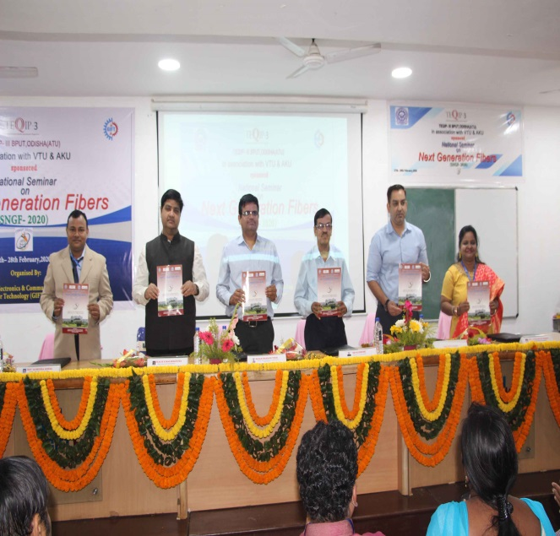

GALLERY

 