E-Wave

(July 2021-22)

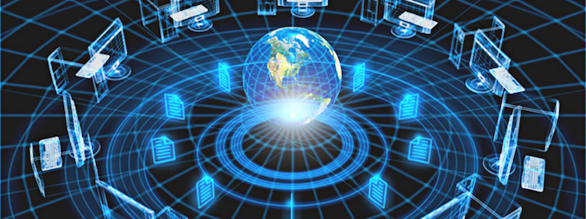

DEPARTMENTOF
ELECTRONICS & COMMUNICATION ENGINEERING
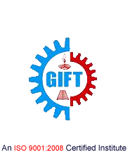
GIFT, BHUBANESWAR

DEPARTMENT OF

ELECTRONICS AND COMMUNICATION ENGINEERING

Electronics and Communication Engineering is one of the most upcoming areas of Research &Engineering among all other branches of engineering. As of today, Electronics and CommunicationEngineers are working in all spheres of modern industry. The goal of this course is to impart all-roundtechnical education to the students to fulfil the requirements of new challenges of industries to solve the practical problems of our daily life, as well as to find new ways.

The Department of Electronics and Communication Engineering was established in the year 2007 inGANDHI INSTITUTE FOR TECHNOLOGY (GIFT), Bhubaneswar. The department has well equipped Labs and dedicated and ebullient faculties having vast experience in their respective fields. Industrialvisits and practical projects are also encouraged by the department in various sectors.

Vision

To establish a conducive ambience for advancing and enriching the knowledge of electronicsand communication engineering, through qualitative and holistic collaboration amongstudents, faculties, PG Scholars, Domain experts from premier institutions andResearch laboratories

Mission

To advance knowledge and educate in major paradigms of electronics and communicationengineering, circuit design and signal processing and to create a distinctive culture ofresearch and innovation among faculties and students, with an inherent focus onbehavioural and communication aspects, so as to generate a pool of admirable quality ofprofessionals and entrepreneurs with the ability to address
the industry and social problems.

Message from the Principal …

I congratulate the department of ECE for bringing out the 2019-20 issue of the departmental e-magazine, E-Wave. I am sure that the magazine will provide a platform to the students and faculties to expand their technical knowledge sharpen their hidden literary talent and will also strengthen the all-round development of the students.

Dr Ch V S Parameswara Rao

Message from the HoD…

Competition is an opportunity to prove one’s mettle. If students are on their toes to prove themselves to be true competitors, their success graph is always impressive. The ECE department is putting its best possible efforts to make their students global competitors. I am happy to learn that, our department is going to publish the second issue of our e-magazine, E-wave. I wish all success to this endeavor by students and staff.

Prof. SaumendraBehera

From the Editor…

I feel privileged in presenting the second issue of our Department e-magazine, E-WAVE. I would like to placeon record my gratitude and heartfelt thanks to all those who have contributed to make this effort asuccess.

I congratulate all my team members for their constant effort in launching this Magazine. We are also thankful to our Management and Principal for their support and encouragement. Finally, we are gratified to our reviewers for their frank opinion and constructive suggestions.

Prof. MonalisaSamal

“Our greatest weakness lies in giving up. The most certain way to succeed is always to try just one more time.”

CONTENTS:

- Semiconductors can behave like metals
and even like superconductors
- Drones in Blood Delivery
- Inductors in Integrated Circuits
- Next on Smart Homes:An Ear to Internet
- VOLTE Technology
- New study allows brain and artificial
Neurons to link up over the web
- Department Activities
- Gallery

SEMICONDUCTORS CAN BEHAVE LIKE METALS AND EVEN LIKE SUPER CONDUCTORS

The crystal structure at the surface of semiconductor materials can make them behave like metals and even like superconductors, a joint Swansea/Rostock research team has shown. The discovery potentially opens the door to advances like more energy-efficient electronic devices.Semiconductors are the active parts of transistors, integrated circuits, sensors, and LEDs. These materials, mostly based on silicon, are at the heart of today's electronics industry.We use their products almost continuously, in modern TV sets, in computers, as illumination elements, and of course as mobile phones.Metals, on the other hand, wire the active electronic components and are the framework for the devices.

The research team, led by Professor Christian Klinke of Swansea University's chemistry department and the University of Rostock in Germany, analyzed the crystals at the surface of semiconductor materials.

Applying a method called colloidal synthesis to lead sulphide nanowires, the team showed that the lead and sulphur atoms making up the crystals could be arranged in different ways. Crucially, they saw that this affected the material's properties.

In most configurations the two types of atoms are mixed and the whole structure shows semiconducting behavior as expected.However, the team found that one particular "cut" through the crystal, with the so called facets on the surface, which contains only lead atoms, shows metallic character.This means that the nanowires carry much higher currents, their transistor behaviour is suppressed, they do not respond to illumination, as semiconductors would, and they show inverse temperature dependency, typical for metals.

Dr. Mehdi Ramin, one of the researchers from the Swansea/Rostock team, said, “After we discovered that we can synthesize lead sulphide nanowires with different facets, which makes them look like straight or zigzag wires, we thought that this must have interesting consequences for their electronic properties.But these two behaviours were quite a surprise to us. Thus, we started to investigate the consequences of the shape in more detail."

The team then made a second discovery: at low temperatures the skin of the nanostructures even behaves like a superconductor. This means that the electrons are transported through the structures with significantly lower resistance.Professor Christian Klinkeof Swansea University and Rostock University, who led the research, said, "This behaviour is astonishing and certainly needs to be further studied in much more detail.
But it already gives new exciting insights into how the same material can possess different fundamental physical properties depending on its structure and what might be possible in the future.One potential application is lossless energy transport, which means that no energy is wasted.Through further optimization and transfer of the principle to other materials, significant advances can be made, which might lead to new efficient electronic devices.

Prof.SubratKumarPanda
Asst.Professor,ECE

DRONES IN BLOOD DELIVERY

There is in need of a device which delivers blood packs during emergency situation at the times of flood, in areas where there is heavy traffic and to the tribal villages where medical camp has been set up and vehicles take more time in reaching the spot. Hence for this purpose hex copters can be used. It is a six propeller device that carries a camera and features four leg shaped skis. These skis allow the device to be stable when it lands. It has more lifting power than quad copters and reaches higher altitudes. The main advantage is that it keeps flying even if one propeller blade fails, by placing the propeller blades powering the motor 120 degrees apart. They can be controlled by the pilot by using the transmitter if any problem occurs and they can be operated in dual mode. The weight of the drone is 700 gram and the payload weight is 5600 grams and speed is 21m/s (approx.).It is more cost efficient than drones using wings. By means of INAV and N8N flight controller GPS module is fixed which makes the copter to reach
its destination and return back to the source automatically. Ultrasonic sensor is used for obstacle detection. Blood packets are safely placed in a box and they are scanned to find the blood groups of the packet delivered and scan code is provided by the pilot to check whether the blood packet has been taken by the person in need. Hence there is safe landing and delivery of other critical medicines on time. Altimeters, accelerometers, gyro meters are used to maintain the altitude and fly in the direction of the wind. The flight time is 15-30 min depending on the cargo and vertical takeoff and landing is used for safe delivery

Mohit Kumar
8thSemester,ECE

INDUCTORS IN INTEGRATED CIRCUITS

Most of the analog and digital circuits are possible to be implemented in Integrated Circuits, but it is still not possible to put inductor inside Integrated circuits. This is because that inductor occupies a comparatively huge area in IC than all other components being fabricated inside it. Also, the induced magnetic field affects the nearby components and changes the properties of the corresponding components. Normally in ICs, pseudo inductors (i.e.) resistors and capacitors are used instead of inductors and they perform more similar like real inductors. But in some applications (i.e.) for Radio Receivers and Satellite Communications. So, there is a need to miniaturize inductors and design them into ICs to allow for low real state requirement on PCBs. The efficient solution for this problem is the use of bond wires. Inductors can be fabricated through bond wires connecting the core die and package pins. In addition, to provide good isolation and to reduce EMI/EMC problems, Guard rings are placed around inductors. Bond wires can be made of any material like gold, silver, copper and aluminium. But gold is used mostly where performance is meant to be important criteria. If properly designed, wire bonding can be used at frequencies above 100 GHz. Bond wires are usually of 15um thickness. So, we can miniaturize the size of inductors with the help of them. As guard rings provide better isolation between neighboring components, there will be no such effect of electromagnetic interference (EMI) at high frequencies. In this way, inductors can be miniaturized and fabricated inside ICs meant for high frequency and satellite communications.

Nidhi Sharma
8thSemester,ECE

NEXT ON SMART HOMES: AN EAR TO INTERNET

Technology is the campfire around which we tell our stories! Houses have been getting progressively smarter for decades, but the next generation of smart homes may offer two cases what scientists are calling an Internet of Ears. Today's smart home features appliances, entertainment systems, security cameras and lighting, heating and cooling systems that are connected to each other and the Internet. They can be accessed and controlled remotely by computer or smart-phone apps. The technology of interconnecting commercial, industrial or government buildings, someday even entire communities, is referred to as the "Internet of Things," or IoT. We are using principles similar to those of the human ear, where vibrations are picked up and our algorithms decipher them to determine your specific movements. That's why we call it the Internet of Ears. There is actually a constant 60 Hz electrical field all around us, and because people are somewhat conductive, they short out the field just a little. So, by measuring the disturbance in that field, we are able to determine their presence, or even their breathing, even when there are no vibrations associated with sound. They expect the system could provide many benefits.
• The first advantage will be energy efficiency for buildings, especially in lighting and heating, as the systems adjust to how humans are moving from one room to another, allocating energy more efficiently.
• Another benefit could be the ability to track and measure a building's structural integrity and safety, based on human occupancy, which would be critical in an earthquake or hurricane. Also on the disadvantage we are trying to predict if there is going to be structural damage because of the increased weight or load based on the number of people on the floor or how they are distributed on that floor. Modern Technologies make people try to do everything at once….!

Ahmed Belal
6thSemester ,ECE

VOLTE TECHNOLOGY

VOLTE, voice over LTE is an IMS-based specification. Adopting this approach, it enables the system to be integrated with the suite of applications that will become available on LTE. When 3GPP started designing the LTE system, prime focus was to create a system which can achieve high data through put with low latency and at the same time it has the capability to guarantee an end to end quality of service (QOS).
LTE is an all IP network and during the initial phases of its development, the ability to carry traditional service like the voice was not given much importance. Therefore, the LTE network to carry traditional circuit-switched voice calls, a different solution was required. This solution to carry voice over IP in LTE networks is commonly known as VOLTE. Basically VOLTE systems convert voice into the data stream, which is the transmitted using the data connection. In the VOLTE solution with voice services now sharing the data pipe with other data enabled services like web browsing, video streaming and social media, the ability to manage the speed, quality and volume of data along with associated signaling is critical for providing a positively differentiated user experience.
This is achievable in the LTE network by way of exploiting capabilities of the IMS infrastructure, which provides a definite framework for ensuring end- to-end QOS for different applications including voice.

Swati Kumari
4thSemester ,ECE

NEW STUDY ALLOWS BRAIN AND ARTIFICIAL NEURONS TO LINK OVER THE WEB

Brain functions are made possible by circuits of spiking neurons, connected together by microscopic, but highly complex links called synapses. In this new study, published in the scientific journal Nature Scientific Reports, the scientists created a hybrid neural network where biological and artificial neurons in different parts of the world were able to communicate with each other over the internet through a hub of artificial synapses made using cutting-edge nanotechnology. This is the first time the three components have come together in a unified network.
During the study, researchers based at the University of Padova in Italy cultivated rat neurons in their laboratory, whilst partners from the University of Zurich and ETH Zurich created artificial neurons on Silicon microchips. The virtual laboratory was brought together via an elaborate setup controlling nanoelectronic synapses developed at the University of Southampton. These synaptic devices are known as memristors.
The Southampton based researchers captured spiking events being sent over the internet from the biological neurons in Italy and then distributed them to the memristive synapses. Responses were then sent onward to the artificial neurons in Zurich also in the form of spiking activity. The process simultaneously works in reverse too; from Zurich to Padova. Thus, artificial and biological neurons were able to communicate bidirectional and in real time.
Themis Prodromakis, Professor of Nanotechnology and Director of the Centre for Electronics Frontiers at the University of Southampton said "One of the biggest challenges in conducting research of this kind and at this level has been integrating such distinct cutting edge technologies and specialist expertise that are not typically found under one roof. By creating a virtual lab we have been able to achieve this."
The researchers now anticipate that their approach will ignite interest from a range of scientific disciplines and accelerate the pace of innovation and scientific advancement in the field of neural interfaces research. In particular, the ability to seamlessly connect disparate technologies across the globe is a step towards the democratization of these technologies, removing a significant barrier to collaboration.
Professor Prodromakis added "We are very excited with this new development. On one side it sets the basis for a novel scenario that was never encountered during natural evolution, where biological and artificial neurons are linked together and communicate across global networks; laying the foundations for the Internet of Neuro-electronics. On the other hand, it brings new prospects to neuroprosthetic technologies, paving the way towards research into replacing dysfunctional parts of the brain with AI chips."

Prof.SukantBehera
Asst.Professor,ECE

DEPARTMENT ACTIVITIES

Department of Electronics and Communication Engineering of Gandhi Institute For Technology (GIFT), Bhubaneswar has organized TEQIP-III BPUT, Odisha sponsored two-day National Seminar on Next Generation Fibers(SNGF-2020)from February 27-28, 2020.
The main objective of this national seminar is to encourage faculty members &the students to involve themselves in various research fields of recent developments in Engineering and Science to deal with next-generation fibers.It was really an excellent opportunity for the participants in order to share their research and professional experiences on various aspects of modern communication technologies.
Dr.Ranjan Kumar Jena, TEQIP Coordinator, BPUT, Odisha was the Chief Guest of this august function & the program was inaugurated by Dr.BijayanandaPatnaik, of IIIT Bhubaneswar. The inaugural function was presided over by Dr. P. K. Subudhi, Professor in ECE, GIFT, Bhubaneswar, Dr.Alok Kumar Mohapatra, TEQIP Coordinator, GIFT, Bhubaneswar, Mr.Vivek Sharma, Registrar,GIFT, Bhubaneswar, Prof. SaumendraBehera, Convenor, SNGF-2020and Prof. JyostnamayeeBehera, Coordinator SNGF-2020. Participants from various Engineering Colleges under BPUT attended the program.
Dr.BijayanandaPatnaik, Assistant Professor in ETC, IIIT Bhubaneswar &Dr.GopinathPalai, Professor, GITA Bhubaneswar handled the technical session-1 & 2 respectively in day-1. Dr. P. K. Sahu, Associate Professor, School of Electrical Sciences, IIT Bhubaneswar &Dr.UrmilaBhanja, Associate Professor in ETC, IGIT,Sarang handled the same in day-2 respectively.
The program ended with the distribution of the certificates to the participants by the Chief Guest Dr.UrmilaBhanja. Prof. SaumendraBehera, Convenor,SNGF-2020 proposed the Vote of Thanks.
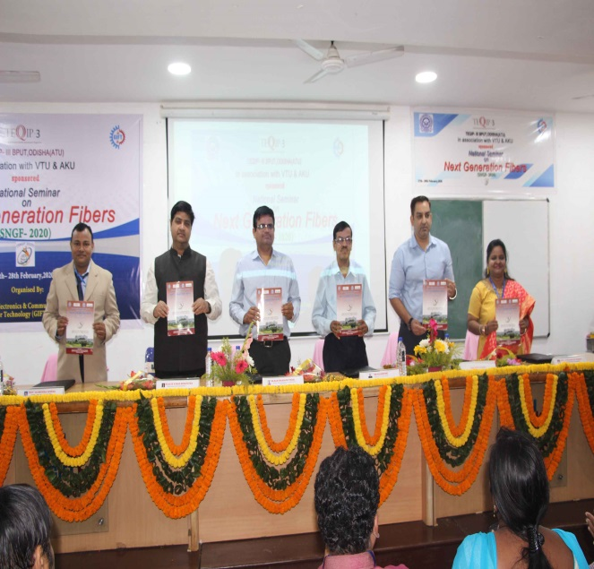

GALLERY

 